ATS Package

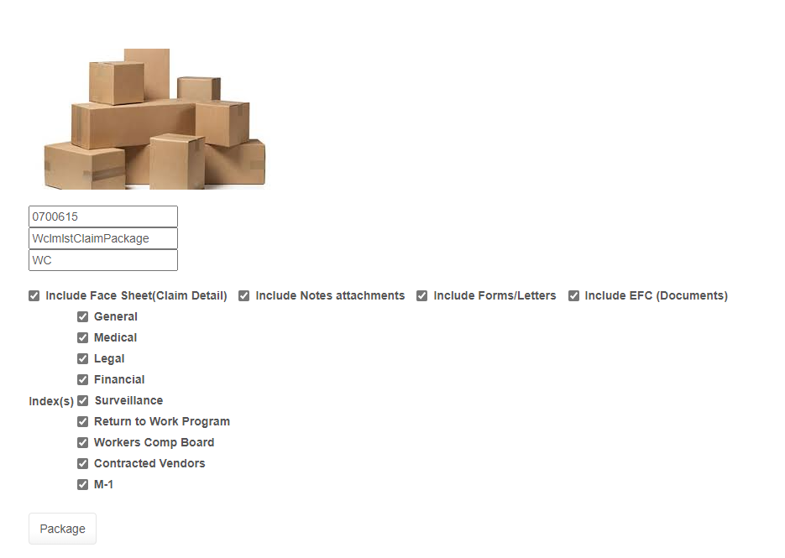
Select the options you want and then press the Package Button.

You will get a link to download your content.

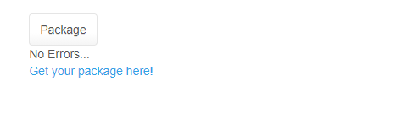
You then will get prompted at the bottom of your browser – This is a download to your PC containing the content requested.

