Entering a New Dependent
There are a number of reasons for creating dependent records. Some of them are:
- The employee was a Medicare beneficiary and is now deceased. Dependent records must be entered for any “Additional Claimants” that need to be submitted to the CMS (Centers for Medicare and Medicaid Services).

- The individual wants to attach a lien to the employee’s payments or be considered when calculating the benefit amount for a claim.

- The individual is the employee’s beneficiary and entering the person as a dependent will simplify the payment process for a fatality claim.
To enter a new record or modify an existing one, click the Dependents button to display the Dependents List.
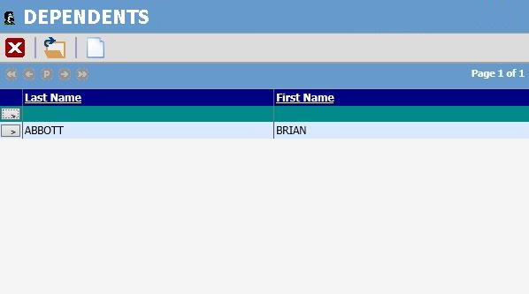
Figure 2-6: Employee Dependent List
Click on the new button. The following screen will appear. Enter all pertinent data and then click Save. The dependent record is now available to use.
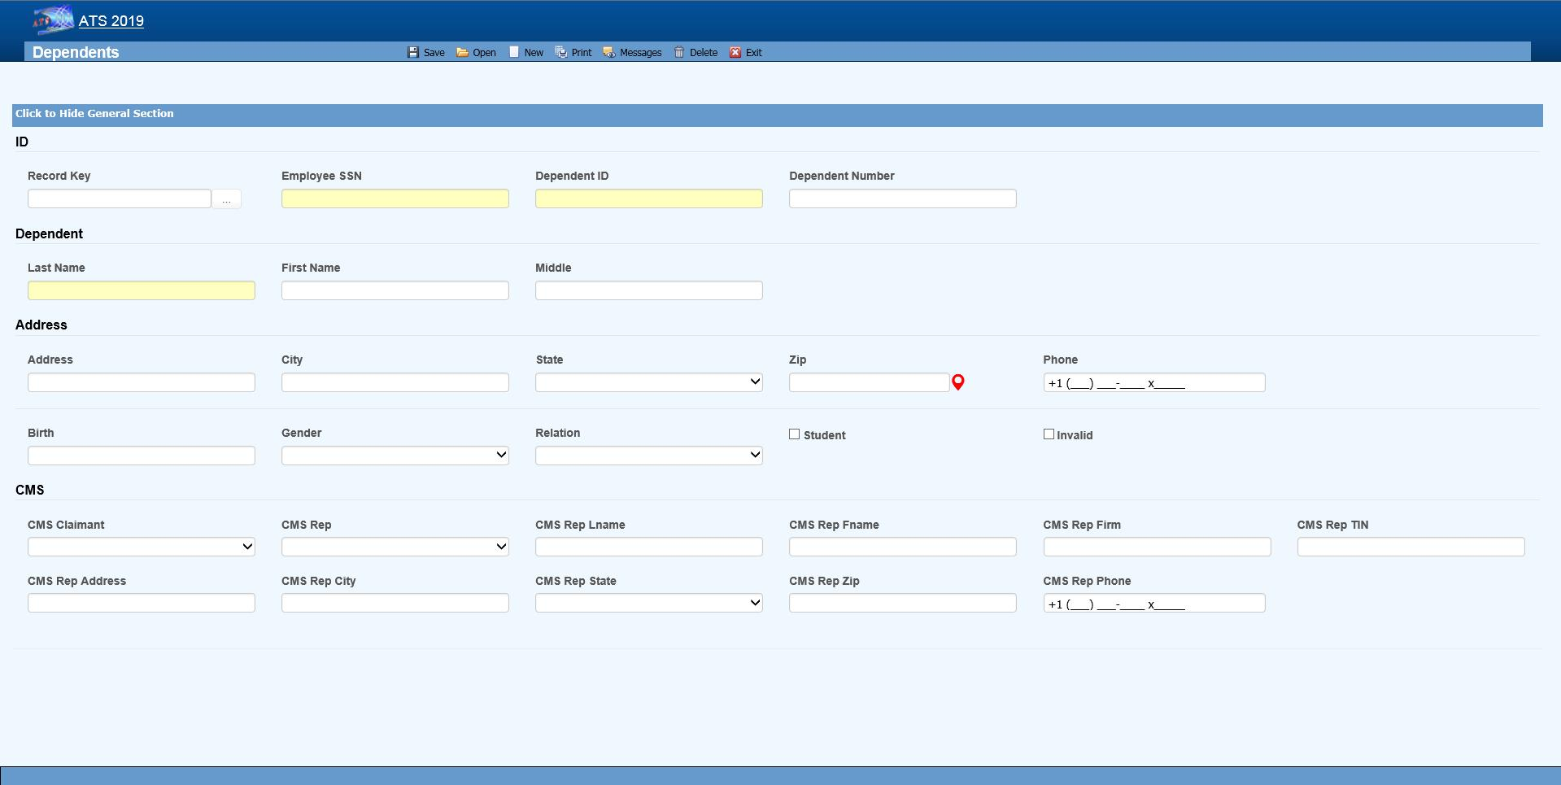Figure 2-7: Employee Dependent Data Input
The fields on this screen are described as follows:
Field Name | Description
SSN | A valid SSN should be entered for the individual.
Last Name  First Name  M.I | The complete name if the dependent is an individual. If the dependent is an estate, enter “The Estate of <employee>”, “the Family of <employee>” or “The Trust of <employee” depending on the entry in the Relationship field. In any case, leave the other name fields empty.
Address | The individual’s address, city, state, and zip code
Phone | The individual’s phone number.
Birth Date | The individual’s birth date is important if the state of jurisdiction for the employee’s claim has an age limit for tacking deductions for dependents (when calculating the benefit rate).
Gender | The individual’s gender if relevant.
Relationship | The dependent’s relationship to the employee. The valid options are:  F = Family Member, Individual Name Provided  O = Other, Individual Name Provided  X = Estate, Entity Name Provided (e.g. "The Estate of John Doe")  Y = Family, Entity Name Provided (e.g. "The Family of John Doe")  Z = Other, Entity Name Provided (e.g. "The Trust of John Doe")
Student | A check indicates that this individual is a student.
100% Dependent | A check indicates that the dependent is to continue being on a claim’s eligible list regardless of age.
Additional CMS Claimant | This number from C1 to C4 must exist in the record in order for the dependent’s data to be submitted to the CMS.
Type of Rep | The type of representative for the dependent. Valid choices are:  - Guardian/ Conservator  - Attorney  - Power of Attorney  - Other
Name  Address... | The rest of the fields for the representative are self-explanatory.
Saving a new record (or deleting an existing one) will update the # of Dependents for the associated employee.

