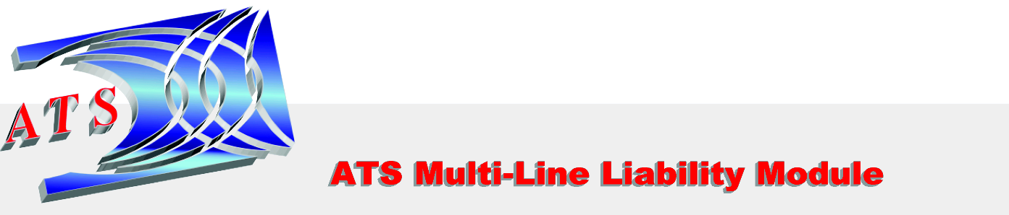

The ATS/PAC Multi-Line Liability module is a complete, end-to-end application designed to provide adjusters with all the tools they need to make liability claims management a streamlined and efficient process. The ATS software will guide users from incident reporting through the “promotion” of an incident to a liability claim and on to financial management and comprehensive claims analysis reporting.

General Liability Event’s pane from the Console:
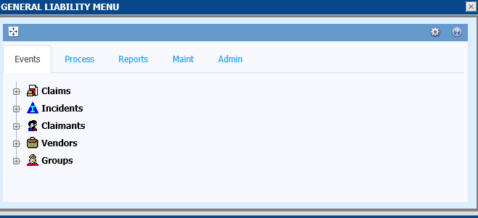

All ATS console panes utilize the familiar expandable tree.
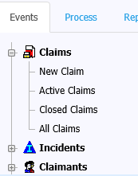
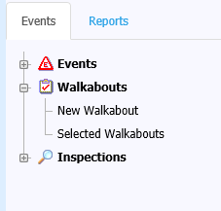
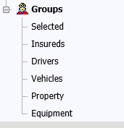

ATS.NET - Unparalleled search capability.
Once you select a menu item you will be able to search information, sort filter or group by any column in the related grid. Export to PDF or XLS/XLSX directly from your search results.
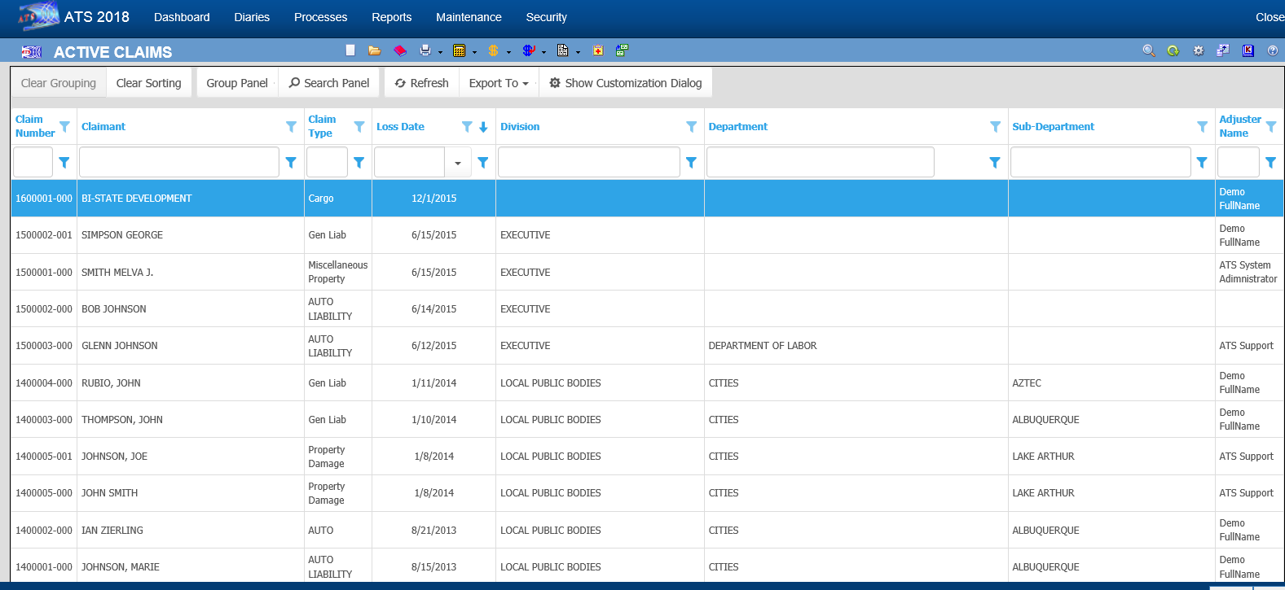

Claim Screens are customizable by claim type, level or even user.
Main Module Menu allows for quick links to Diaries, Notes, Letters, Payments Document Management and other desired features. Sub-menu allows for “Save”, “Save as draft” and other features such as “Smart Fields”, table edit and other features the user’s security allow.

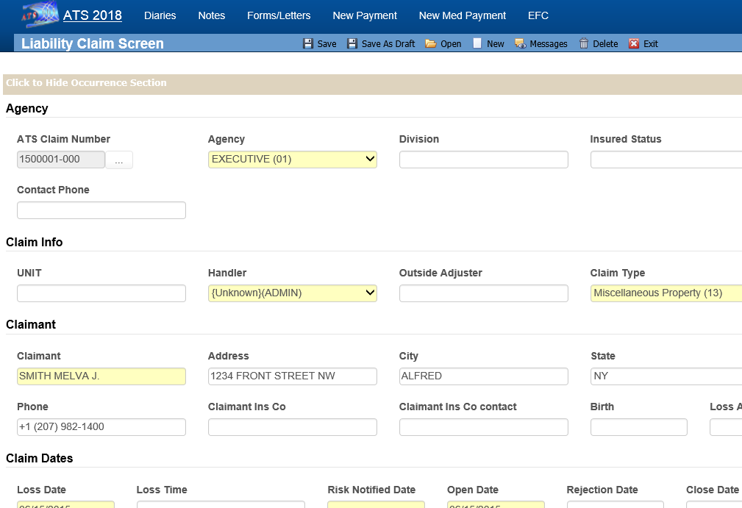
ATS.NET Process

The process section contains two major components.

- Process - Manage Batched Payments/Held Med-fee records, Print Payments, Search History, Re-batch and Reconcile.
- Data Exchange – Manage exports and imports to and from systems such as CMS, ISO, Pharmacy, HR, AP, and any other interfaces.

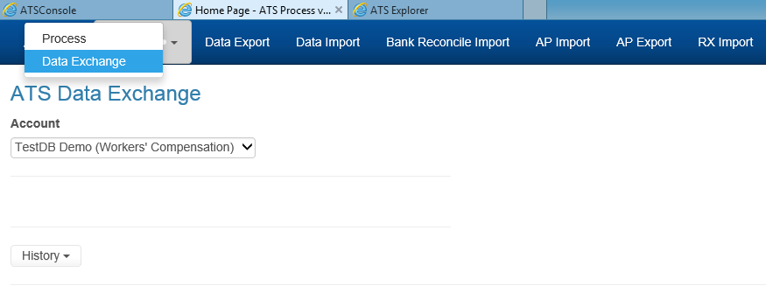
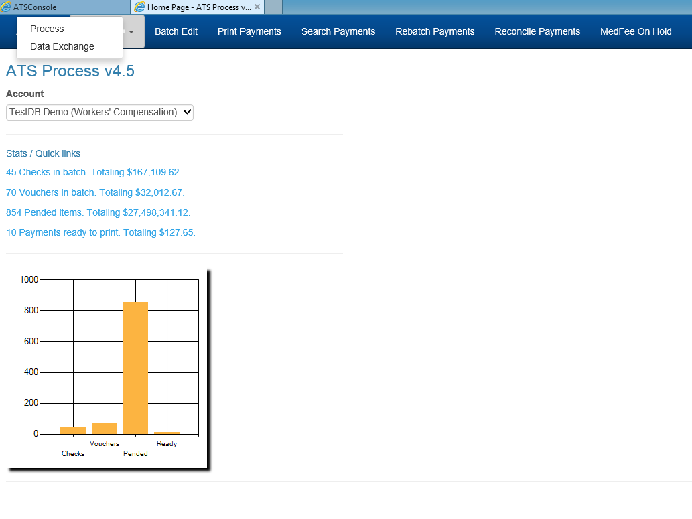
ATS.NET Groups

Manage any related data such as driver’s, aircraft, fleet, equipment, property and any other data you wish to track, whether related to incidents/claims or not.

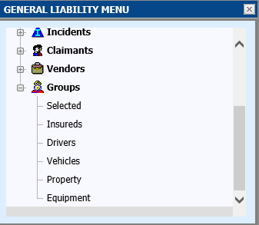
ATS.NET Security

Security at the User and Group Level allows for setting access to data, segments of data, modules and tasks. Limits can be set such as reserve authority or payment limits.

