Payments

Accessing Payment Entry
The payment entry screen, as with many other options, can be opened from the claim screen or claim search page.
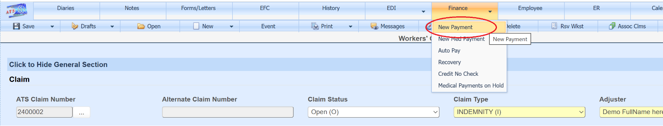
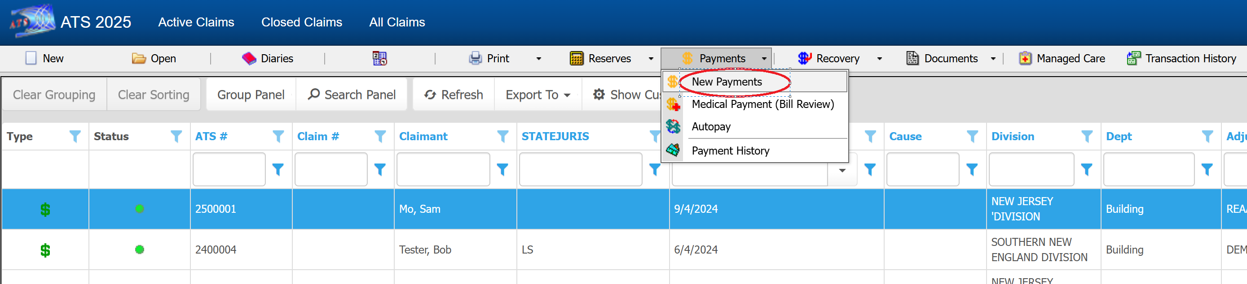

Payment Field Customizations
Field properties can be over-ridden on the payment screen to change the requirement status, background color, default value, tab stop on/off, and visibility. Unlike the majority of data entry screens in the system which allow users with authority to make changes to these and additional properties, ATS support will need to assist in changes made to the payment entry screens.
For this example, the requirement status of Due Date has been turned on and is thus now showing with a yellow background. The system default is not required for Due Date.
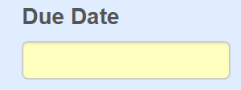

Reserves
A red message on top of the page will let you know if the claim is closed.
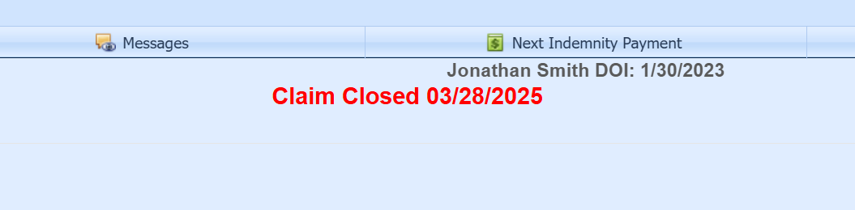

If the claim is closed, and you decide to make the payment, the application can automatically adjust the reserves depending on system parameter settings. Authorized users can adjust these settings from the Maintenance option found on the ATS Console page.
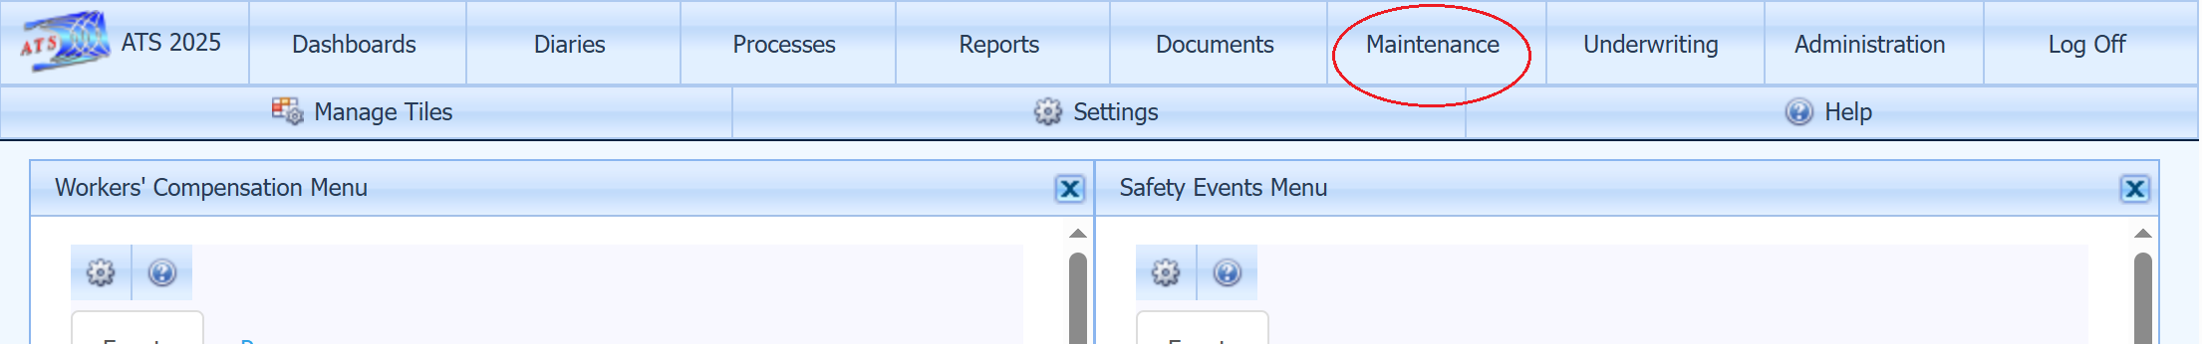

From the Table drop-down, select Parameters (COMP) and double-click the record in the grid to edit. The Stair Step Reserves drop-down has three options, C - only closed claims, A - any time a payment is being made that exceeds the current reserves, and N – which forces the user to adjust reserves prior to the payment any time reserves are insufficient. There is also a Neg Rsv option on the Parameters II page to allow payments to be made without reserves set.
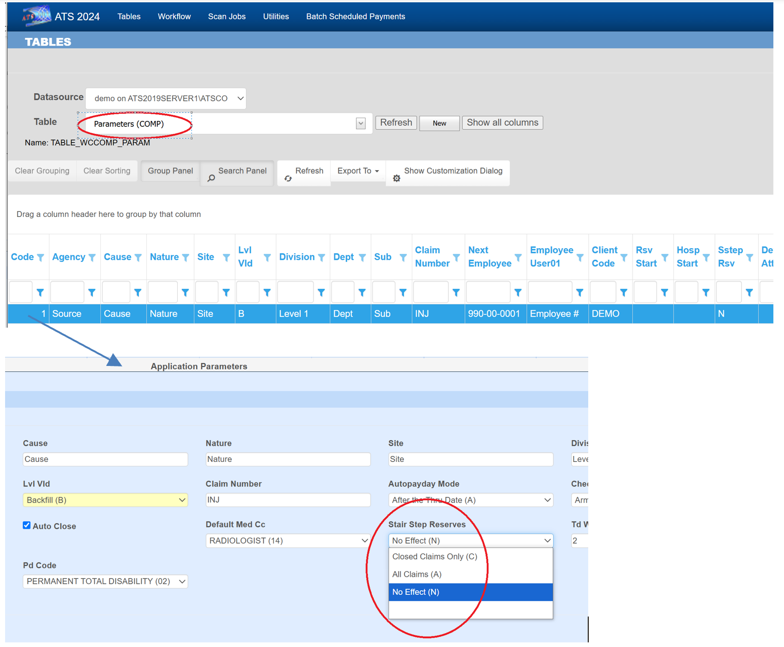

Reserve information is displayed at the bottom of the payment screen. Your system might not be set to use all the reserve categories shown here.
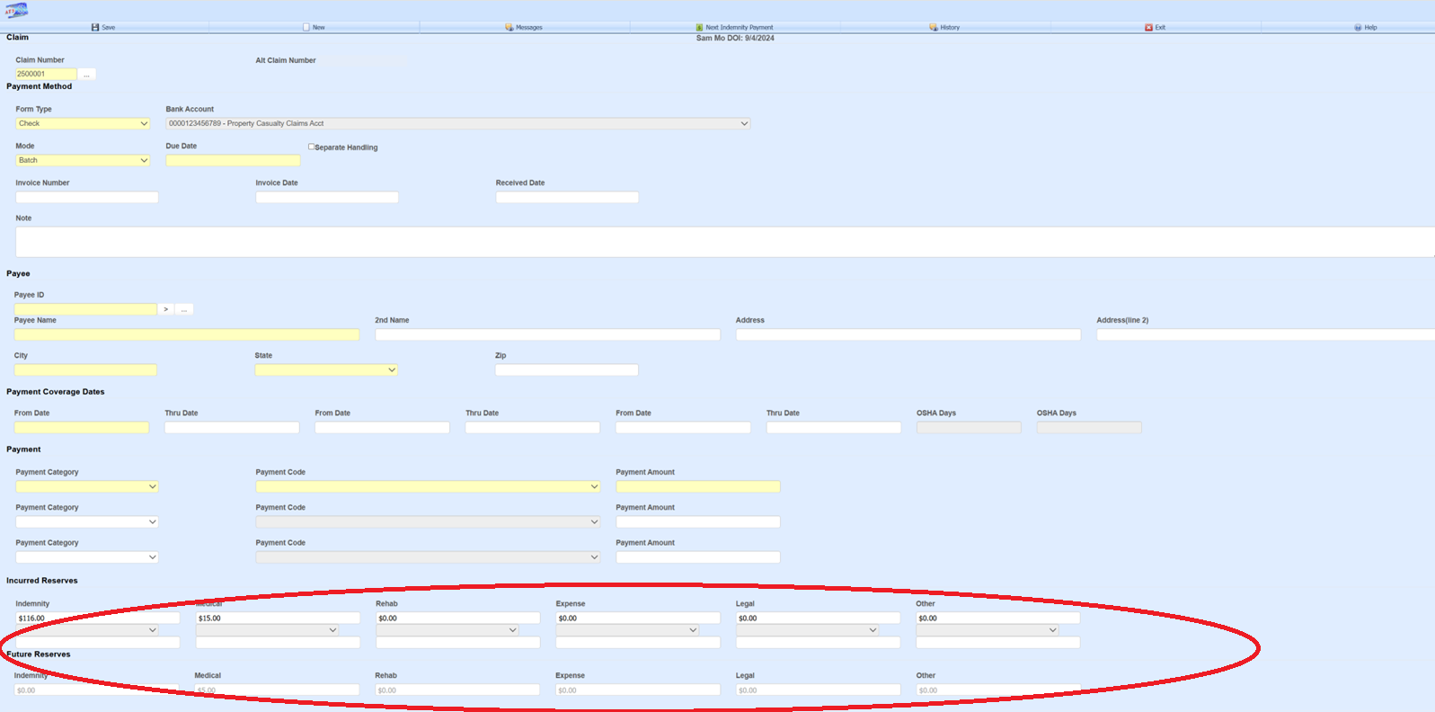

For users with reserve authority, incurred can be adjusted on the payment screen.
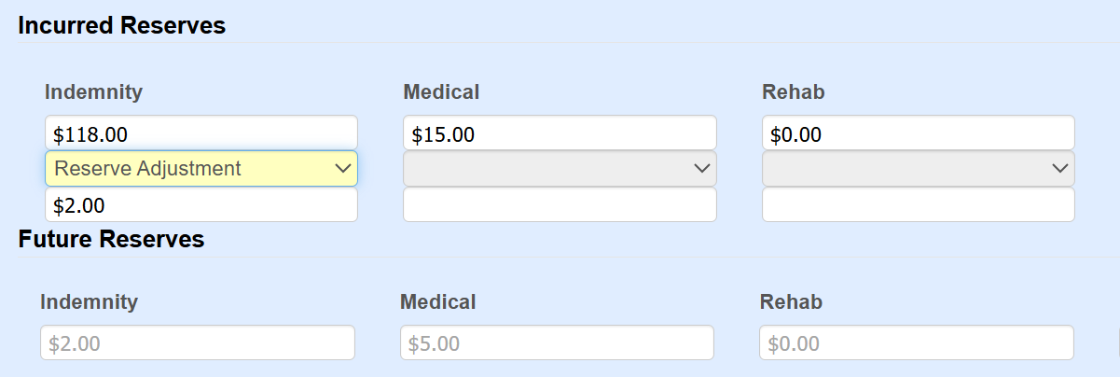

Indemnity Payment Entry Assistance
The Next Indemnity Payment button on the payment screen tool bar will fill the payment screen in with the amount, service dates, employee’s name, address, reserves category, and cost center it determines should be used for the next indemnity check.
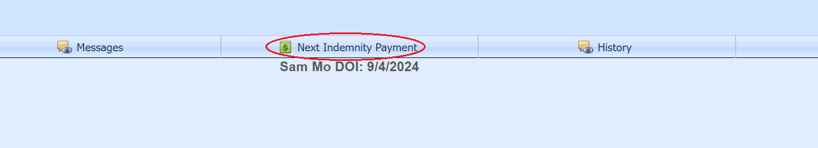
It uses fields TD Weeks, TD Code, PD Weeks and PD Code from the Parameters page depending on the claim benefit type and the dates of the last indemnity payment to determine the service dates. The claim benefit rate and new set of service dates are used to determine the payment amount.
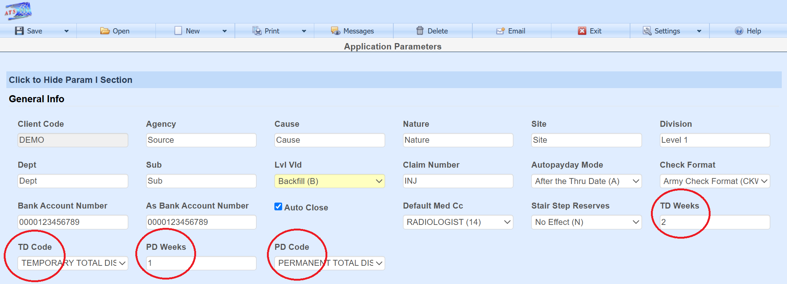

Batch/Notate
The Mode drop-down determines if the payment will be batched for printing/export or notated directly to check history with the check number and process date entered by the user.
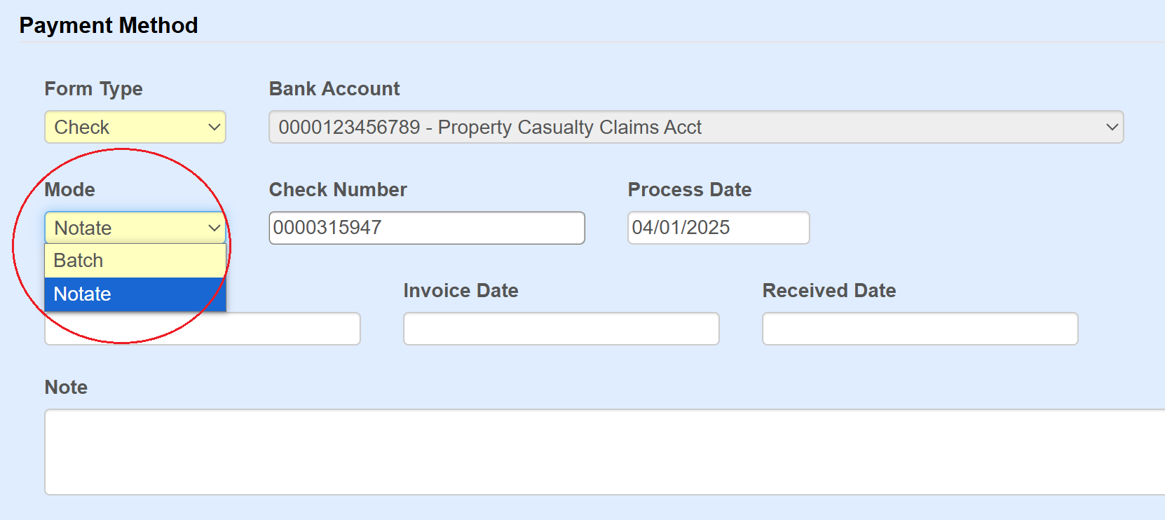

If the payment is being batched, then Due Date can be entered to determine when the payment should be printed. The Separate Handling field, which if set tells the printing process not to combine this payment with any other payment records to the same payee.
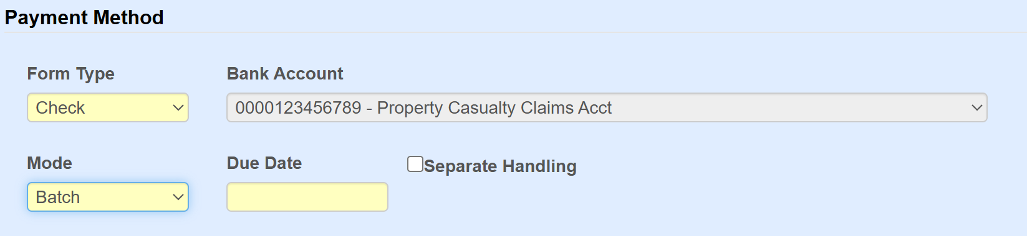

When checks are printed from the Payment Printing page and the Combine Vendors check box is checked, then payments with the same payee will be combined into one physical check, unless the Separate Handling field was checked when entering the payment. The Due Date field on the Payment Printing page will filter out batched payments unless the due date on the payment record is set to nothing or the same date range.
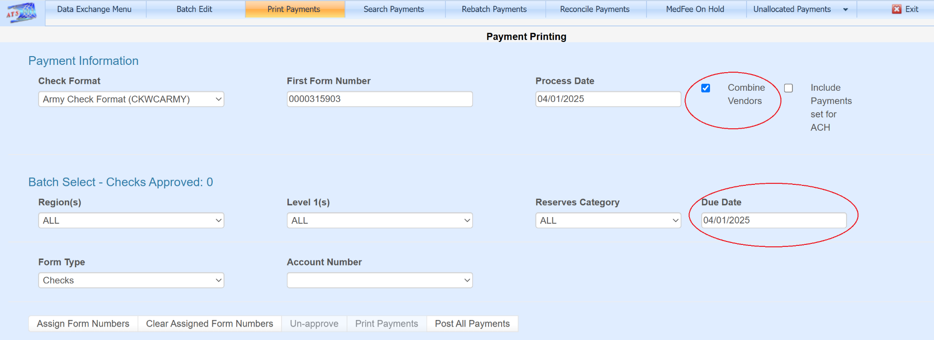

Pending Payment
If the payment amount is larger than the user is authorized for, then the payment will be pended where it can be released by a user with authority. Pending payments are released from the Batch Edit page found under Processes accessed from the ATS Console.
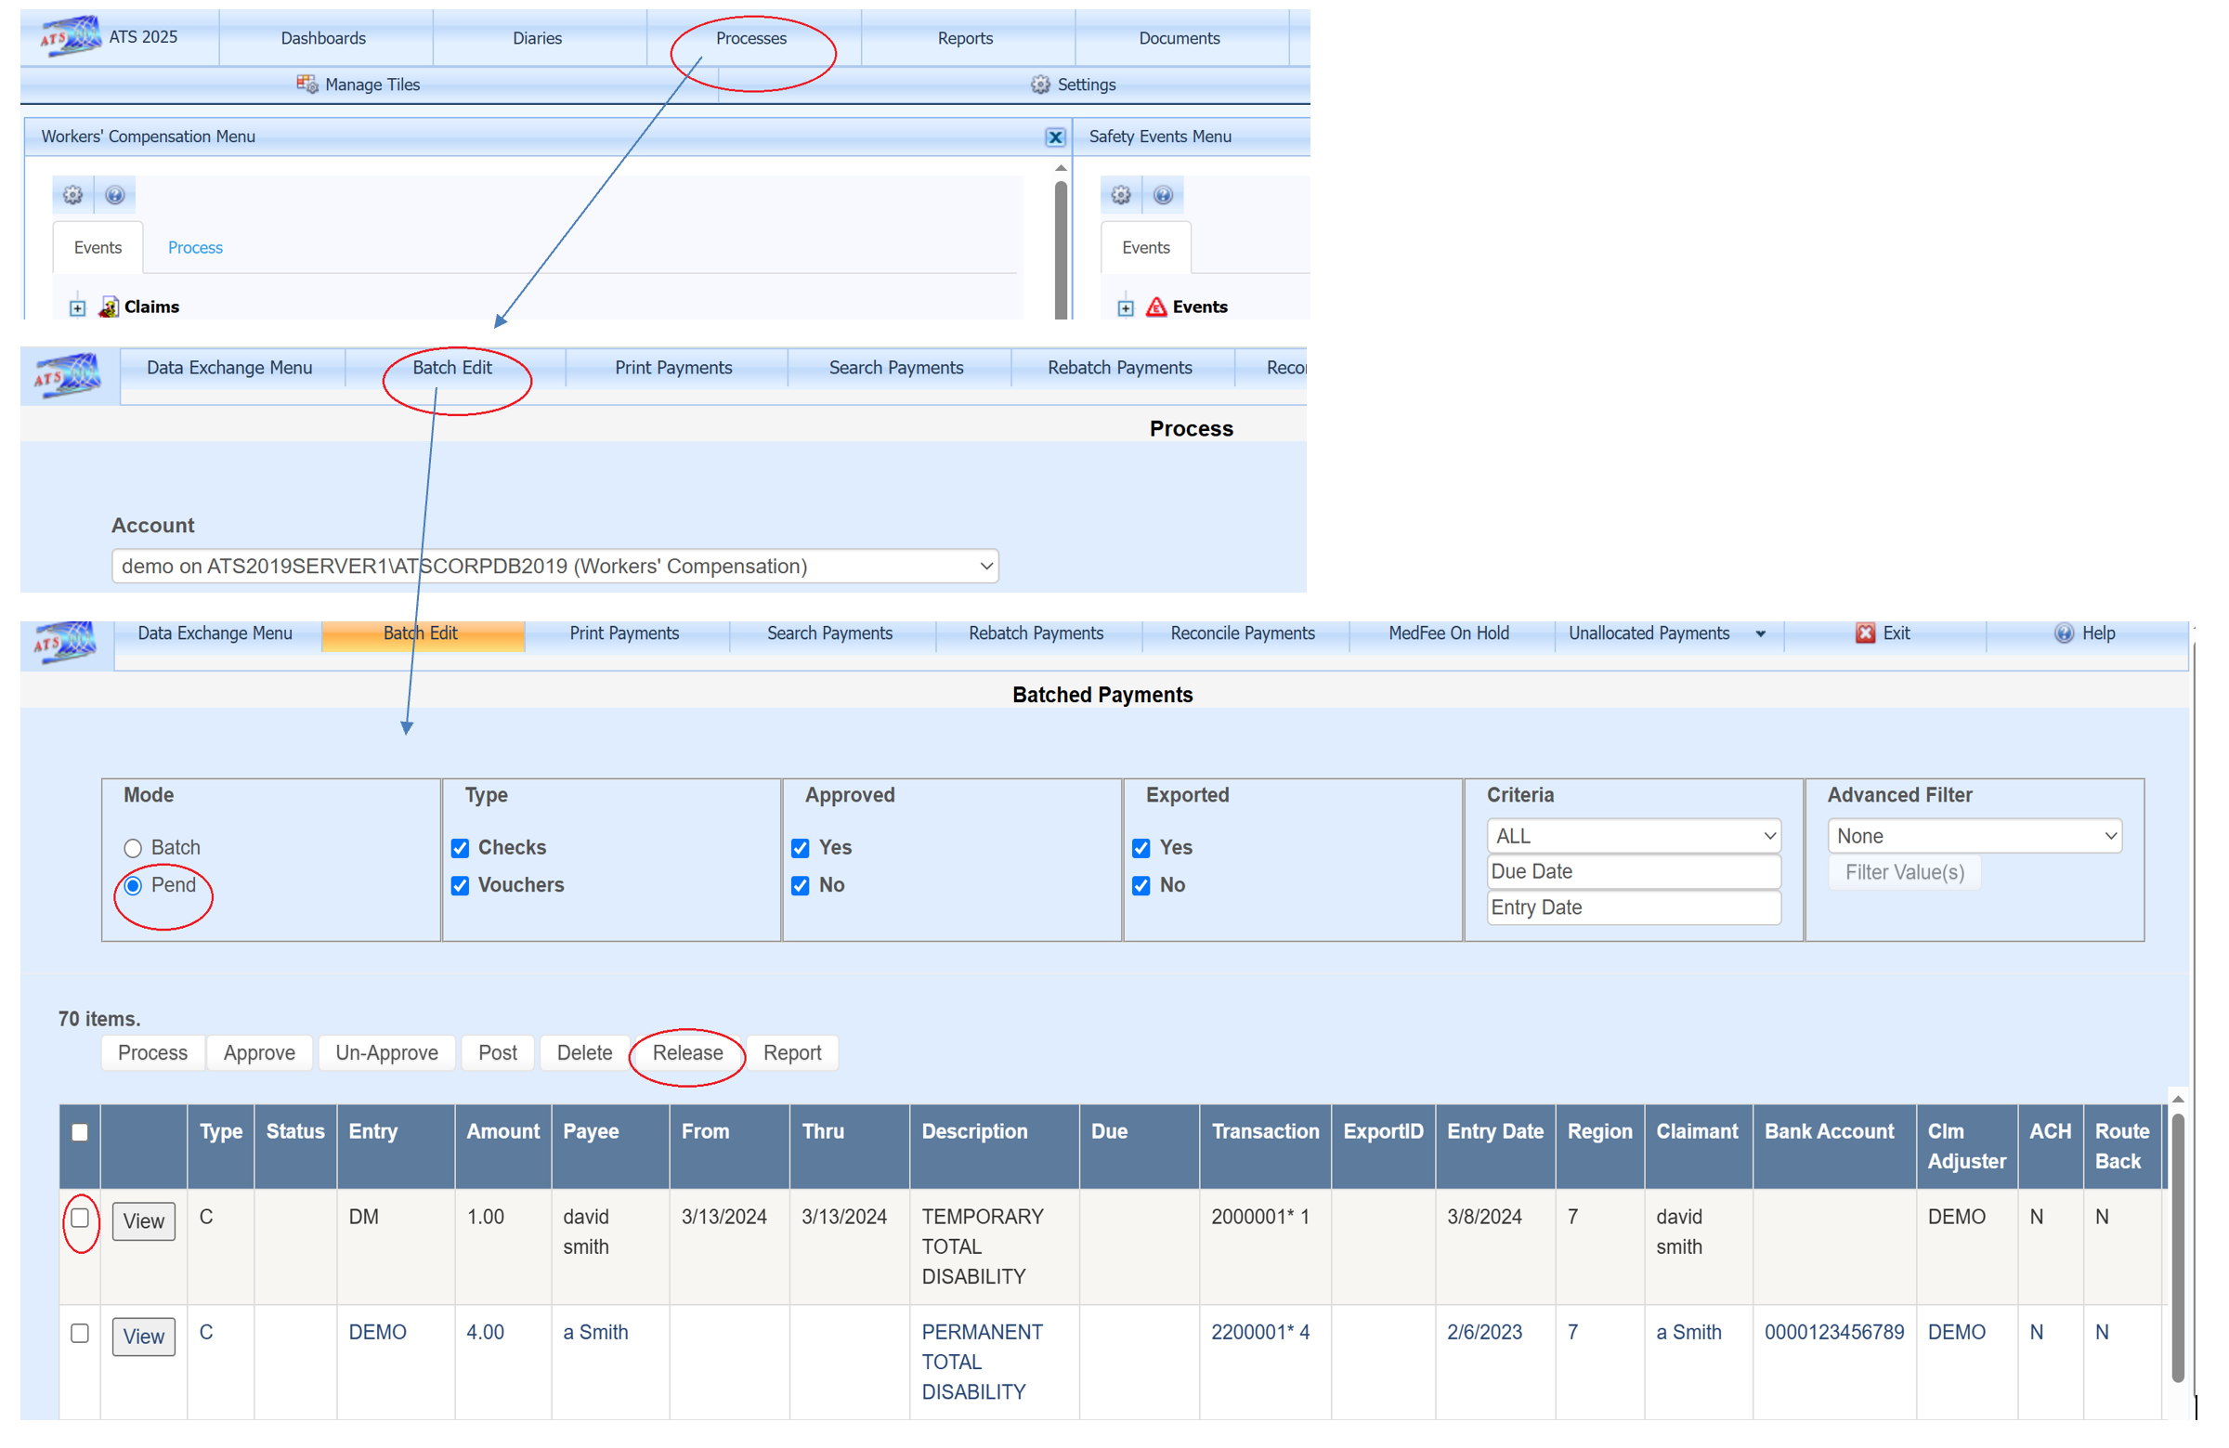

Payee Selection
The … ellipsis button next to the Payee ID field brings up a menu listing the top 5 most recent paid vendors, top 5 most used vendors, and vendors listed in the claim screen such as the claimant attorney. To search for a vendor, select option Search Vendors (Alt-v) or use the key combination Alt and V without the need to open this menu.
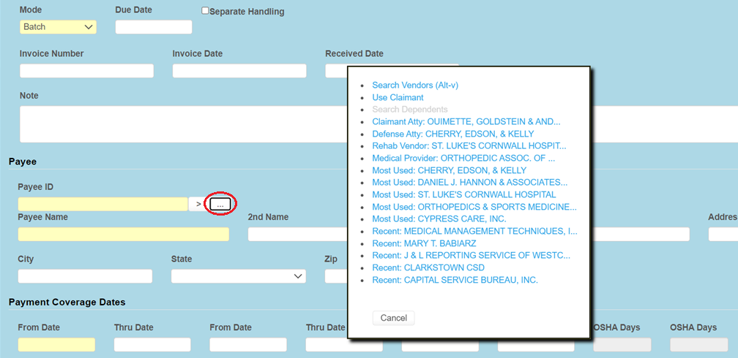

The > button next to the Payee ID field will switch to the next active vendor record with the same federal ID of what is currently entered in the Payee ID field. In this example if the > button is clicked, the payee will change to Peter Hoffman using 11-2050523*02. If just 11-2050523 is entered without the *, then the first vendor record will be loaded, 11-2050523*01 if active. This allows the federal ID to be entered if known without using the search menu.
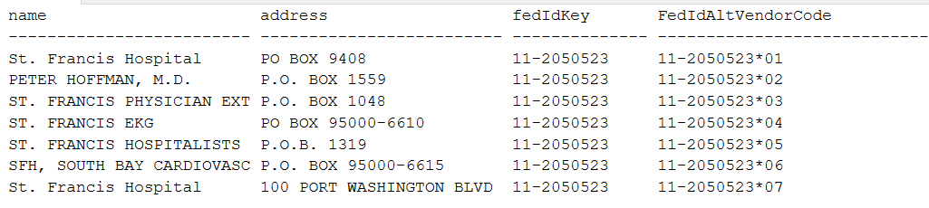
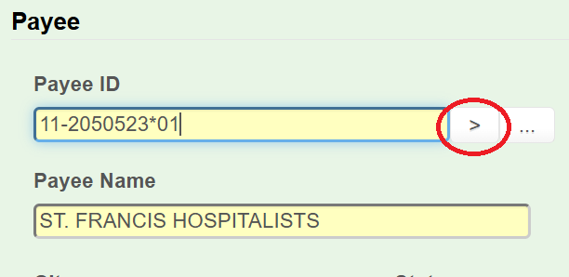

The vendor page has a default payment category and code, which will be used by the payment screen if set.
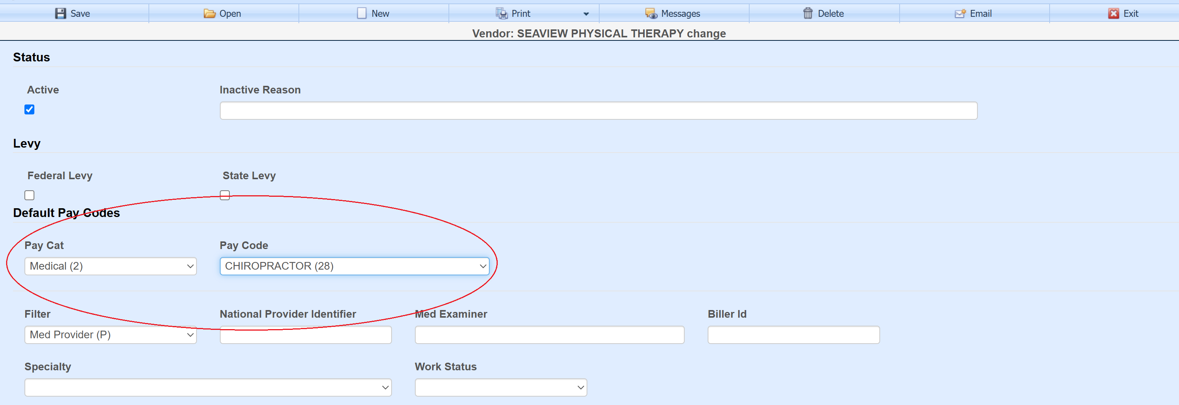

Entering Multiple Payments
If there is more than one payment record to be entered for the same payee, claim, service dates along with all the other fields being the same, then they can be entered here. The screen will grow thus allowing an unlimited number to be entered. A separate payment record will be created for each amount entered here upon save.
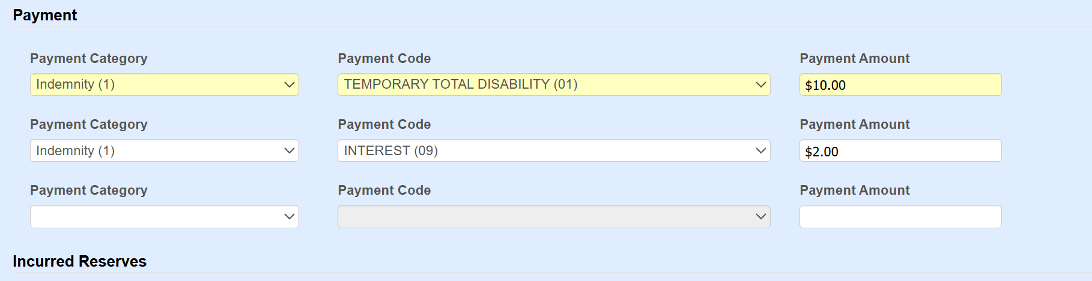

Once a payment is saved, the screen will be cleared to allow another payment. The vendor’s information and service dates will remain unless the system settings are set to clear them. ATS support can help with this adjustment. The Claim Number field on the upper left of the screen allows you to switch to another claim, thus once you’ve saved a payment, another can be entered for a different claim without exiting the page. The Messages button on the toolbar will show a list of payments entered for the session.
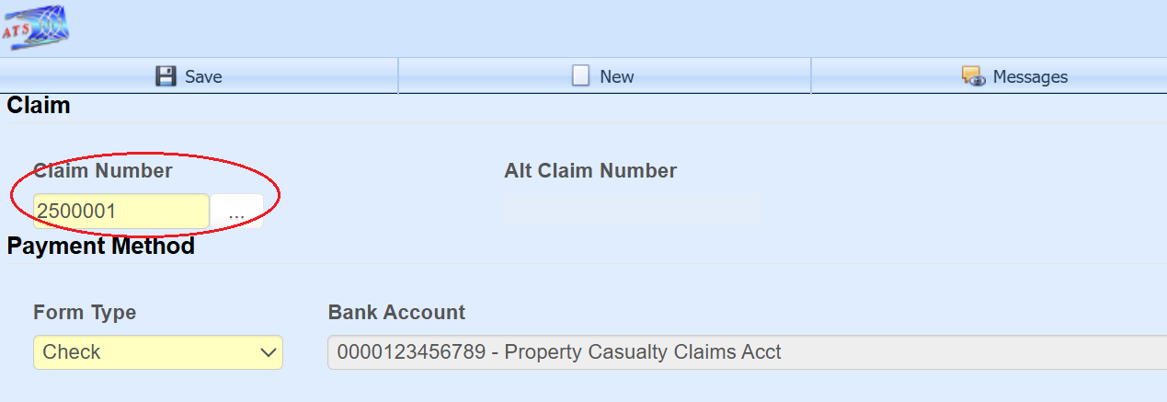

Wage Continued
If the Wage Continued checkbox is set in the claim record, and a TD or PD type payment code is selected when making the payment, then a message warning the user will appear on the status bar explaining that the employee is receiving their salary in lieu of worker’s comp benefits.
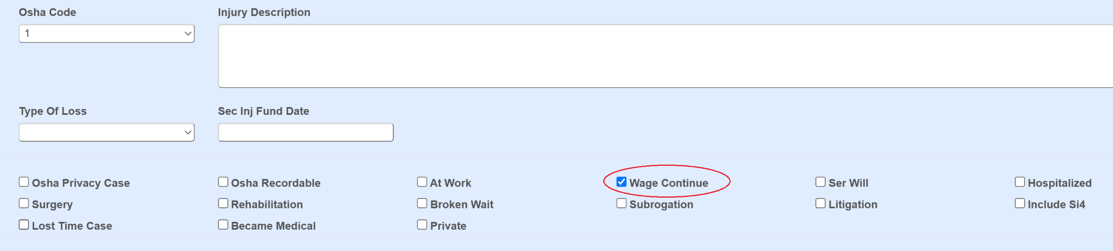
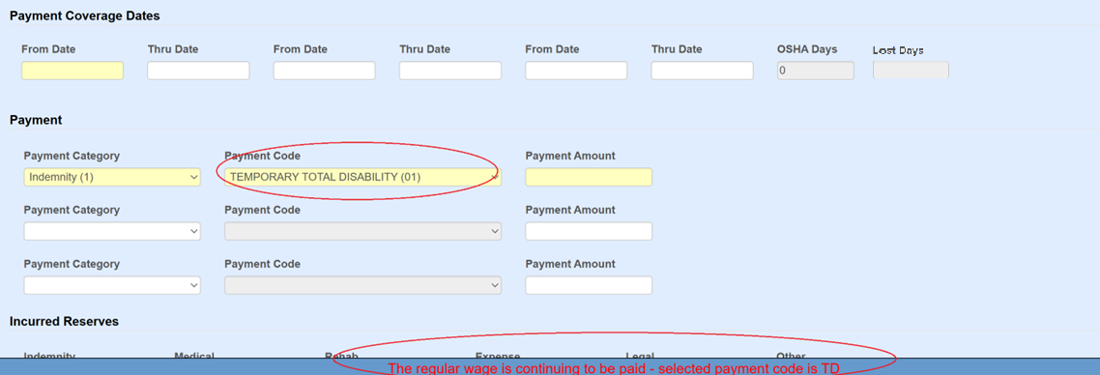

Osha Days
When making a payment to the employee for reserve category 1-indemnity or 3-rehab, the program will check the field Grouper in the payment codes table for the specified payment code entered for the payment. The payment code records can be edited under Maintenance on the ATS Console.
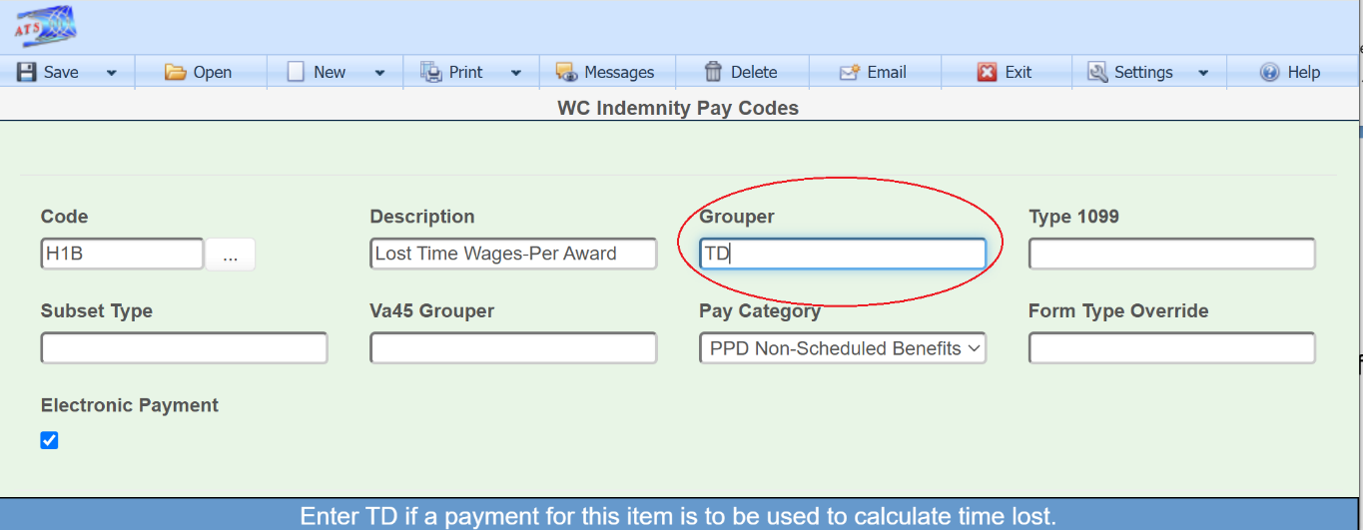

If this value is “TD”, then the From Date/Thru Date fields are used to calculate OSHA Days based on a calendar week. This value will be displayed on the screen and added to the existing values in the claim record.

When an employee performs another job or the same job with restrictions due to an injury or illness, and the job pays less than usual, the employee should get a comp payment to make up the difference. In that case the temporary disability payment should be made with a pay code that contains I08 (wage loss) in the report category so the days in the from/thru period will be ignored when reporting to OSHA. If this feature is not used and the grouper is TD, then days would be counted as lost time when the employee is really at work.
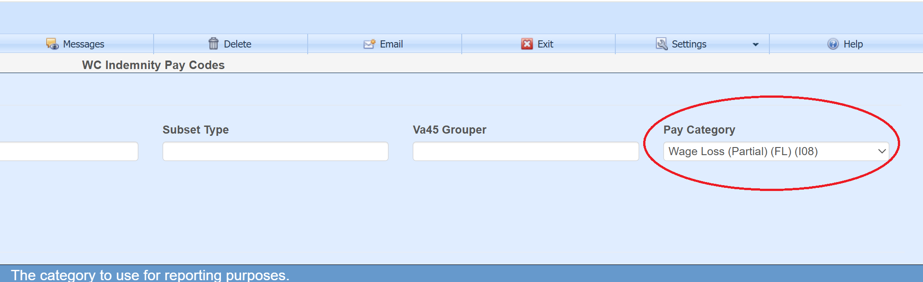

Duplicate Payment Warning
Upon save, a list of existing payments with the same claim number, reserve category, and ((similar service dates and the same payment code) or (invoice number and vendor)) will be displayed in a warning pop-up with an option to continue to save or cancel. Payments can be opened on this list with the Select button.
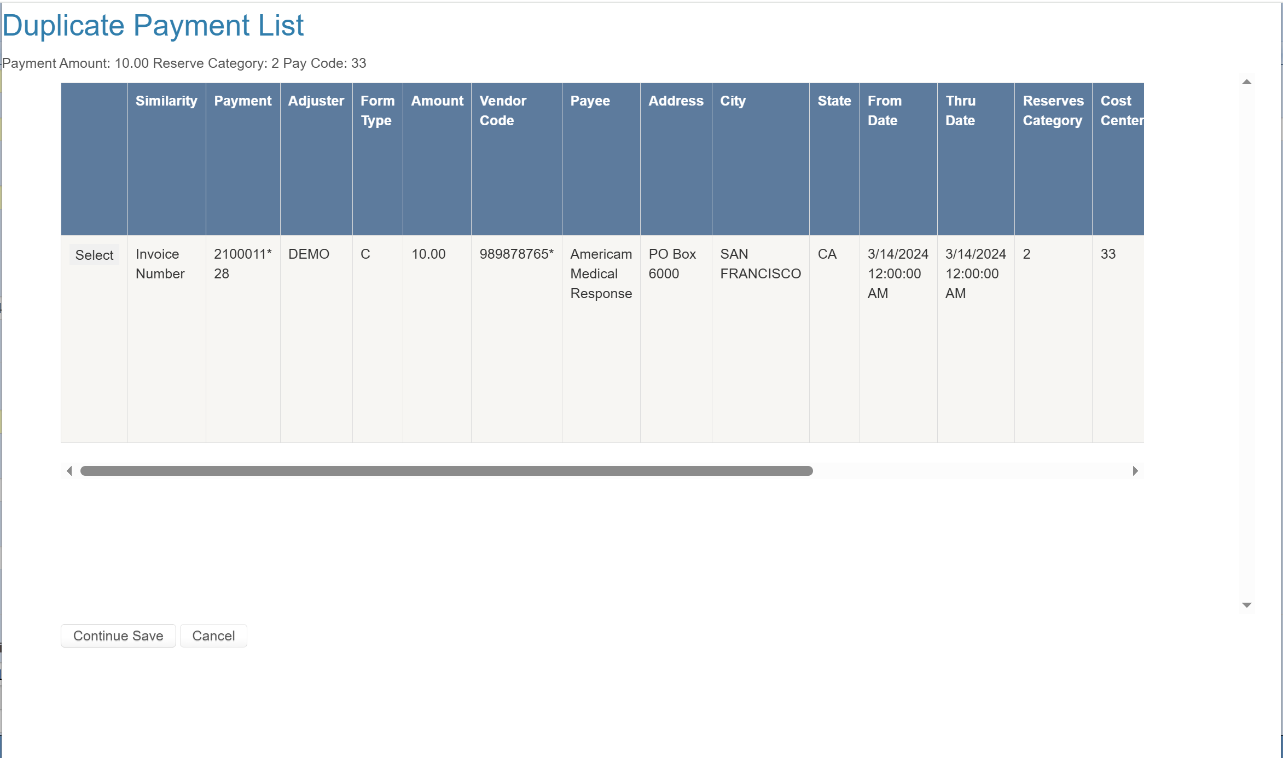

Print
The toolbar Print button will list records that have been saved in the current session and can be printed to a Crystal report.
