Pending Reserves

The ability to pend reserves when users have exceeded reserving limits is an option that can be turned on by ATS support if requested. When a user has exceeded their reserve change limit, they have the option of requesting approval from another user with authority via a diary and email.

In this example the Reserve Worksheet is being used.
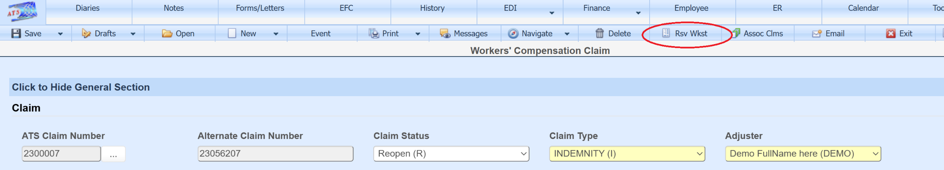

Once the fields on top are filled in and the Add to Proposed Grid button clicked, a message on the status bar will indicate if some or all the transactions attempted are over user limits, but can be pended.
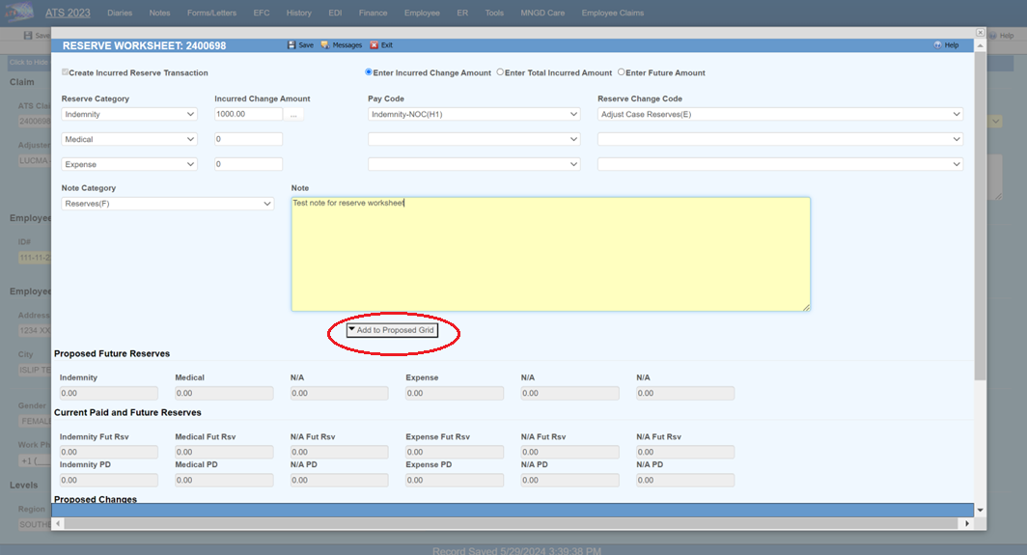

The Pend column in the Proposed Changes grid indicates this record can only be pended.
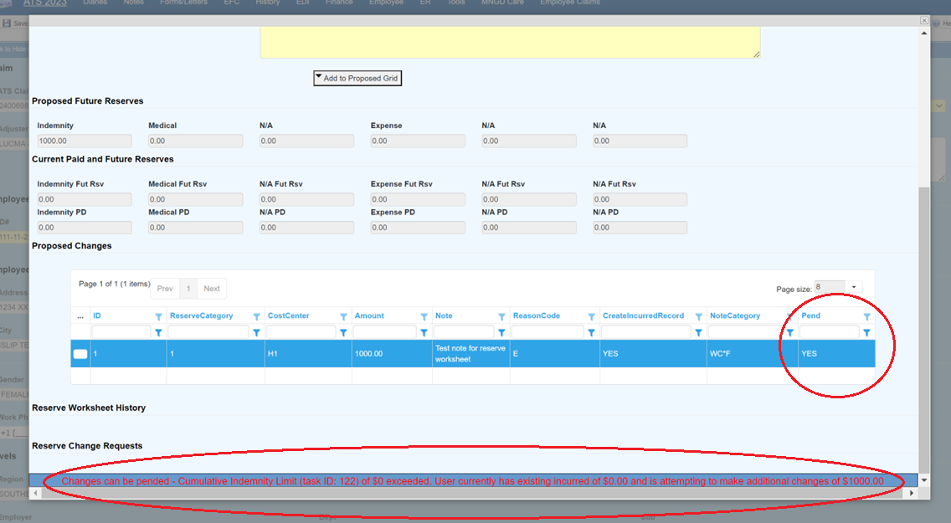

Once the reserve worksheet is saved, the allowed changes will be saved, and the Reserve Change Request page will open with changes that can only be pended.
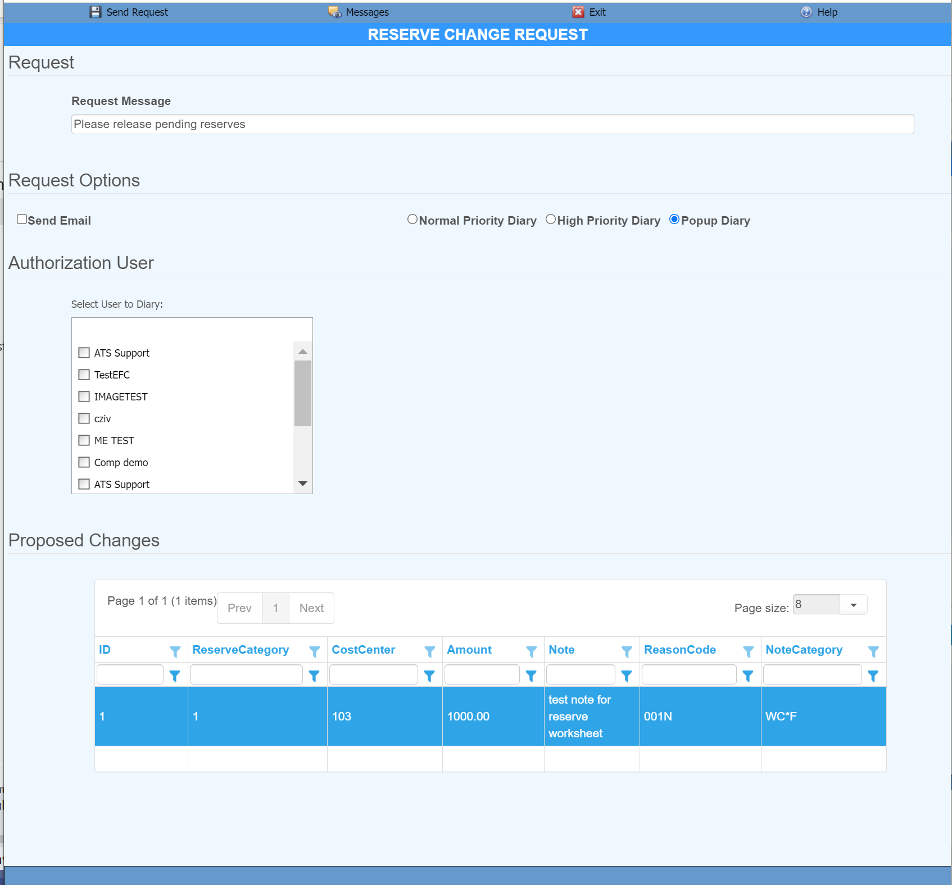

The Authorization User list is ordered with the managers of the requesting user on top, if any.
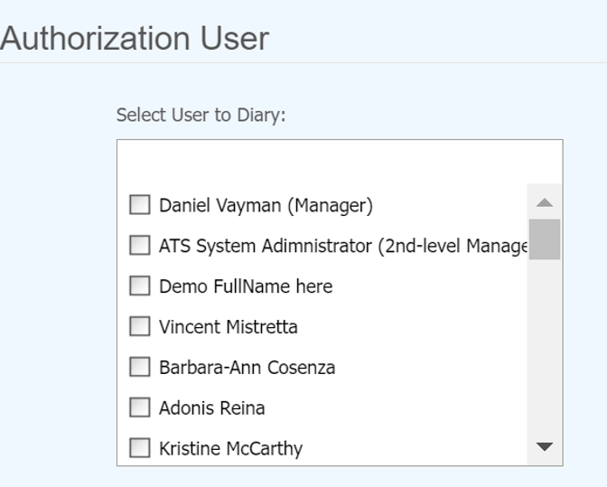

An email can be sent to give the requested user an alert that a reserve change request diary has been created. The diary importance can also be set.


If the diary requesting a user to authorize the reserve is created with an importance level of Popup Diary, then the user is notified that they have an action to do with a popup from the ATS Console. Clicking on the message will open the diary.
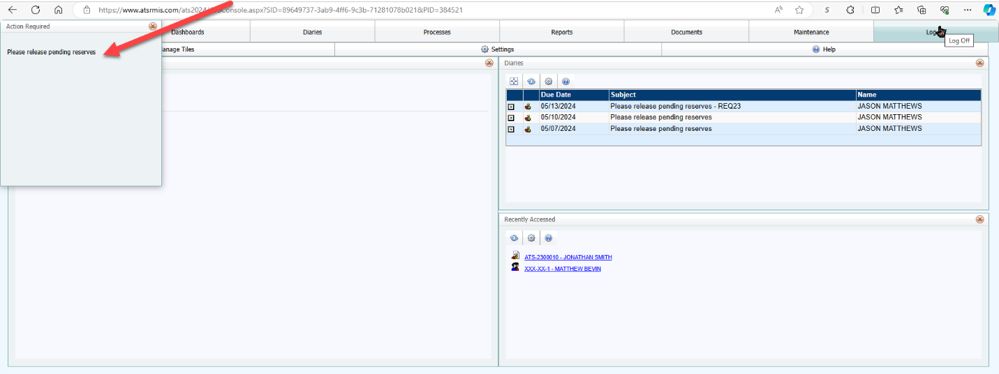

Once one or more authorized users have been selected for approval and the Send Request button clicked, a message will appear on the status bar indicating the request was created and sent.
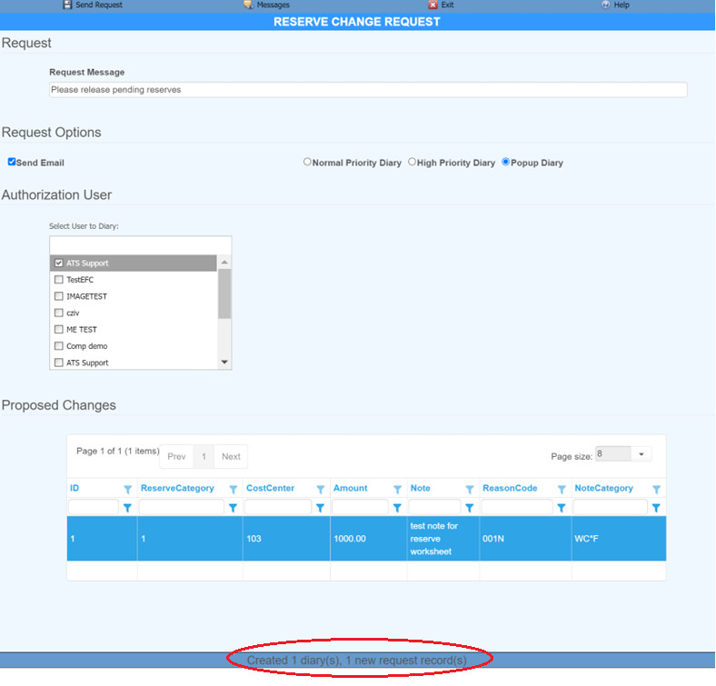

The Messages button can be used to get a list of previous items displayed on the status bar.
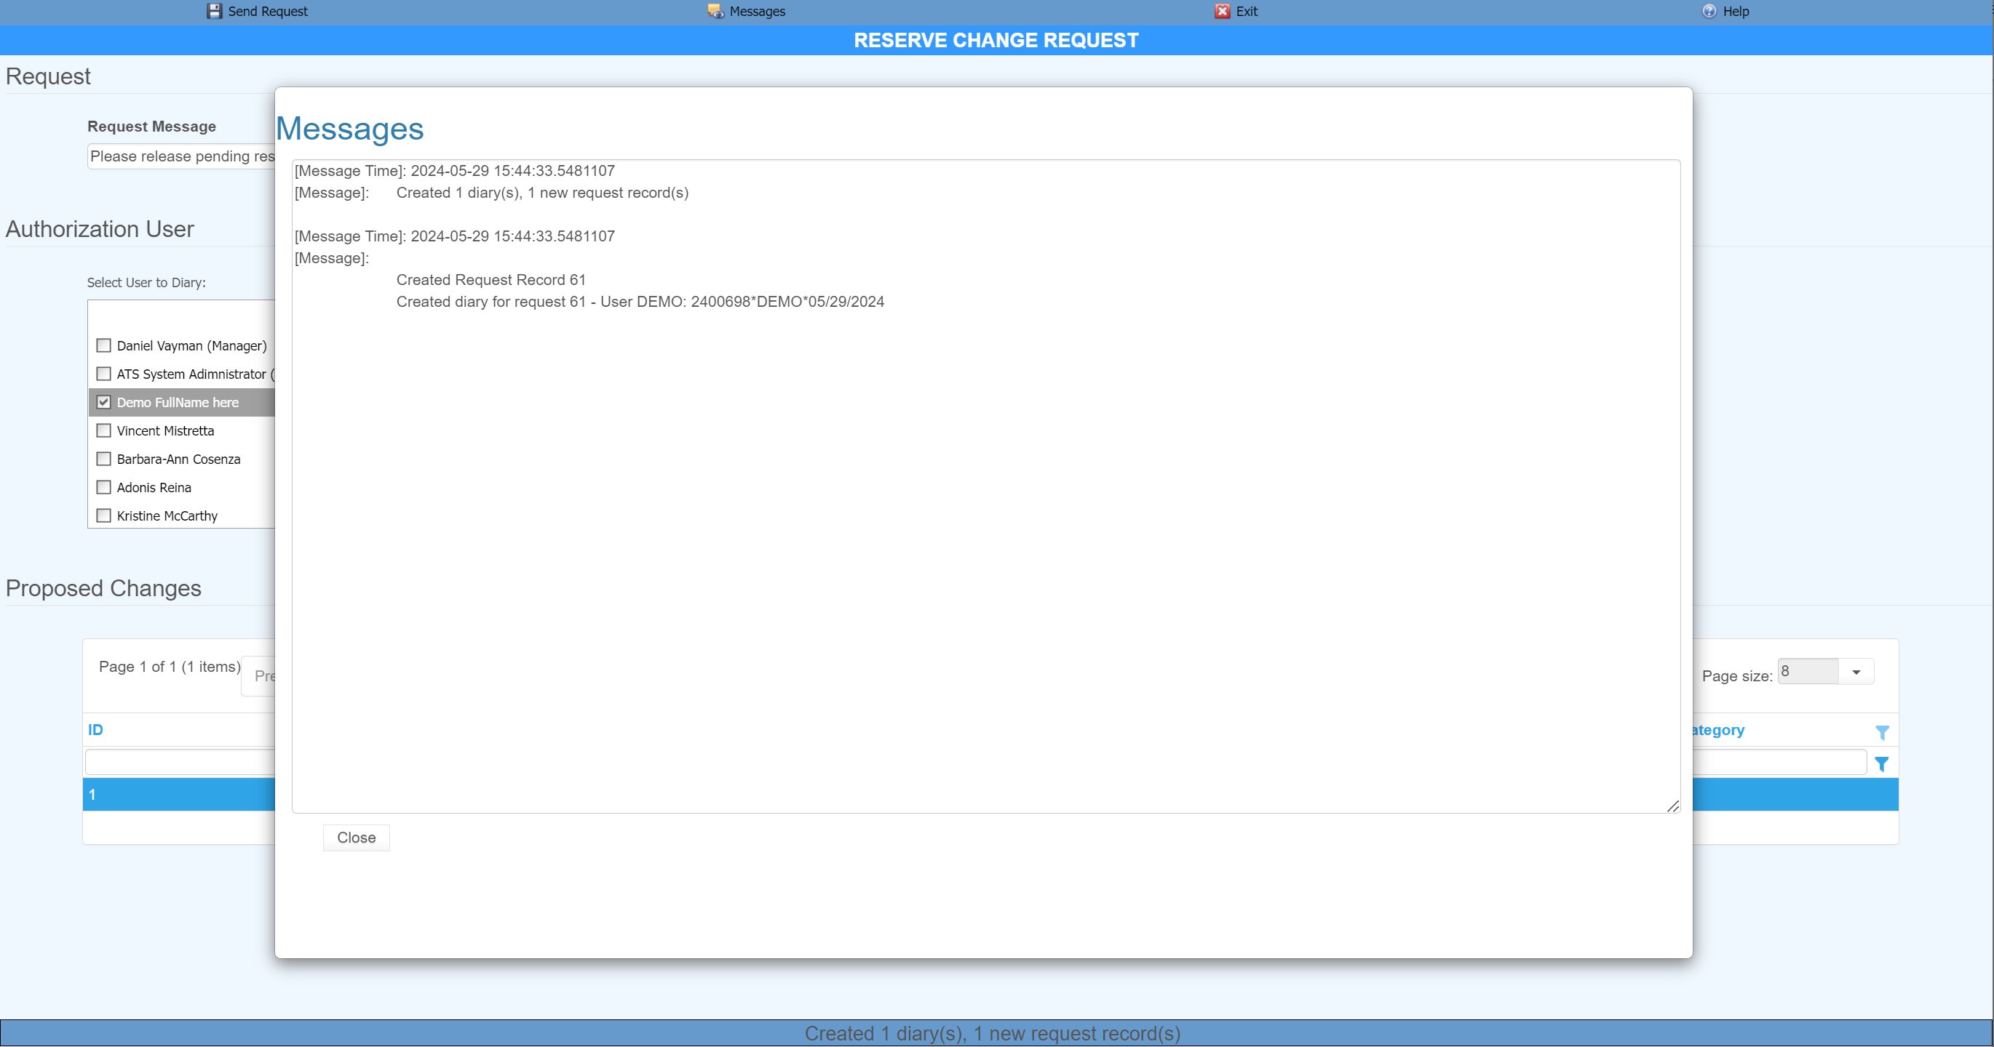

The Reserve Worksheet screen remains open on the original tab and the status bar indicates if any authorized reserves were created.
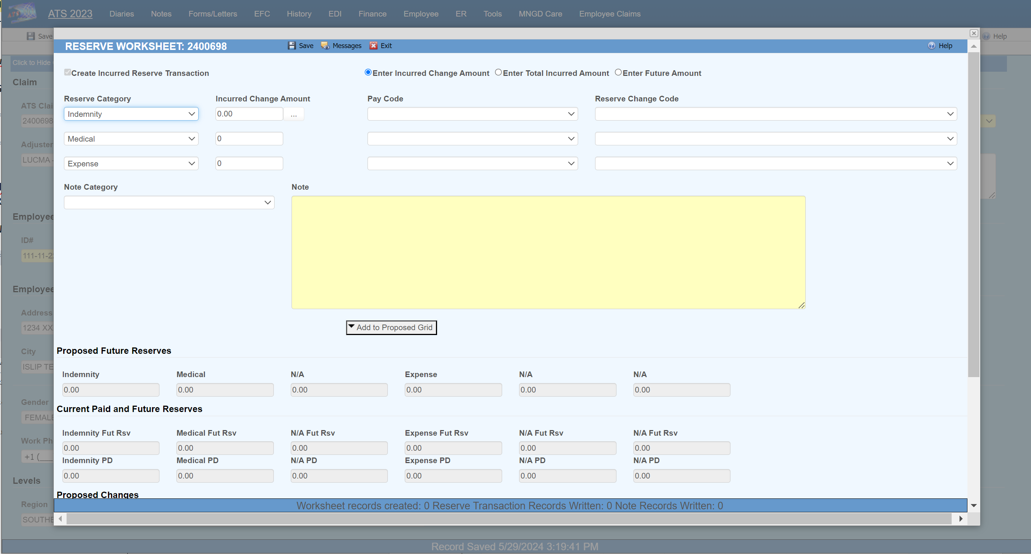

The bottom of the reserve worksheet has a Reserve Change Requests list showing the history of prior requests. A double click on a specific record will open it into a screen and if not already denied/allowed, can be edited.
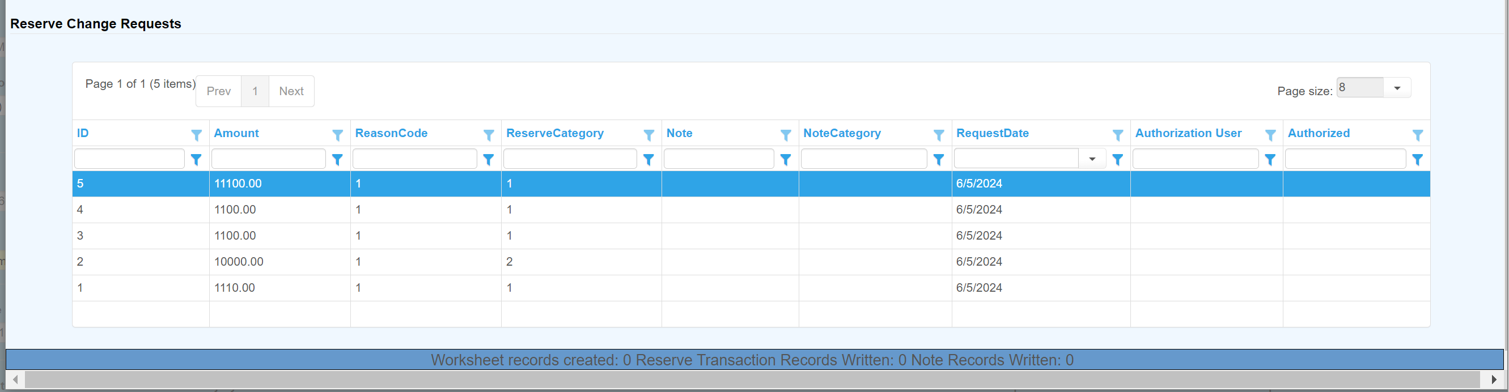

If not already denied/allowed, the request detail screen allows a few fields to be edited or for the request to be deleted. If deleted the request diary records will also be removed.
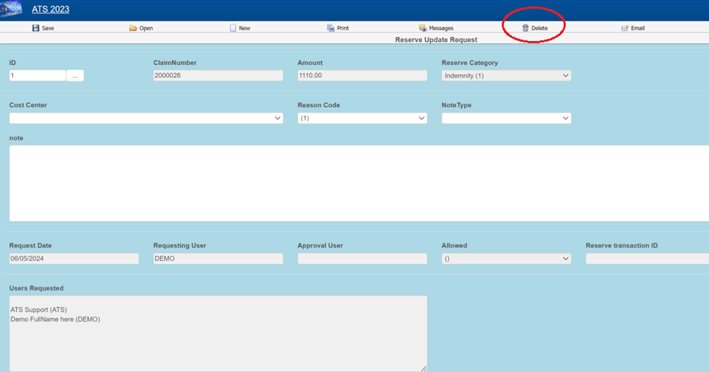

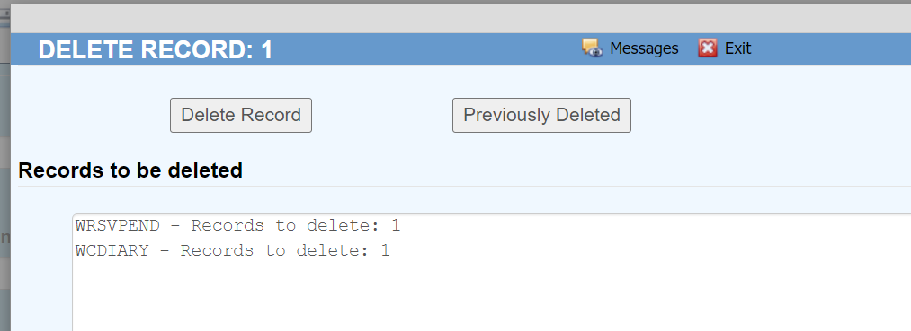

For the example the request was sent to the user Demo. This screen shows the user Demo now logged into the application with the diary Activity List page open.
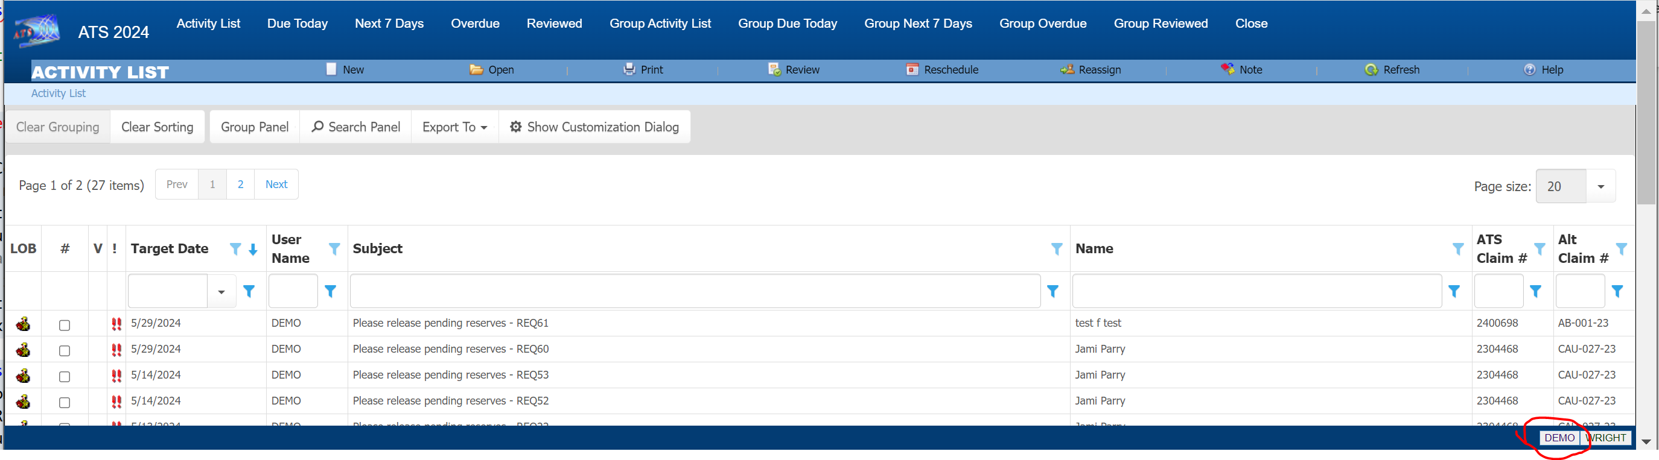

From the diary the Allow, Deny or View buttons are available to process the request. Once the request has been allowed or denied then any diary requests sent to other users will be removed.
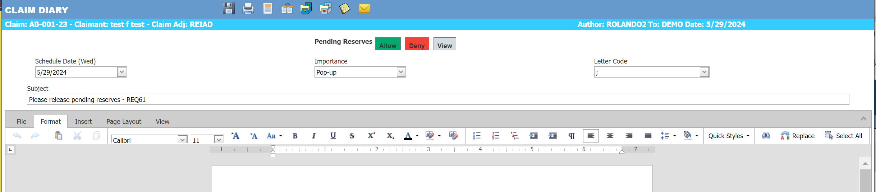

Tooltips on the buttons have additional information.
