Scheduled Payments

Setup

The AutoPay module is included with the standard ATS System so you may schedule payments to be made on a regular, ongoing basis. This feature is available from the menu from within a claim or from the Selected Claims list screen after selecting a claim.
The program displays the following screen. .
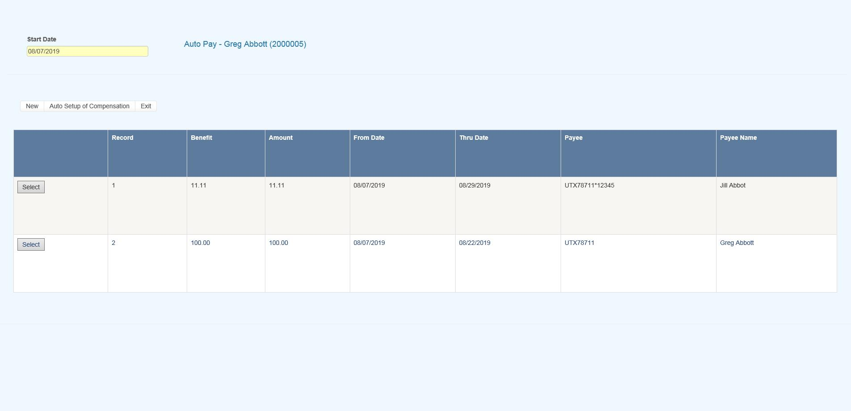
Figure 6-1: AutoPay Screen
Depending on how the claim has been set up, the following buttons may be used.
Button | Function
Edit | Displays the selected payment record for viewing and/or editing purposes. If the list is empty, this button will be disabled.
New | Displays a blank form so a new record may be entered.
Auto Setup | Sets up a new payment schedule automatically. This button will be disabled if there is a Start TD or Start PD Date in the claim.
Close | Exits to wherever you started, either the claim or the Selected Claim menu.
There are two ways of scheduling new payments. Each method will be covered in this section.

Using the Auto Setup of Compensation Button
The Auto Setup button is available for setting up the benefit period. It will be enabled for indemnity claims that have a specific Benefit Rate, but no benefit payments (i.e. the Start TD and Start PD Date fields are both empty).
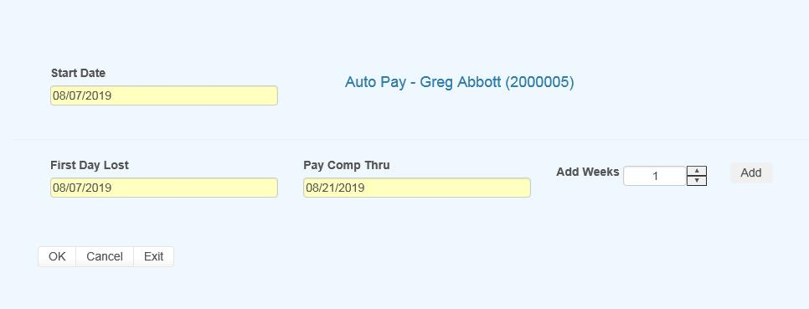
Figure 6-2: AutoPay Setup
Selecting the button will prompt for the compensation period. The First Day Lost will be displayed if the date exists in the claim record. Enter the date when the period will end. It can always be changed later. If you don’t know the exact date, add the number of weeks to be paid and click the Pay Comp Thru field to update the ending date.
Click OK and the program will set up the payment schedule as shown in the following example.
In addition to the information found in the claim record, the program will search the various tables to find the default values for the Pay Code, State Days, and Waiting Period when the Auto Setup of Compensation feature is used. (All of the fields will be covered next.)
If the program finds all the required information and the Pay Day value for the employer is set to something besides any day, then the only thing left to do is save the record. Otherwise, the date for the Next Check must be entered before the record can be saved.

Using the New Button to Schedule Payments
If you use the New button, normally the information on the form will have to be entered manually. The fields are described as follows:
Field Name | Description
Record # | The default is “1” for the first payment schedule. Enter “2” to indicate a 2nd one.  A total of nine records may exist at any one time. Records no longer appear on the list after the last payment has been made.
PMT Type | The payment type is either checks or vouchers. If necessary, a system administrator may change the default value.
Payee ID | The payee’s social security or federal ID number. Enter "C" if the payee is the claimant, "D" for a dependent receiving alimony or child support, or press the Ellipsis button for a list of vendors.  If this is a fatality case, we recommend that you enter the individual who will receive the death benefits as a dependent to make it easier to schedule payments.
Payee | The name of the payee will be filled in automatically after reading the social security number or vendor code in the previous field.
2nd Payee | The name of a second payee if any. For example, if the employee's check needs to go to a legal firm for disbursement, the c/o name should be entered here.
Address, City, State, Zip, Phone | The address and phone information will be filled in automatically after reading the record with the specified social security or federal ID number.
RSV Cat | The reserve category to be used. The Auto Setup feature will enter “Indemnity” by default. Press the Ellipsis button for a list of other categories that are available on your system.
Pay Code | The payment or cost center code. Press the Ellipsis Button for a list of codes that are available for the specified reserve category.  If the Auto Setup button is used, the program will use the Benefit Type code specified in the claim record to look for the default code set up with the Administer-Configure-Application Parameters menu.
Rate | The employee’s benefit rate. If an amount has been entered in the claim record, it will be displayed here automatically. (A benefit rate must have been entered in the claim in order to use the Auto Setup feature.)
Work Comp From | When the Auto Setup of Compensation button is used, the program will calculate the starting date based on the First Day Lost and the days in the state's waiting period, otherwise it must be entered manually. In either case, the From Date will be adjusted as payments are made.
Work Comp Thru | The day benefits should end. The program that batches the payments will generate "Next to Last Payment" and "Last Payment" diaries to warn the adjuster that the claim should be reviewed. This date may be modified if the payment period needs to be shortened or extended.
Wait Period From/Thru | When the Auto Setup of Compensation button is used, the program automatically calculates the From and Thru dates based on the Waiting Period and Before Paid values in the record for the claim's state of jurisdiction.  This feature will not work correctly if the values in the state's record are incorrect. If for some reason, you do not want the program to calculate the waiting period payment, zero out the values for the state.
Pay Period | The Auto Setup feature will automatically enter “B” (bi-weekly) as the Pay Period.  Other valid entries are “W” (weekly) and “M” (monthly).
Benefit Type | The benefit type from the claim record, either “TD” (temporary disability), “PD” (permanent disability), or “VR” (vocational rehabilitation).
PMT Periods | The total number of payments to be made will be calculated after you have entered the pay period and from/thru dates. This value can not be modified. It will be updated automatically as payments are made.
Original From | The Comp Period From Date will be updated as payments are made, but the original date is displayed here for your information.
Next Check | The date of the next payment. This date will appear as the first Batch On date on the list of future payments. (See below for details.)
Prior Check | The date of the last payment that was batched.

Saving a Payment Schedule
When the record is saved, the program will check the claim to verify that there are sufficient reserves to make the payments. If there aren’t, you will be prompted to increase the reserves accordingly.
AutoPay creates the payment schedule and displays it on the screen as it saves the record. This particular example was created to batch the payments after the pay period (AutoPay Mode set to A) and the employer’s Pay Day set to any day. (Refer to the Setup Procedure in a later section.) The Next Check date is used as the first Batch On date. This is the most typical configuration.
Note the first payment on the list is for the waiting period. In the state of jurisdiction for the claim, there is a 14 day period before those days can be paid.

Calculating the Last Payment
Typically, the Comp Thru Date does not fall at the end of a pay period so the last payment is only for a few days. When that happens, the program will check the Scheduled Hours in the claim record.
If there are no Scheduled Hours, AutoPay assumes that the individual works a regular week and calculates the payment accordingly. But, suppose the employee works Monday and Wednesday through Saturday. (Work days are those which contain a value in the Total field on the Scheduled Hours dialog.) If the Thru Date falls on a Wednesday, the program will know that the employee does not work on Tuesday and only pay for two lost days.
The program that batches the auto payments will generate a diary to the adjuster when the next to the last and the last payments are batched.

Batching Auto Payments
The Autobat program must be run to batch payments according to their Batch On date. AUTO will be stored as the user who processed the transaction. Although the reserves must be sufficient to schedule the payments, the reserves may have been used up since then.
Auto payments will always be batched because of a possible late penalty. When the reserves are insufficient, the program checks the Stair Step Reserves value entered with the Application Parameters. If it is either "Closed" or "All", the reserves will be automatically increased to cover the payment. Unless Negative Reserves has been set to “N”, the futures will become negative. In any case, a diary will be sent to the adjuster.
Auto Batch logs may be viewed with the Image Files menu. When appropriate, "Next to Last Payment" and "Last Payment" entries will appear along with a diary telling the adjuster to review the claim.
The number of OSHA Days in the claim is updated as payments are batched against reserve categories 1 and 3 (indemnity and rehab) for pay codes with “TD” in the Grouper field. This number is based on a calendar week.

Setup Procedure
The system administrator must set up AutoPay so payment schedules are created to meet your particular needs. When the record is saved, the program will check the Pay Day and AutoPay Mode values as defined below.
Item | Set In | Value
Pay Day | Employer’s record | Sunday thru Saturday or Any Day
AutoPay Mode | Application Parameters | Standard (sets the first Print Date to the first Pay Day at the end of the pay period)  After (sets the first Print Date to the first pay day after the pay period ends)
When the Auto Setup of Compensation feature is used and Pay Day is set to a specific day of the week, the program will ignore the Next Check date, if one exists, and use the AutoPay Mode to calculate it and the subsequent Print Dates (displayed with the List option). Changing the Next Check date will have no effect.

