Medical Fee Module
The Medical Fee module is an optional add-on feature designed to prevent medical overcharges. Each line item on the invoice is reviewed based on the state’s fee schedule, the DOL’s OWCP schedule, and/or the Usual and Customary Reimbursement (UCR) value depending on the set up. A vendor’s custom fee schedule may also be used. The UCR module is an optional feature and not part of the standard ATS/Comp Medical Fee product. Bundling and unbundling is another optional feature that is available. The data to implement any of these features is available from a third party.

Making a Payment
Fields on the entry screen:
Field Name | Description
Form Type | The type of payment, either check or voucher.
Invoice Number | The invoice number being paid.
Invoice Date | The date of the invoice.
Received Date | The date the department received the invoice may be entered for accounting purposes
Mode | The status of the payment can be Batch to be printed/exported later, Notate which writes the payment record to check history with a specified form number and processed date, or Hold which causes the data entered to be saved without creating a payment record so that it can be edited later. Hold is often used with importing medical payment data so that the users can review and edit data before batching for payment.
Image ID | Optionally links the payment to bill images in our electronic filing cabinet.
Note | A note to be displayed on the check or voucher.
Payee ID | The ID of the vendor, claimant, or dependent being paid.
Separate Handling | If checked, the payment will not be combined on the same printed check for payments made to the same vendor.
ICD Codes | The ICD code(s) from the invoice A-L.

Field Name | Description
Service Zip | By default, the vendor’s zip will be used to set the service zip code for where the service was performed. This zip code will not only determine which fee schedule is used, but also the tax rate if tax is to be applied as in New Mexico.
Inpatient | A check indicates that the employee has been admitted in a facility and treated as an inpatient.
Line Item | The number of the line item. Use the arrow keys to enter another item or review a previous one listed in the grid below.
Service From/Thru | The starting and ending date of the billing period. (The default ending date is the same as the From Date.) These dates will determine which particular fee schedule to use. (It must be after the open date on the claim.)  For your convenience, the previous From/Thru dates will be displayed as you enter new line items.
ICD Reference | Letters A-L to specify which ICD codes applies to the specified CPT code for the line item.
Code Invoiced | The CPT code for the item. Normally, this must be a valid code (in the fee schedule) in order to continue. The exception is “00000”, which may be used to enter a miscellaneous item that is not found in any fee schedule.
Modifiers | Up to three modifiers may be applied to the CPT code.
Specialty | When there is a specialty associated with the CPT code, it may be selected from a list of choices by clicking the Ellipsis button.
Qty | The number of units billed for this line item.
Invoiced Amount | The amount billed for the procedure.
Accepted Amount | The Maximum Reimbursable Amount (MRA) is used if it is less than the amount invoiced. As the amount of each line item is accepted, the total value in the Payable field will be incremented.  Note that if the Bundling/Unbundling feature is in use, the program will check for major or comprehensive procedures that consist of a number of individual procedures. For example, the CPT code 31505 (larynoscopy diagnostic) consists of many other procedures, one of which is 36000 (microsurgery add-on). If both are on the same bill, the program will detect that the "code 36000 is part of the comprehensive procedure code 31505" and enter ZERO in the accepted amount for line 36000. The program will also look for mutually exclusive procedures (e.g. 27177 and 11010) that are not allowed on the same bill.
Override | An override code to explain why the amount to be paid is different than the amount billed. Press the Ellipsis button for the user-defined choices, which are maintained from the console Maintenance menu item.
Futures | The amount available in the claim’s (future) medical reserves. See below for details when the amount is insufficient to cover the payment.
Total Payable | As line items are entered and accepted, the program will adjust this value accordingly. When the record is saved, this amount will be used to update the paid to date and future reserves in the claim.
Rate Table | The program will display the name of the fee schedule table in use.

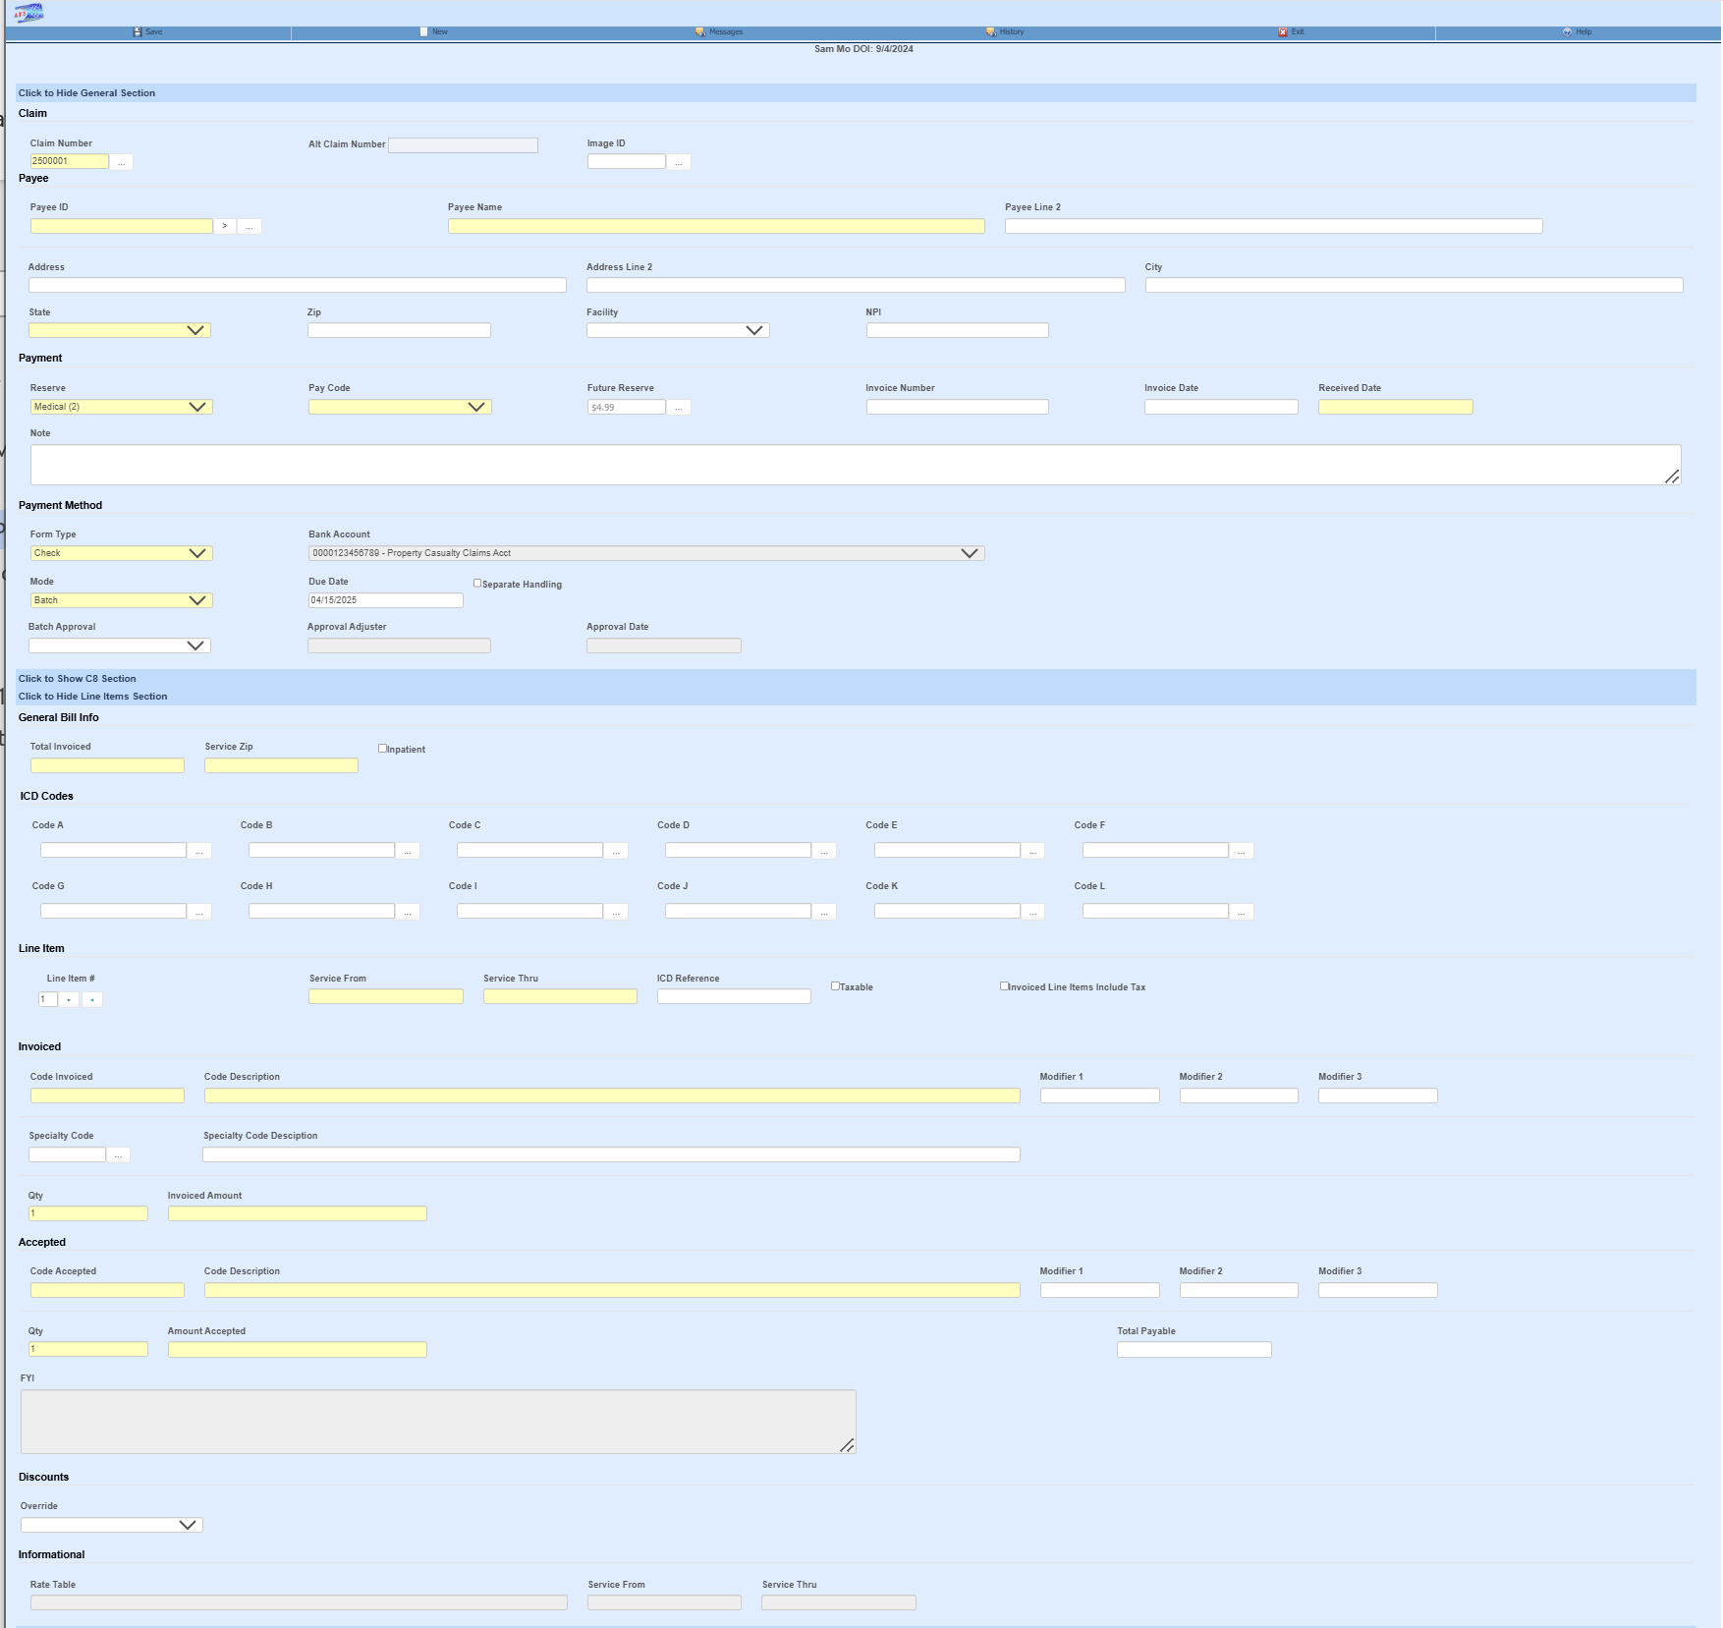

As the user enters line items, they are displayed in a grid at the bottom of the screen. The Line Item # field determines which item is currently being edited. By default, when a new line item is entered, the previous From/Thru dates will be copied to the new record and can be modified if needed.

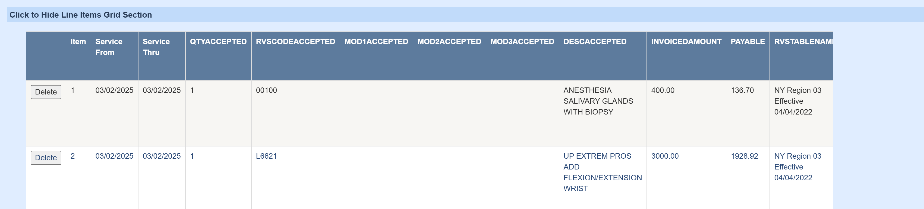

Payee Selection
The three-dot button brings up a dialog with options to select a payee. The Search Vendors option brings up a search list of all active vendors. Vendors from the claim screen will be shown as options if filled in on the claim such as the Claimant and Defense Atty. If this claim has prior payments then the most recent and most used vendors will be selections as well.
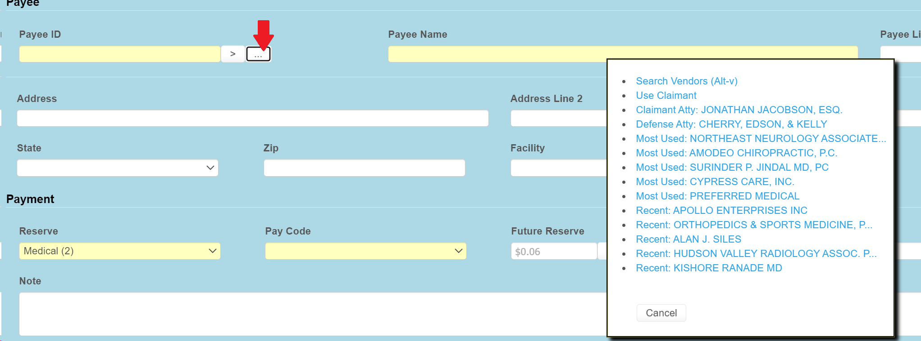

If the fed ID is known, it can be entered in the Payee ID field and the first vendor record found with that fed ID will be filled in. If there are multiple vendor records with the same fed ID, then the greater than sign button can be used to the fetch the next vendor record for the same fed ID. In this example, Payee ID would become 77-0683170*016 if the button is clicked, then if clicked again 77-0683170*099…
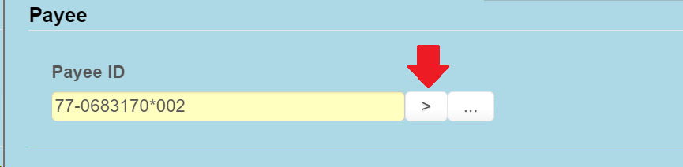
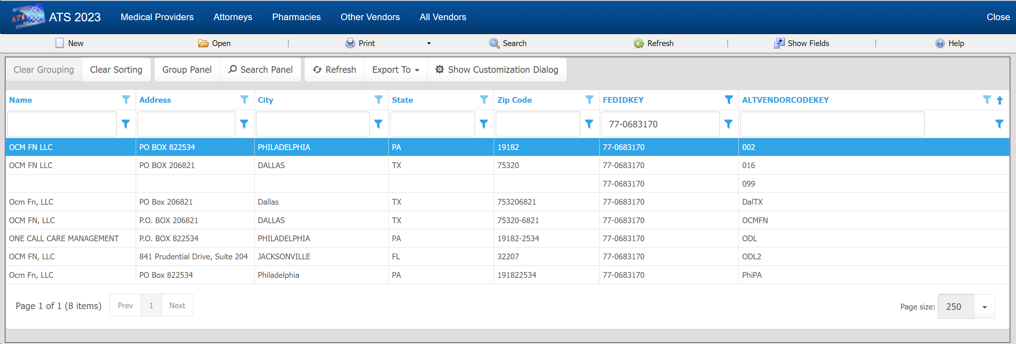

Discounts

The user defined Override dropdown list is used to give a reason for the amount reduction of the billed line item.

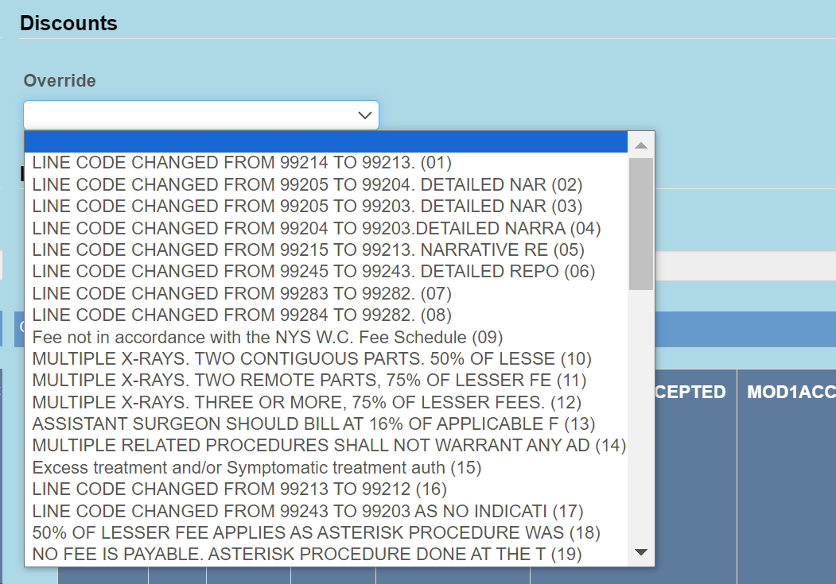
Optionally, if a list of codes are provided to ATS, then these line item discount fields can be added to the payment screen. These fields will not appear on the screen otherwise.
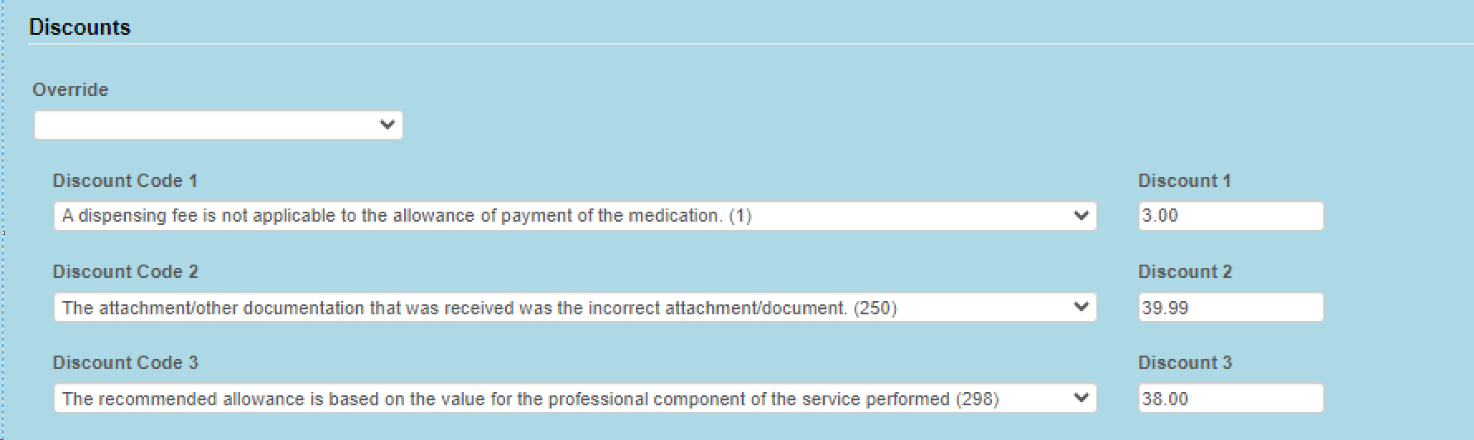

C-8.4/C-8.1
For NY an optional screen will be available to enter data for the forms C-8.4 and C-8.
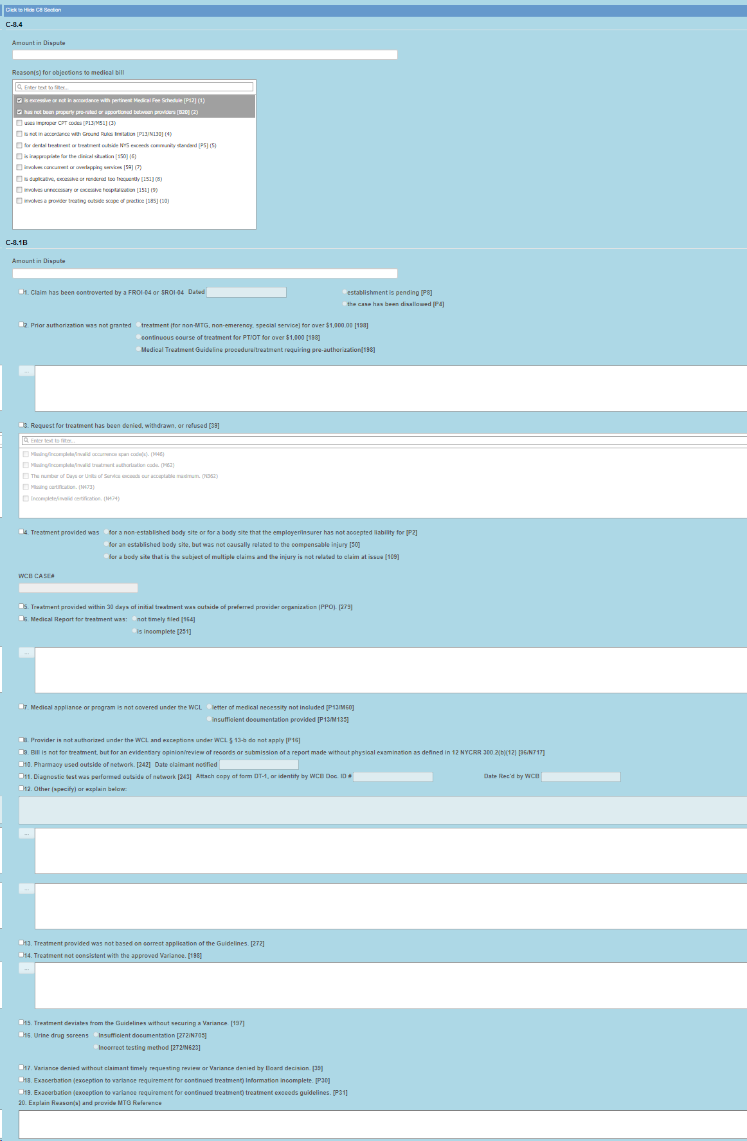

Fee Reduction
The record of the vendor being paid will be checked for optional HMO/PPO from/thru dates that cover the service dates in the payment record. If found, it will use the HMO/ PPO’s record for the allowed amount rate. If no HMO/PPO, then the optional UCR percentile for the vendor’s zip code is checked.
3. If the Override State flag has been set with the Module Parameters menu, the program will calculate the amount of the line item using both of the above methods and display whichever amount is lower.
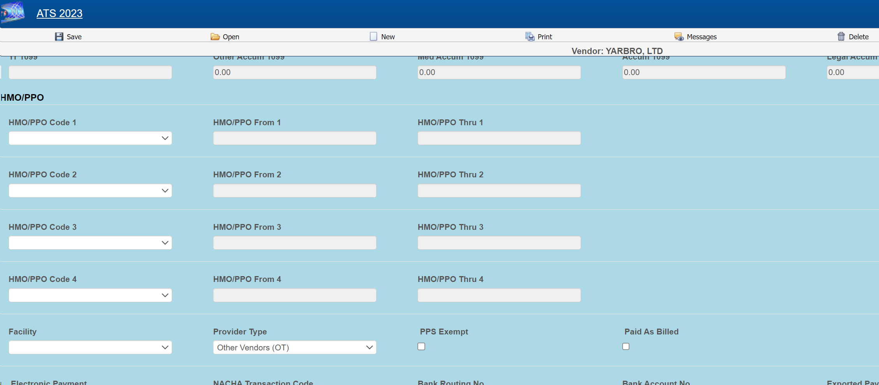
When this optional feature is in use, the program will check for mutually exclusive procedures (e.g. 27177 and 11010) that are not allowed on the same bill. It will also look for major or comprehensive procedures that consist of a number of individual components or procedures. For example, the CPT code 31505 (larynoscopy diagnostic) consists of many other procedures, one of which is 36000 (microsurgery add-on). If both are on the same bill, the program will detect that the "code 36000 is part of the comprehensive procedure code 31505" and enter ZERO in the accepted amount for line 36000.
The ATS system supports multiple fee schedules; federal (DOL), state, and the usual and customary reimbursement (UCR) schedule. In that case, the program will display the amounts in the different schedules so the user can make a selection.
Discounts and/or custom fee schedules can also be setup for specific vendors. (Without this ability to use custom schedules, invoices for vendors that use their own service codes could not be reviewed.) After custom schedules have been setup, their use is transparent during data entry unless the code on the invoice is found in multiple schedules.

Saving the Record
During the save process, future medical reserves will be verified. If the futures are not enough, the program will check the Negative Reserves value set with the Module Parameters menu.
If the Negative Reserves check box is set, then the payment entry is allowed and the future reserves in the claim will become negative, which is not how systems are typically opted to set up. If the check box is not set, then the program will check the Stair Step Reserves value that was set using the Application Parameters screen.
If the Stair Step Reserves value is set to ALL or Closed Claims Only for a closed claim, then the amount incurred in the claim will automatically be increased to cover the payment. Otherwise, the button next to the Future Reserves field on the payment screen can be used to increase the reserves. All changes depend on the operator's reserve limit.
The field labeled Mode determines if the payment will be batched, notated to check history or left on hold to be finished in the future. Although if batch or notate are selected and the payment amount is over the operator’s limit then the payment will be pended. Pended payments must be released by a user with authority to do so using the Batched Edit selection from the Process menu.
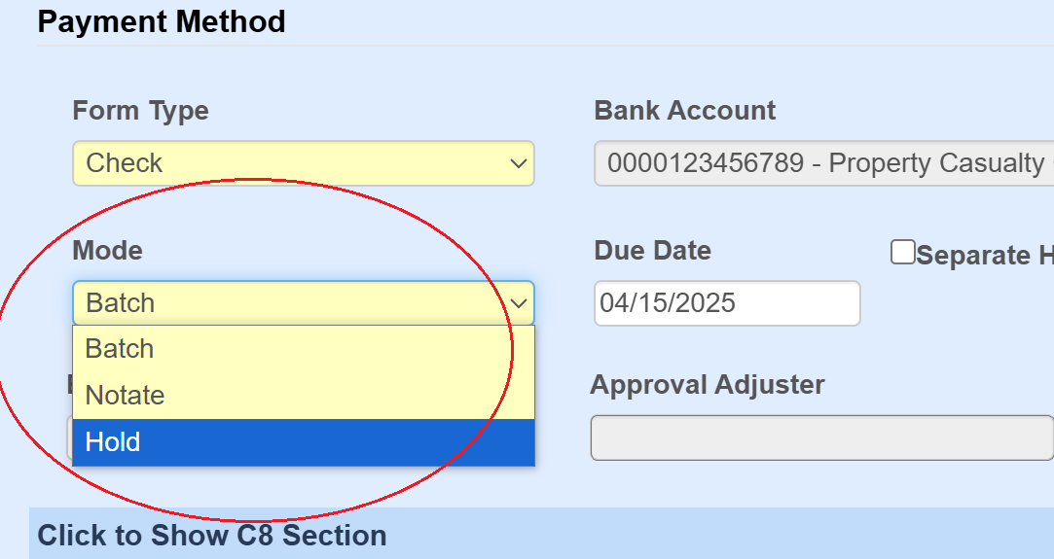

If the payment is put on hold, it can be accessed from the Medical Payments on Hold option on the claim screen or from the Medfee on Hold option from the ATS Process menu.
