About ATS Reports

Using the Menu



Home – List of available reports with an account selection and category selection.

Schedule View – List of Scheduled reports.

Imaged – List of Imaged reports.

About – Application information.

Add/Modify Report – Allows for Deleting, Adding and Category Changes.

Administer – Setup user groups for access to reports by category.

Note: User/Group Security may limit these menu options.

Home

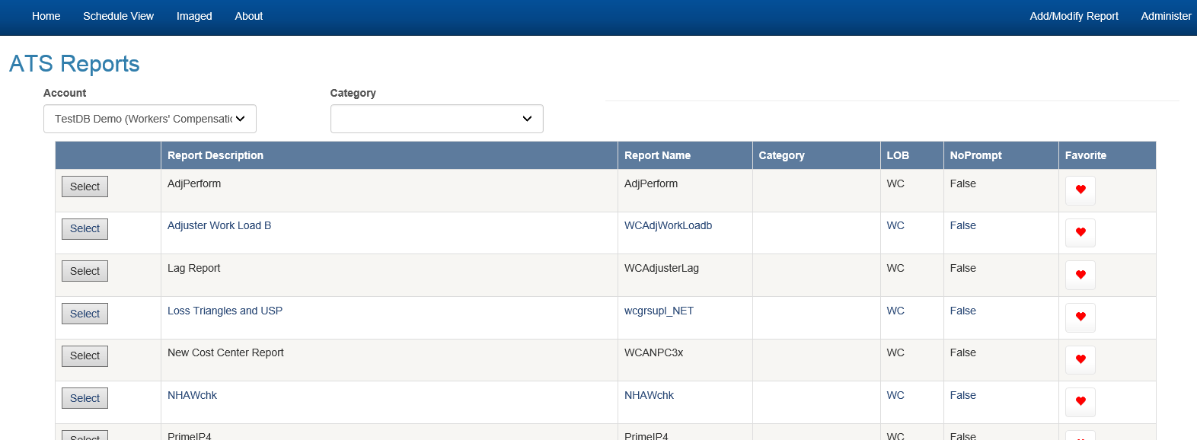

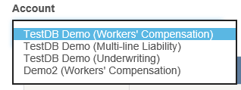

This dropdown for selection of the data sources available to the user to execute reports in.

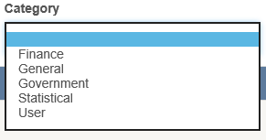

This dropdown allows for the selection of report categories the user can select to adjust the list of reports available to the user. Leave blank for a full list.

Grid (List of available reports)

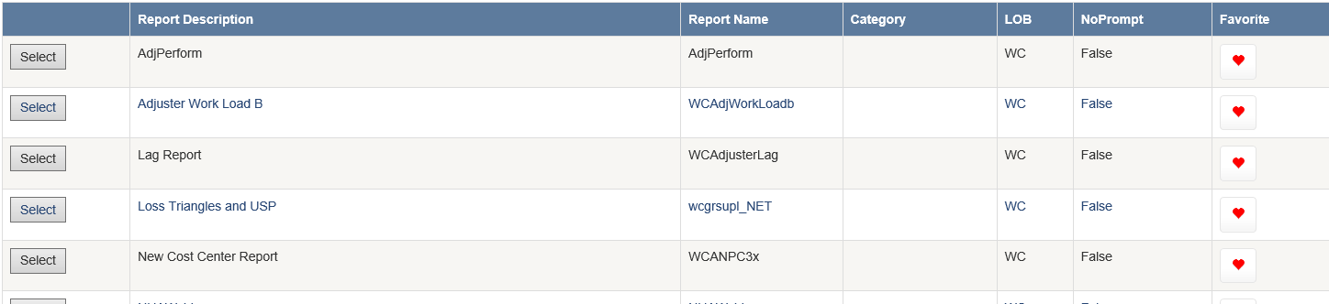

Use the select button to execute the desired report.

Click the favorite button for any report you would like to add to your favorites list.

Prompting Page

Once you select a report to run you will be directed to a page that shows you the available prompts associated with the selected report. Some reports are designated as “NoPrompt”. In this case the report either has no prompting or the report will do it’s prompting.

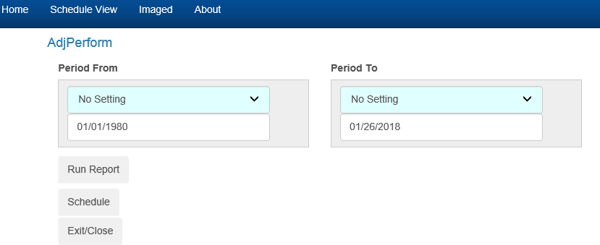

Prompts

Each prompt will default to values specific to the report. Each report allows you to set values and date fields allow for special settings.

Dates

If you click in the setting portion of the control you will be presented with a dropdown list of options. These date options allow for defaulting to various known system values such as the date the report runs, beginning/end of the month, quarter, year, and so on…

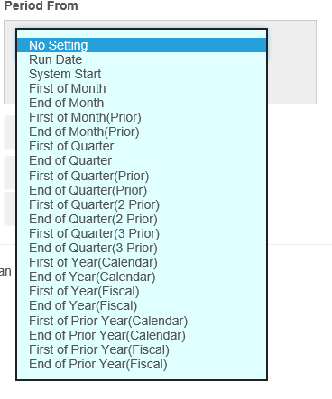

Buttons

Run Report – Executes the report

Schedule – Launches the Schedule report dialog for the selected report. (Select all default options prior to scheduling the report)

Exit/Close – Returns you to the Home page of the report module.

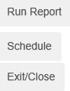

Run Report

Once in a report you can page though the report, use the find option, print or export the report.



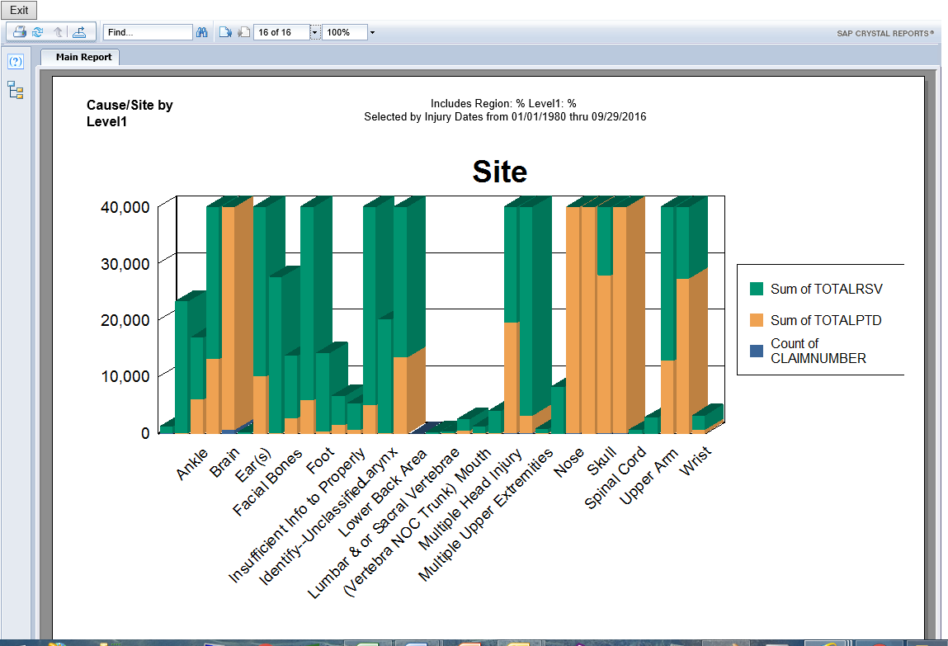

Schedule

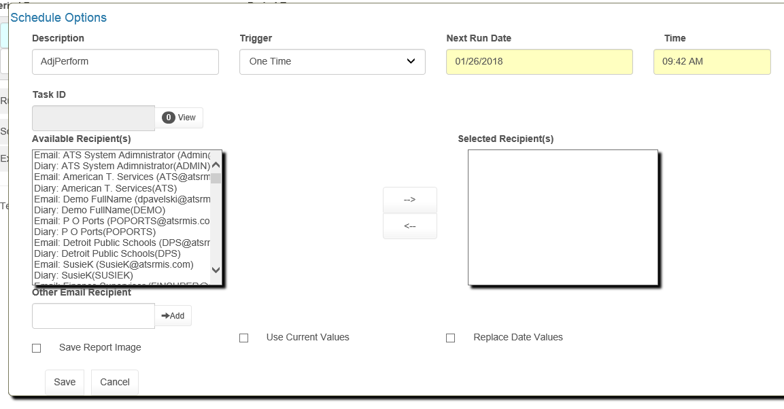

Once in the report schedule dialog you can select a trigger (when you want the report to execute), select recipients to receive the report via ATS diary or email, Save the report to Image for system retention, Use the current values (defaults you set on the prior prompting page) by checking this option, and replace dates at runtime based on report defaults or the settings for the date that you selected for the dates.

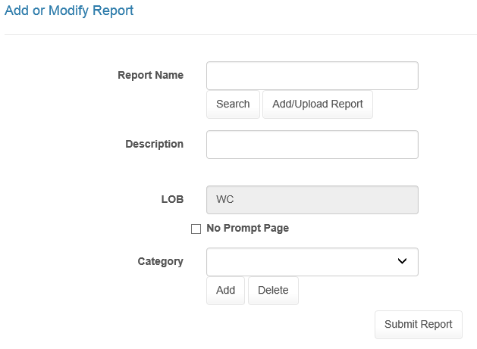

This Page allows you to Add, Delete or change the prompting and category settings.

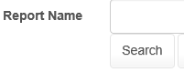

Pressing the Search button will bring up a list of the systems reports. Select brings you to the add/modify page for the selected report and delete will remove the report from the list.

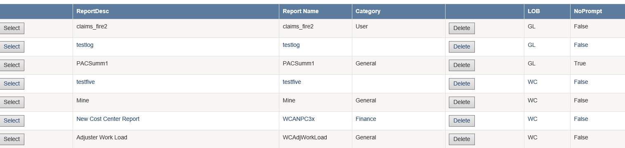

Add/Modify edit page (with report selected)

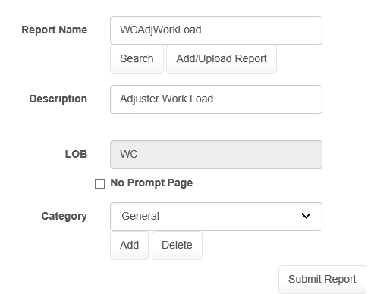

Checking the No Prompt Page checkbox will cause the system to allow the report to use the report writer’s native prompting if any prompts exist in the report.

Clicking the Category dropdown will allow you to set the report’s category.

The Add button under category allows you to add a new Category. Delete removes the category selected.

Use the Submit Report button when you finish the changes you want to save.

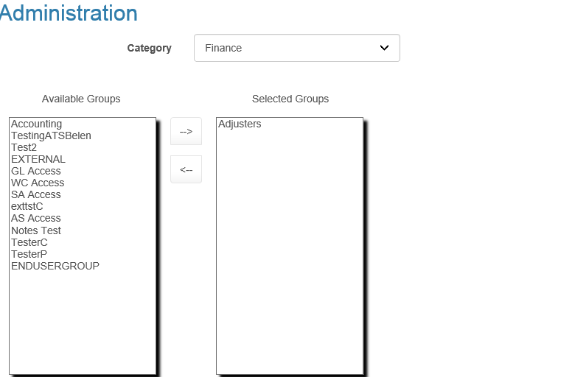

This page is only available to users designated as administrators (see security).

This is page allows, by category, the ability to add/remove user groups for specific report categories.