## The ATS Console

The main window that appears after login is referred to as the ATS Console because console is a synonym for "control panel". Regardless of whether you use one or all of the ATS products, the ATS Console will appear as the primary access point for the system.

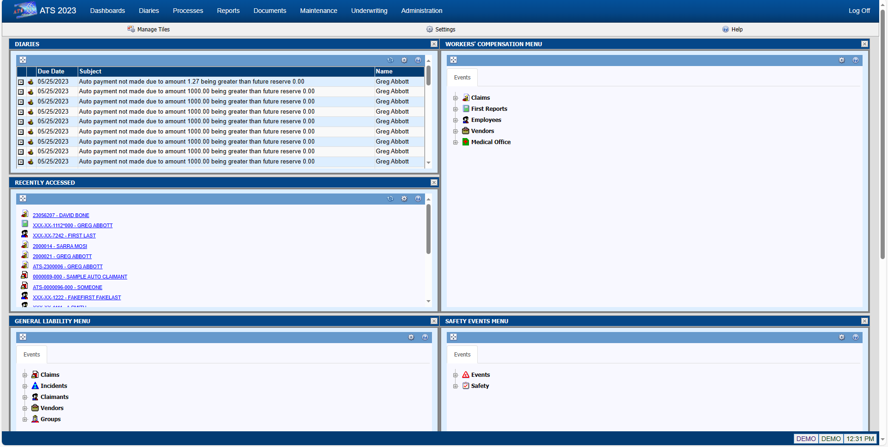

Figure ‑: ATS Console

The Console page consists of four (4) major components; the Menu Bar, the Toolbar, the Work Area, and the Status Bar.

### Menu Bar

The Menu Bar is located at the top of the page and provides access to major sections of the system, depending on your security settings.

The available menu options are as follows:

| **Menu Option** | **Description** |
| --- | --- |
| Dashboards | Provides access to interactive dashboards that provide analytical information about the contents of the database(s). |
| Diaries | Displays the workflow diary items for the user and, if a supervisor, the diary items of subordinates. |
| Processes | The functions that generally affect multiple claims simultaneously, such as reviewing payments in batch and/or printing them. |
| Reports | Provides access to a wide variety of reports that include claims analysis, statistical, financial, and more. It also provides access to a general purpose tool for performing ad hoc queries against the ATS database(s). Knowledge of SQL is required to use this feature. |
| Documents | A repository for documents related to claims, incidents, first reports, etc. Documents can be in a wide variety of formats, such as; Word (.doc/.docx), Excel (.xls, .xlsx), Adobe (.pdf), Text (.txt), Graphics (.jpg, .gif, .png, etc.) and many more. |
| Maintenance | Allows users to maintain the look-up tables that the system uses for organization codes, loss codes, etc. |
| Administration | The features that allow administrators to configure the system-wide options that affect how the system will look and function, and features that are used to maintain the security settings for Users and Groups. |

When you click any of the options on the Menu Bar it will open a new tab or window (depending on your settings) with the selected component.

### Toolbar

Toolbars in ATS 2019 contain tools, represented by icons and/or text, that provide access to processes and features associated with the current page or that act upon a selected item on the current page. The name of the current page is also displayed on the left side of the toolbar.

The following tools are available on the Console toolbar:

| **Icon** | **Tool** | **Purpose** |
| --- | --- | --- |
|  | Manage Tiles | Opens the tile selection screen to add or remove tiles from the work area. |
|  | Settings | Opens the settings dialog for the current screen. |
|  | Help | Opens the Help file associated with the current page. |

### Work Area

The Work Area of the Console page displays one or more Tiles. Each tile provides access to different information and functionality, such as; menus, claim lists, recently accessed items, diaries, email, system notices, graphs, statistics, and more.

The Work Area is fully configurable and you can modify it to meet your specific work requirements. The layout of the Work Area is like a grid. It can have from one (1) to five (5) columns and any number of rows. You can also set the width of each column.

### Status Bar

The Status Bar displays messages on the left side. The right side displays the name of the database that you are connected to and the name of the user that logged in.

### Tiles

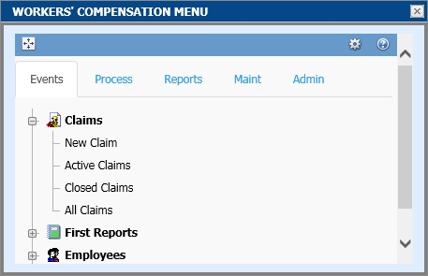A Tile is a small window that provides access to a particular set of functions. For example, Menu Tiles contain menu options that allow you to easily access a particular feature, such as entering a New Claim record or running a report. All tiles can be expanded to a full screen for easier viewing and, in some instances, additional capabilities.

The following lists various Tiles available with ATS/COMP that are available at the time of this writing; however, new Tiles are being developed as time goes on.

| **Tile** | **Tile Description** |
| --- | --- |
|  | The System Notices Tile displays general interest messages that have been created by authorized users and/or informational messages from the system, such as workflow task assignments and other reminders.  The expanded page allows you to view all recent messages or notifications. |
|  | The Open Claims Tile shows a list of all open claims that are assigned to the current user. Clicking on an item will open the associated claim record.  The number of entries displayed can be set by the user.  The expanded page shows the entire list of open claims assigned to the user. |
|  | The Recently Accessed Tile shows a list of the most recently opened claims for the current user, in reverse chronological order. Clicking on an item will open the associated claim record.  The number of entries displayed can be set by the user.  The expanded page shows the entire list of recently accessed claims. |
|  | The WC Reserves Dashboard Tile provides a quick view of the overall reserves set for the Workers’ Compensation claims in the system.  The expanded page displays an interactive graphical dashboard that provides more specific information on the reserves. |
|  | The WC Claim Types Dashboard Tile provides a quick view of the breakdown of claims by type for the Workers’ Compensation claims in the system.  The expanded page displays an interactive graphical dashboard that provides more specific information for each claim type. |
|  | The Open Claims Dashboard Tile provides a quick view of the overall number of currently open claims in the system, of each type.  The expanded page displays an interactive graphical dashboard that provides more specific information on the breakdown of each type of claim. |
|  | The Email Tile integrates with your email system to provide a list of current items in your inbox. Individual items can be opened and read. New email messages can also be created.  The expanded page provides access to a fully functional email manager that includes a calendar, task list and more. |
|  | The Diaries Tile provides a list of Diary/Workflow entries that are assigned to the current user. Entries are listed in chronological order by due date. Diaries can be opened, reviewed, marked as complete from the tile and new Diary entries can be created.  The expanded page provides a complete list of all diaries for the current user and, if authorized, show diaries for members of a group. |
|  | The WC Average Claim Cost Tile displays a graph that compares current, recent and historical cost data.  The expanded page shows a larger view of the graph. |
|  | The WC Injury Date Tile displays a graph that shows the frequency of injuries by month.  The expanded page shows a larger view of the graph. |
|  | The WC Indemnity Reserves Tile displays a graph that compares Reserves, Paid-to-Date, and Future Reserves for all open claims.  The expanded page shows a larger view of the graph. |
|  | The User Menu Tile allows you to create a menu that contains only the menu items you select. You can add as many or as few items as you choose, in order to make your job as efficient as possible.  The expanded page displays the menu in a larger area. |
|  | The Workers’ Compensation Menu Tile contains all available menu items for the module.  The expanded page displays the menu in a larger area. |
|  | The WC Events Menu Tile contains only those menu items that are located on the Events tab of the Workers’ Compensation menu.  The expanded page displays the menu in a larger area. |
|  | The WC Processing Menu Tile contains only those menu items that are located on the Process tab of the Workers’ Compensation menu.  The expanded page displays the menu in a larger area. |
|  | The WC Report Menu Tile contains only those menu items that are located on the Reports tab of the Workers’ Compensation menu.  The expanded page displays the menu in a larger area. |
|  | The WC Maintenance Menu Tile contains only those menu items that are located on the Maint tab of the Workers’ Compensation menu.  The expanded page displays the menu in a larger area. |
|  | The WC Administration Menu Tile contains only those menu items that are located on the Admin tab of the Workers’ Compensation menu.  The expanded page displays the menu in a larger area. |