# Dashboards

The ATS System provides a dynamic dashboard system that provides the ability to view information in graphical format with drill-down capabilities. Dashboards can be configured to display directly on the Console and then expand to the full screen when desired. Dashboards can also be accessed via the Dashboard option on the Console menu bar.

## Viewer

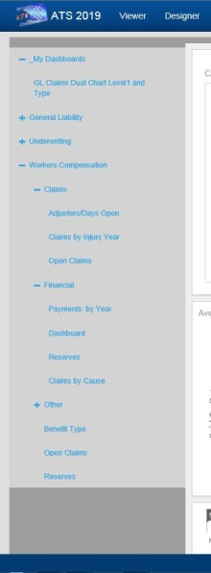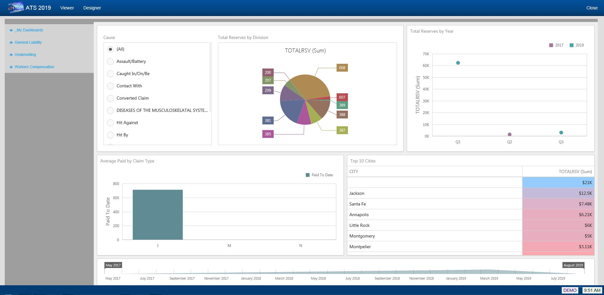   
Figure 11‑1: Dashboard Viewer

The Dashboard Viewer allows you to display interactive dashboards that operate on data in real time. Subsets of data can be selected and clicking on specific identifiers within the display will automatically cause the other portions of the screen to display data based on the specified identifier.

The left side of the viewer contains the menu of available dashboards. The menu is broken down by Line of Business and then by category, such as Claims, Financial, etc.

The My Dashboards section of the menu contains any dashboards created by you with the Designer.

## Designer

The Dashboard designer allows authorized users to create new dashboards that report on information that is meaningful to them.

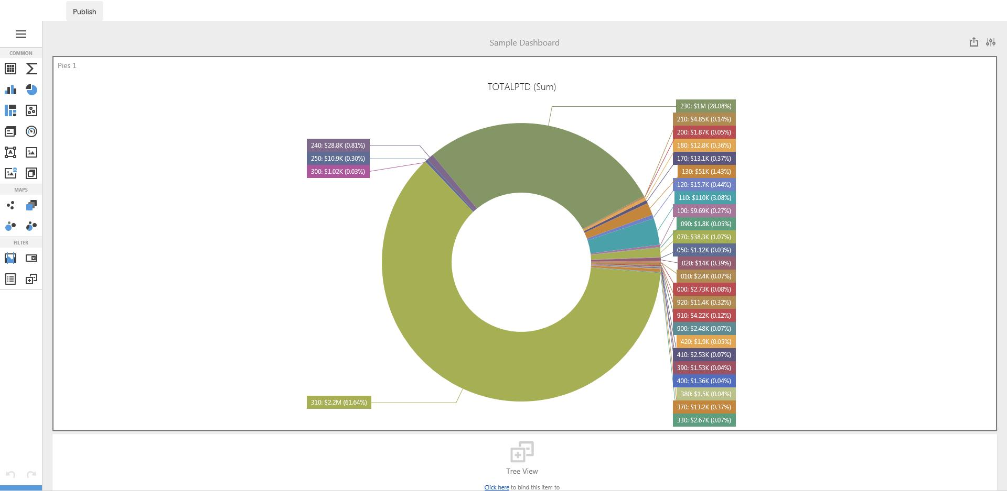   
Figure 11‑2: Dashboard Designer

In addition to the web-based designer, a more robust Windows version is available