## Entering a New Dependent

There are a number of reasons for creating dependent records. Some of them are:

1. The employee was a Medicare beneficiary and is now deceased. Dependent records must be entered for any “Additional Claimants” that need to be submitted to the CMS (Centers for Medicare and Medicaid Services).
2. The individual wants to attach a lien to the employee’s payments or be considered when calculating the benefit amount for a claim.
3. The individual is the employee’s beneficiary and entering the person as a dependent will simplify the payment process for a fatality claim.

To enter a new record or modify an existing one, click the Dependents button to display the Dependents List.

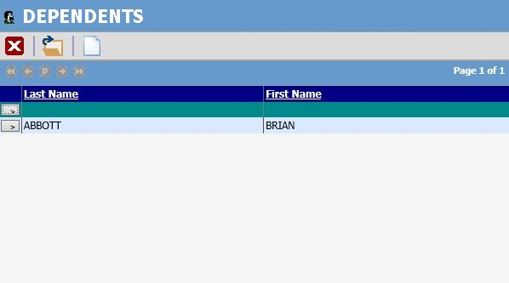

Figure 2‑6: Employee Dependent List

Click on the new button. The following screen will appear. Enter all pertinent data and then click Save. The dependent record is now available to use.

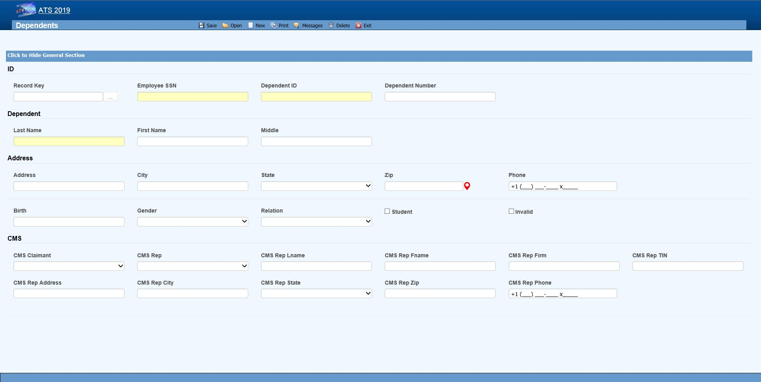Figure 2‑7: Employee Dependent Data Input

The fields on this screen are described as follows:

| **Field Name** | **Description** |
| --- | --- |
| SSN | A valid SSN should be entered for the individual. |
| Last Name  First Name  M.I | The complete name if the dependent is an individual. If the dependent is an estate, enter “The Estate of <employee>”, “the Family of <employee>” or “The Trust of <employee” depending on the entry in the Relationship field. In any case, leave the other name fields empty. |
| Address | The individual’s address, city, state, and zip code |
| Phone | The individual’s phone number. |
| Birth Date | The individual’s birth date is important if the state of jurisdiction for the employee’s claim has an age limit for tacking deductions for dependents (when calculating the benefit rate). |
| Gender | The individual’s gender if relevant. |
| Relationship | The dependent’s relationship to the employee. The valid options are:  F = Family Member, Individual Name Provided  O = Other, Individual Name Provided  X = Estate, Entity Name Provided (e.g. "The Estate of John Doe")  Y = Family, Entity Name Provided (e.g. "The Family of John Doe")  Z = Other, Entity Name Provided (e.g. "The Trust of John Doe") |
| Student | A check indicates that this individual is a student. |
| 100% Dependent | A check indicates that the dependent is to continue being on a claim’s eligible list regardless of age. |
| Additional CMS Claimant | This number from C1 to C4 must exist in the record in order for the dependent’s data to be submitted to the CMS. |
| Type of Rep | The type of representative for the dependent. Valid choices are:   * Guardian/ Conservator * Attorney * Power of Attorney * Other |
| Name  Address... | The rest of the fields for the representative are self-explanatory. |

Saving a new record (or deleting an existing one) will update the # of Dependents for the associated employee.