1. **Finance**

Operators with the appropriate authority can handle any financial operation regarding a claim. The transactions will be covered in the following order:

* Making General Payments
* Entering Recoveries
* Scheduling Auto Payments
* Voiding Payments
* Changing Reserves
* Editing Batched Payments
* Issuing Credits
* Using the Bill Review Module

**Making General Payments**

If you are in Explore, you can make payments without actually opening the claim. Simply select the desired claim and click the General Payments button. The button is also available if you are already editing a claim and want to make a payment.

Knowing that some bills arrive after a claim has been closed, the ATS System has a special Stair Step Reserves feature that may be set so you can make a payment without having to reopen the claim.

The future reserves are always displayed for your convenience, but the bank account number and the balance in the trust will not appear if you are creating vouchers. (The number of reserve categories and their names will depend on how your ATS System has been set up.)

On the upper right side of the screen, you’ll see a special field that displays the claim number with an ellipsis button to the right. This field allows you to enter multiple payments rapidly by saving the payment, typing the next claim number in this field, entering the next payment and saving. The ellipsis button provides a claim search function if you don’t have the claim number available.

The example above shows an indemnity payment that was set up by simply clicking the Ellipsis button next to the amount. Refer to the fields below for information on this feature. The fields are described as follows:

| **Field Name** | **Description** |
| --- | --- |
| Pay Type | The payment type is either voucher or check. Note that checks debit the trust fund (bank account) balance, but vouchers do not.  The record shown above will produce a voucher so the number of the trust fund account and the balance in the account are not displayed at the bottom of the screen. This information will appear if you produce checks. |
| Amount | The amount to be paid. A special feature allows you to make an auto indemnity payment by pressing the Ellipsis button. The program will automatically display the amount, the employee’s name and address, the default From/Thru dates and “1” in the reserve category field. A default pay code may also appear. (The defaults are set with the Administer-Configuration-Application Parameters menu.)  If there is a negative account balance, you may get a "Bank Balance Insufficient" message depending on a setting entered with the Administer-Configuration- Module Parameters menu. When this message appears, the amount will be reset to zero.  Another setting may allow you to enter a batched payment with a negative balance. Attempting to print a payment or enter a notation will display the message "You may only batch this payment due to low funds".  If you are using the Stair Step Reserves feature set with the Administer- Configuration-Application Parameters menu, the reserves will automatically be increased to cover the payment. |
| Vendor Code | If the payee is any of the following, enter the code and the program will fill in the information from the claim.  C claimant  D dependent (a choice list will appear)  CA claimant’s attorney  DA defense attorney  P medical provider  Otherwise, enter the vendor code including the asterisk and location or press the Ellipsis button to select a vendor from the table. |
| From/Thru Periods | The dates for up to three billing/payment periods may be entered. Pressing the Ellipsis button next to the amount will display a period based on the Thru date for the last indemnity payment and whether the Benefit type for the claim is “TD” or “PD”. By default, these are two week periods, but the values may be changed with the Administer-Configuration-Application Parameters menu. If the From/Thru period is changed for an auto calculated indemnity payment, the program will display a message explaining how the benefit amount was recalculated and ask if the amount should be adjusted.  When a future date has been entered, the program will display “Warning: Date entered is greater than today’s date” on the title bar. Depending on your check printing schedule, you may need to enter future dates. In that case, ignore the warning message when it appears.  Back and post-dating payments may be allowed depending on the settings entered with the Administer-Configuration-Module Parameters menu. Note that it is very important to be able to back-date a notated payment that was printed on a prior date. The post-dating feature is also useful since it allows payments to be entered for printing sometime in the future when you may or may not be in the office (e.g, on vacation). |
| Reserve Cat | The code for the reserve category that the payment will be drawn against. If the payee is a vendor with a default reserve category and pay code, these values will be displayed on the screen automatically, but they can be modified. |
| Wage Continued | If the Wage Continued flag is set in the claim, the message “Warning - Wage Continued” will appear to remind you that an indemnity payment is being made to an employee who is receiving his or her salary in lieu of worker’s comp benefits.  A message will also be displayed when auto payments have been scheduled for that period.  Unless the Negative Reserves value has been set to “Y” with the Administer- Configuration-Module Parameters menu, the amount to be paid may not be more than the future reserves for the specified category. If the amount is higher, the program will read the Stair Step Reserves value set with the Administer- Configuration-Application Parameters menu. If the value is “N”, you will be given an opportunity to edit the reserves and increase the amount so the payment may be issued. For example, “Futures insufficient by 286.00. (Use the Change Reserves icon on the tool bar.”  If Stair Step Reserves contains an “A”, the incurred amount will be automatically increased by the amount of the payment. A value of “C” will increase the reserves for closed claims only. In both cases, the future reserves will still be zero after making the payment.  Refer to the Editing Reserves section in this chapter for more information on this process. |
| Payment Code | The payment or cost center code for the specified reserve category. Default codes for auto TD or PD indemnity payments may be set with the Administer- Configuration-Application Parameters menu. |
| OSHA Days | When making a payment to the employee from reserve category 1 or 3 (indemnity or rehab), the program will check the contents of the Grouper field in the specified Payment Code. If this value contains “TD”, then the From/Thru days are used to calculate the OSHA Days based on a calendar week. This value will be displayed on the screen and added to the existing values in the claim record.  There will be times when an employee performs another job or the same job with restrictions due to an injury or illness. If the job pays less than the usual, the employee should get a comp payment to make up the difference. In that case, it is very important that the temporary disability payment is made with a pay code that contains I08 (wage loss) in the report category so the days in the From/Thru period will be ignored when reporting to OSHA. If this feature is not used, the days would be counted as lost time when the employee is really at work. |
| Note | An optional note or memo to be displayed on the check/voucher. |
| Status | There are three choices:   1. Batch the payment record so that it can be printed later or exported with the Accounting Interface module. 2. Notate payments that were issued without using the ATS System. For example, suppose a check is lost. After voiding the original payment, enter a notated payment with the same date. 3. Click the Print button if you want to print the payment immediately. |
| Form Number  Process Date | When the Status is Print or Notate, the program will make these fields available and fill in the form number and current date which can be changed if necessary.  This is a handy feature when the original payment was incorrect (e.g. has the wrong reserve category) and has to be voided. You can’t batch another payment because the check has already been cashed. In this case, you will need to enter a notated payment  Note that the next check number is stored in the bank information entered with the Trust Fund menu while the voucher number is in the client’s record. |
| Due Date | The Due Date field is available when the payment is to be batched. If there is no specific date, leave the field empty so the payment will be included the next time a batch is printed.  Back and post-dating payments may be allowed depending on the settings entered with the Administer-Configuration-Module Parameters menu. Since the Print Batch program asks for a due date, the post-dating feature allows you to enter payments to be printed in the future. It is also important to be able to back- date a notated payment that was printed on a prior date. |
| Separate Handling | If the Separate Handling box is checked, the payment will not be combined with other payments to the same vendor. Checking this box also allows you to inform the accounting department (when the Handle Return File option in the Accounting Interface is used) that the check should be sent back to claims for special handling before it is mailed. |
| EDI Late Reason | Each state requires that the initial indemnity payment is issued a specific number of days after the date of injury. If this payment will be transmitted to the state via EDI, then select a code to indicate why the payment is late. Omitting the code may cause the state to reject the transaction. |
| Invoice Number | The invoice or reference number being paid, if any. |

**Saving a Payment**

At this point, the program will search for possible duplicate payments for the same payee, reserve category, pay code and from date. If one is found, the program will display all the details on the other payment(s) so you can decide whether you should click Continue and save the payment. Clicking Cancel will leave you in the payment screen without saving the record the payment is over this amount, the program will display “Over check limit. Record will be pended.” The payment will be pended until someone with a higher limit releases it (to batch) with the Process- Edit Batch menu.

In states such as Florida and South Carolina, the MMI Date in the claim determines whether a $10 copayment can be applied to a medical payment. A message will appear if the date has been reached. Click **Yes** to apply the $10. The No button will return to the payment program. When you Save the record, the program will clear the screen except for the payee. At this point, you can enter another payment to the same or a different payee or exit the program.

**Scheduling Auto Payments**

The AutoPay module is included with the standard ATS System so you may schedule payments to be made on a regular, ongoing basis. This feature is available from the menu from within a claim or from the Selected Claims list screen after selecting a claim.

The program displays the following screen. .

**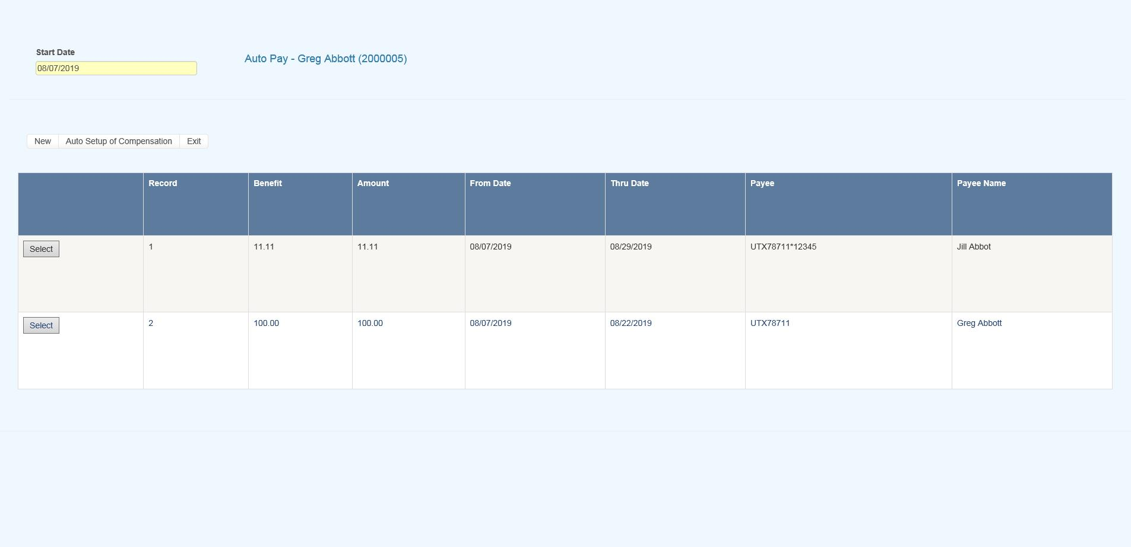****Figure 6‑1: AutoPay Screen**

Depending on how the claim has been set up, the following buttons may be used.

| **Button** | **Function** |
| --- | --- |
| Edit | Displays the selected payment record for viewing and/or editing purposes. If the list is empty, this button will be disabled. |
| New | Displays a blank form so a new record may be entered. |
| Auto Setup | Sets up a new payment schedule automatically. This button will be disabled if there is a Start TD or Start PD Date in the claim. |
| Close | Exits to wherever you started, either the claim or the Selected Claim menu. |

There are two ways of scheduling new payments. Each method will be covered in this section.

Using the Auto Setup of Compensation Button

The **Auto Setup** button is available for setting up the benefit period. It will be enabled for indemnity claims that have a specific Benefit Rate, but no benefit payments (i.e. the Start TD and Start PD Date fields are both empty).

**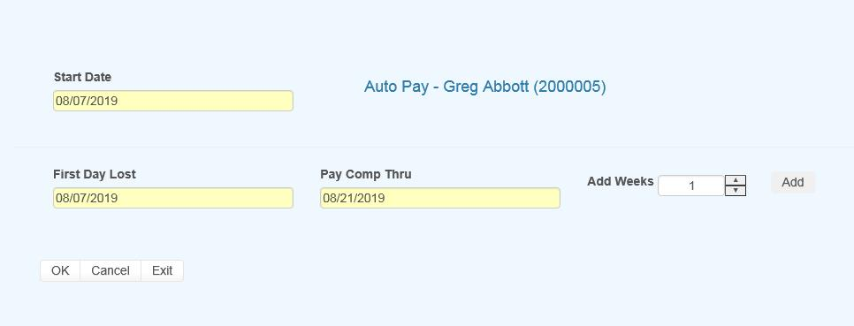****Figure 6‑2: AutoPay Setup**

Selecting the button will prompt for the compensation period. The First Day Lost will be displayed if the date exists in the claim record. Enter the date when the period will end. It can always be changed later. If you don’t know the exact date, add the number of weeks to be paid and click the Pay Comp Thru field to update the ending date.

Click OK and the program will set up the payment schedule as shown in the following example.

In addition to the information found in the claim record, the program will search the various tables to find the default values for the Pay Code, State Days, and Waiting Period when the Auto Setup of Compensation feature is used. (All of the fields will be covered next.)

If the program finds all the required information and the Pay Day value for the employer is set to something besides any day, then the only thing left to do is save the record. Otherwise, the date for the Next Check must be entered before the record can be saved.

Using the New Button to Schedule Payments

If you use the **New** button, normally the information on the form will have to be entered manually. The fields are described as follows:

| **Field Name** | **Description** |
| --- | --- |
| Record # | The default is “1” for the first payment schedule. Enter “2” to indicate a 2nd one.  A total of nine records may exist at any one time. Records no longer appear on the list after the last payment has been made. |
| PMT Type | The payment type is either checks or vouchers. If necessary, a system administrator may change the default value. |
| Payee ID | The payee’s social security or federal ID number. Enter "C" if the payee is the claimant, "D" for a dependent receiving alimony or child support, or press the Ellipsis button for a list of vendors.  If this is a fatality case, we recommend that you enter the individual who will receive the death benefits as a dependent to make it easier to schedule payments. |
| Payee | The name of the payee will be filled in automatically after reading the social security number or vendor code in the previous field. |
| 2nd Payee | The name of a second payee if any. For example, if the employee's check needs to go to a legal firm for disbursement, the c/o name should be entered here. |
| Address, City, State, Zip, Phone | The address and phone information will be filled in automatically after reading the record with the specified social security or federal ID number. |
| RSV Cat | The reserve category to be used. The Auto Setup feature will enter “Indemnity” by default. Press the Ellipsis button for a list of other categories that are available on your system. |
| Pay Code | The payment or cost center code. Press the Ellipsis Button for a list of codes that are available for the specified reserve category.  If the Auto Setup button is used, the program will use the Benefit Type code specified in the claim record to look for the default code set up with the Administer-Configure-Application Parameters menu. |
| Rate | The employee’s benefit rate. If an amount has been entered in the claim record, it will be displayed here automatically. (A benefit rate must have been entered in the claim in order to use the Auto Setup feature.) |
| Work Comp From | When the Auto Setup of Compensation button is used, the program will calculate the starting date based on the First Day Lost and the days in the state's waiting period, otherwise it must be entered manually. In either case, the From Date will be adjusted as payments are made. |
| Work Comp Thru | The day benefits should end. The program that batches the payments will generate "Next to Last Payment" and "Last Payment" diaries to warn the adjuster that the claim should be reviewed. This date may be modified if the payment period needs to be shortened or extended. |
| Wait Period From/Thru | When the Auto Setup of Compensation button is used, the program automatically calculates the From and Thru dates based on the Waiting Period and Before Paid values in the record for the claim's state of jurisdiction.  This feature will not work correctly if the values in the state's record are incorrect. If for some reason, you do not want the program to calculate the waiting period payment, zero out the values for the state. |
| Pay Period | The Auto Setup feature will automatically enter “B” (bi-weekly) as the Pay Period.  Other valid entries are “W” (weekly) and “M” (monthly). |
| Benefit Type | The benefit type from the claim record, either “TD” (temporary disability), “PD” (permanent disability), or “VR” (vocational rehabilitation). |
| PMT Periods | The total number of payments to be made will be calculated after you have entered the pay period and from/thru dates. This value can not be modified. It will be updated automatically as payments are made. |
| Original From | The Comp Period From Date will be updated as payments are made, but the original date is displayed here for your information. |
| Next Check | The date of the next payment. This date will appear as the first Batch On date on the list of future payments. (See below for details.) |
| Prior Check | The date of the last payment that was batched. |

**Saving a Payment Schedule**

When the record is saved, the program will check the claim to verify that there are sufficient reserves to make the payments. If there aren’t, you will be prompted to increase the reserves accordingly.

AutoPay creates the payment schedule and displays it on the screen as it saves the record. This particular example was created to batch the payments after the pay period (AutoPay Mode set to A) and the employer’s Pay Day set to any day. (Refer to the Setup Procedure in a later section.) The Next Check date is used as the first Batch On date. This is the most typical configuration.

Note the first payment on the list is for the waiting period. In the state of jurisdiction for the claim, there is a 14 day period before those days can be paid.

**Calculating the Last Payment**

Typically, the Comp Thru Date does not fall at the end of a pay period so the last payment is only for a few days. When that happens, the program will check the Scheduled Hours in the claim record.

If there are no Scheduled Hours, AutoPay assumes that the individual works a regular week and calculates the payment accordingly. But, suppose the employee works Monday and Wednesday through Saturday. (Work days are those which contain a value in the Total field on the Scheduled Hours dialog.) If the Thru Date falls on a Wednesday, the program will know that the employee does not work on Tuesday and only pay for two lost days.

The program that batches the auto payments will generate a diary to the adjuster when the next to the last and the last payments are batched.

**Batching Auto Payments**

The Autobat program must be run to batch payments according to their Batch On date. AUTO will be stored as the user who processed the transaction. Although the reserves must be sufficient to schedule the payments, the reserves may have been used up since then.

Auto payments will always be batched because of a possible late penalty. When the reserves are insufficient, the program checks the Stair Step Reserves value entered with the Application Parameters. If it is either "Closed" or "All", the reserves will be automatically increased to cover the payment. Unless Negative Reserves has been set to “N”, the futures will become negative. In any case, a diary will be sent to the adjuster.

Auto Batch logs may be viewed with the Image Files menu. When appropriate, "Next to Last Payment" and "Last Payment" entries will appear along with a diary telling the adjuster to review the claim.

The number of OSHA Days in the claim is updated as payments are batched against reserve categories 1 and 3 (indemnity and rehab) for pay codes with “TD” in the Grouper field. This number is based on a calendar week.

**Setup Procedure**

The system administrator must set up AutoPay so payment schedules are created to meet your particular needs. When the record is saved, the program will check the Pay Day and AutoPay Mode values as defined below.

| **Item** | **Set In** | **Value** |
| --- | --- | --- |
| Pay Day | Employer’s record | Sunday thru Saturday or Any Day |
| AutoPay Mode | Application Parameters | Standard (sets the first Print Date to the first Pay Day at the end of the pay period)  After (sets the first Print Date to the first pay day after the pay period ends) |

When the Auto Setup of Compensation feature is used and Pay Day is set to a specific day of the week, the program will ignore the Next Check date, if one exists, and use the AutoPay Mode to calculate it and the subsequent Print Dates (displayed with the List option). Changing the Next Check date will have no effect.

**Changing the Reserves**

The **Reserve Change** button will display the following dialog so the reserves for an open claim may be changed depending on the permissions granted in your user’s profile. This dialog also appears when the reserves must be increased in order to enter a payment.

Before the modified reserves can be saved, a Reserve Change reason must be selected using the drop-downs on the right. These changes may be viewed later with the History module.

**Reserve Change Limits**

There are two types of reserve limits that may be set in the ATS Security System: a Cumulative Limit which is the total incurred entered per user that cannot be exceeded and a One Time Limit which is the amount that may be entered during a session. (A session ends after exiting the program.)

These limits may apply to the total reserves or to individual reserve categories. For example, suppose the One Time Limit is set to 25,000 and the Cumulative Limit is 50,000. Depending on the current amount in the specified category, the change may or may not be allowed. Note that the Cumulative Limit examples assume that prior changes to the incurred were made by the same user.

One Time Limit=25,000 Cumulative Limit=50,000

Incurred in Claim Reserve Change Allowed?

Example 1 15,000 25,000 YES

Example 2 35,000 25,000 NO

Example 3 45,000 10,000 NO

It is important to note that when both the limits are zero or null, there is no limitation on the changes that may be made. If the One Time Limit is set to 25,000 and the Cumulative Limit is zero, the user may increase the reserves up to $25,000 a session regardless of the current amount in the claim.

One Time Limit=25,000 Cumulative Limit=0

Incurred in Claim Reserve Change Allowed?

Example 1 15,000 25,000 YES

Example 2 35,000 25,000 YES

Example 3 35,000 35,000 NO

Conversely, if the One Time Limit is set to zero and the Cumulative Limit is 50,000, the reserves may be increased by any amount until a total of $50,000.

One Time Limit=0 Cumulative Limit=50,000

Incurred in Claim Reserve Change Allowed?

Example 1 15,000 25,000 YES

Example 2 35,000 15,000 YES

Example 3 5,000 50,000 NO

The program will automatically update the future reserves and display the new totals as the incurred values are modified.

**Issuing Credits**

There may be times when you need to issue a credit against a specific claim. The credit might be for a particular payment when there was an overpayment. A credit may also be issued when there has been money recovered and the amount should be subtracted from the amount paid. In that case, there would be no prior payment involved. Regardless, if the claim is closed and the futures are zero, they will remain zero after the transaction has been made. Each of these type of credits will be covered in this section.

A Standard Credit

Select the Payment History button if you need to issue a credit for all or a part of a specific payment. The following screen will appear with a list of the payments that have been made. The list may include some existing credits where the form number ends with *R and a number.

Scroll through the list until you find the payment you want. Then, select the payment and click the **Credit** button. The program will display the Credit screen along with the data from the original payment. Note the Status field. A warning message will appear if you attempt to credit a payment that has been voided.

The cursor will be positioned in the Credit Date field so that you can modify the following items. Save the record to complete the transaction.

| **Field Name** | **Description** |
| --- | --- |
| Credit Date - Time | The current date and time appear by default. |
| Amount | The amount to credit may not exceed the amount of the original payment. If a credit has already been applied, it will be subtracted from this value. |
| Note | The note or memo that appeared on the original payment is displayed. It may be modified to indicate the reason for the credit. |

Credit No Check

This option allows you to issue a credit for a claim when there is no particular payment involved (e.g. the credit applies to a group of payments). This feature should also be used when the money recovered on a claim must be deducted from the amount paid. In this case, the amount could not be entered as a recovery since these are tracked separately in the ATS System.

After selecting the desired claim, pick the **Credit** (no check) button. The program will display the same form used to issue standard credits, but the information has to be entered manually since there is no payment record..

The fields on the form are described as follows:

| **Field Name** | **Description** |
| --- | --- |
| Vendor Code | If the payee is any of the following, enter the code and the vendor code, name, and address will be filled in with the information in the claim record.   * C claimant * P medical provider * CA claimant’s attorney * DA defense attorney   If the payee is someone else, press the Ellipsis button to search for the vendor. |
| Reserve Cat | The code for the reserve category to be credited. |
| Amount PTD | As soon as the reserve category has been specified, the total amount paid for that category will be displayed. |
| Payment Type | The type is either check or voucher. |
| Credit Date/Time | Normally, this data is not changed. |
| Reason | A note explaining why the credit was issued. |
| Credit Amount | The amount to be credited may not exceed the amount paid. |

**Entering a Recovery**

In the ATS System, recoveries are tracked separately from payments, credits, and voids. The amount paid will not be adjusted. Use the Credit menu when the money received must be deducted from the amount paid against the claim.

The fields to be entered on the form are described as follows:

| **Field Name** | **Description** |
| --- | --- |
| Recovery Amount | The amount recovered. A warning will be displayed if this amount is greater than the amount paid. |
| Vendor Code | The code for the vendor making the payment. Press the Ellipsis button to search the vendor records or enter “C” to display the Claimant’s information or "S" to display the Recovery (Subro) Party from the claim. In the latter case, no vendor code will appear because there is none in the claim. |
| Invoice No./Date | The invoice or reference number and date. (optional) From/Thru The range of dates in the period. (optional) |
| Reserve Category | The code for the category from which the recovery will be made. |
| Recovery Type | The code indicating the type of recovery is normally a required field. |
| Note | An optional note regarding the recovery. |
| Recovery Date - Time | The current date and time may be modified if necessary. |
| Update Bank | A check will update the bank balance (i.e. the client’s trust fund). This value has no effect if you use the ATS System to issue vouchers, not checks. |

**Voiding Transactions**

Menu options are available so that you may void a payment or recovery. Typically, that is necessary when a transaction was entered incorrectly.

Checks and Vouchers

Whether the payment was entered for the wrong reserve category and pay code or it was lost in the mail, the original transaction should be voided and re-entered.. This is done by selecting the History button . The following screen will appear with a list of the payments that have been made.

Scroll through the list until you find the payment you want. Then, select the payment and click the **Void** button. The program will display the Void screen along with the data from the original payment.

The following screen is used to void payments. The only fields that may be edited are the Void Date, Reason, and the Type. Simply save the record to void the payment. If the claim is closed and the futures are zero, they will remain zero after the transaction has been voided.

Note:

1. Voiding a benefit payment may affect the Start TD or Start PD dates in the claim. If the first payment is voided, the new starting date will be the From Date in the second payment.
2. If the claim is closed and the futures are zero, they will remain zero after the transaction has been voided.

Recoveries

Suppose you receive money on a claim and enter it as a recovery before realizing it should have been a credit so the amount would have been deducted from the paid. In that case, you will need to void the original transaction by selecting the **Recovery History** button.

The following screen will appear with a list of the recoveries that have been made.

Highlight the record to be voided click the Void button. The date, the reason for voiding the transaction, and a code indicating the type of void are the only items that can be entered. To void the recovery, simply save the record. If the bank (trust fund) was updated when the original recovery was made, a message will appear to let you that the balance has been adjusted.

**Editing Batched Payments**

All payments that are entered with a status of “B” are batched for future processing. At any time, these batched payments may be reviewed, approved, posted, deleted and/or released (when pended) by anyone with the proper access level.

Use the Process-Batched Payments menu and click Process to view all the payments.

Use the Previous and Next buttons to page through the list. The columns contain the following information.

| **Column** | **Contents** |
| --- | --- |
| Type | The type of payment where C = check and V = voucher |
| Status | “A” if the Approve feature is used, otherwise empty. |
| Entry | The code for the user who entered the payment or AUTO if the system batched the reoccurring payment. |
| Amount | The amount of the payment |
| Payee | The name of the payee |
| From/Thru | The dates in the billing period |
| Due | The date the payment is to be issued |
| Desc | The pay code |
| Transaction | The claim number followed by an asterisk and the number of the payment issued for the claim |
| Voucher | The number assigned when the item has been exported with the Accounting Interface module |
| Entry Date | The date the payment was batched |

**Mode Filters**

The Edit Batch utility has a wide variety of features as evidenced by the number of buttons and check/edit boxes that appear on the form. Each of the features, including those available from the menu, will be covered in the following sections.

There are two buttons that may be used to process batched (the default) or pended payments which were entered for more than the operator’s check writing limit.

The following filters are available to select a specific group of batched payments.

(Not) Approved

The ATS System has a Pre-Approve feature that may be used to require the approval of payments before they can be printed.

If the Pre-Approve flag has been set using the Module Parameters screen, these filters will be enabled so that all payments that are not approved will be listed when the Process button is clicked. Remove the check in the Not box to get a list of approved payments. (Approved payments will have an "A" in the Status column.)

(Not) Exported

By default, all the payments that have not been exported using the Accounting Interface will be listed. Remove the check in the Not box to get a list of exported payments that have a number in the Voucher column.

Region

When the Region feature has been implemented, this filter may be used to display a list of payments for claims in a specific region. An operator may only view payments for a particular region if one is specified in the operator's record and the Region View is turned on.

Selected Claims

By default, the payments for all the claims that meet the other criteria (filters) will be listed. When this is a long list, it may be difficult to find a payment for a specific claim. In that case, click the Claims ellipsis button to display the Select Claim screen. Pick a claim and only those payments will appear on the list.

Due Date

The Payment program allows you to specify a Due Date for each batched payment. By default, this field is empty so this filter will have no effect.

Depending on the settings entered using the Module Parameters screen, post-dating payments may be allowed. In that case, the Due Date filter may be used to display payments with dates either on or before the date specified (in the filter) or blank.

**Operations**

A variety of buttons are available so you can perform the following functions.

Approve

If the Pre-Approve flag has been set to "Y" using the Module Parameters screen, the **Approve** button will be enabled so batched payments can be approved by an operator with the authority to print checks. Otherwise, this button will be disabled (grayed out) since this step is not required. When this feature is used, approved payments will have an "A" in the Status column.

Delete

Any payment may be deleted from batch by an operator with Delete permission. Simply highlight the desired item and click the **Delete** button. The program will ask if you want to perform the operation. To continue, click the **Yes** button. The program will remove all references to the batched payment from the system and adjust the reserves/paid amounts for the claim.

Post

When a check has been made out by hand or printed with a foreign system, an operator with Print Payments permission should use the **Post** button to post the payment to the check history table. The date and form number may be changed if necessary.

The next voucher number is found in the client’s record, whereas check numbers are stored in the information for the bank account.

Release

Use Pend mode to view any payments that were entered for an amount over the operator’s check writing limit. Select one of the payments. If your check writing limit is higher than the amount of the payment, the **Release** button will be available to place it in Batch mode.

View

Use the **View** button to view all of the information on a specific payment. Notice the **Browse** button in the Payee group. Suppose that a payment had issued to the wrong vendor. This button may be used to display the Select Vendor dialog and pick the correct vendor without having to void the payment and enter a new one. After making a change, click the **Process** button again to update the Payee name on the list.

**Reports**

The Edit Batch **Report** button may be used to produce a wide variety of reports with the currently listed payments. Clicking the button will display the specification screen with all of the default values as shown below. Check the Page Eject box if you want a new page to be used when the value being sorted by changes.

The report specifications are as follows:

| **Field** | **Contents** |
| --- | --- |
| Sort By | Payments may be sorted by Adjuster (the default), Claimant, Reserve Category/ Pay Code, ATS Claim Number, Alternate Claim Number, or Region/Level 1. |
| Mode | Batched or Pending payments. |
| Checks | A check will display only checks on the report. |
| Vouchers | A check will display only vouchers on the report. |
| (Un) Approves | If the Pre-Approve feature is used, a check will indicate which payments should be included. |
| (Not) Exported | A check will either include the payments that have been exported (for printing) or not. |
| Claim Number | By default, the wildcard % is used to include all claims. Click the ellipsis button to select a particular one. |
| Region | By default, payments for all regions will be included. |
| Level 1 | By default, payments for all levels will be included. |
| Page Eject | A check will cause a page eject each time the Sort By value changes. |

When you have finished entering the specifications, click the **Print Preview** button to load the report into the ATS Print Previewer where it may be reviewed and/or printed.

**Medical Fee Module**

Each year, medical costs continue to skyrocket. Instead of simply paying the full amount on every invoice, use the Medical Fee module, an optional, add-on product designed to lower your medical costs. Each line item on the invoice is calculated and either accepted or overridden based on the state’s fee schedule, the DOL’s OWCP schedule, and/or the Usual and Customary Reimbursement (UCR) value. A vendor’s custom fee schedule may also be used.

This module has also automated the printing of Explanation of Benefits to the medical providers. The UCR module is an optional feature and not part of the standard ATS/Comp Medical Fee product.

Bundling and unbundling is another optional feature that is available. The data to implement any of these features is available from a third party.

**Setup Considerations**

1. By default, the program will check to see if the specified vendor has an HMO/PPO with Valid From/Thru dates that cover the From date in the payment record. If so, it will look in the HMO/ PPO’s record for the rate table to be used.

When a rate table is not specified (or found), the program will use the vendor’s State to see if the Schedule flag for that state has been set with the Maintain-State Codes menu.

If the vendor’s State field is empty or the state has no fee schedule, a message will appear indicating that it will use the Fee State Code set with the Administer-Configuration-Module Parameters menu to calculate the amount for the line items to be paid on the invoice.

2. If UCR percentiles are to be used, they should be stored by state with the Medical Fee- UCR Percentile menu. By default, the program will detect that a percentile exists for the vendor’s state and use the UCR value to calculate the amounts, based on the zip code, for the line items ignoring the $ per Unit value in the fee schedule.

3. If the Override State flag has been set with the Module Parameters menu, the program will calculate the amount of the line item using both of the above methods and display whichever amount is lower.

**Making a Payment**

The bill review process is quick and easy. The **Bill Review** button will display a data entry screen with two pages, the first of which is used to enter general information on the payment as shown below.

| **Field Name** | **Description** |
| --- | --- |
| Payment Type | The type of payment, either check or voucher. |
| Invoice | The number of the invoice that is being paid. |
| Invoice Date | The date of the invoice. |
| Received | The date the department received the invoice may be entered for accounting purposes |
| Status | The status of the payment; either batch to be printed later, print when the record is saved or notation only, which writes the payment record to the check history file with a specified form number and processed date without printing it first. |
| Payment Code | The code for the type of payment. |
| Payment Note | A note to be displayed on the check or voucher. |
| Vendor Code | Enter “C” if the payee is the claimant or press the Ellipsis button to select an active vendor. |
| Payee | Making a selection will display the name and address from the vendor’s record. |

Clicking the **Line Items** button will display the page shown below.

The fields on this form are described as follows:

| **Field Name** | **Description** |
| --- | --- |
| Amount | The amount on the invoice. The total amount that will be paid for the line item(s) is displayed in the Payable field. The program will display a message and adjust the amount for the line item or the amount payable if either is greater than the invoiced amount. |
| Service Zip | By default, the vendor’s zip will be displayed as the zip code where the service was performed. This zip code will not only determine which fee schedule is used, but also the tax rate if tax is to be applied as in New Mexico. |
| ICD-9 | The ICD-9 code(s) from the invoice. Up to four codes may be entered. |
| Inpatient | A check indicates that the employee has been admitted in a facility and treated as an inpatient. |
| Item | The number of the line item. Use the arrow keys to enter another item or review a previous one listed in the grid below. |
| From/Thru | The starting and ending date of the billing period. (The default ending date is the same as the From Date.) These dates will determine which particular fee schedule to use. (It must be after the open date on the claim.)  For your convenience, the previous From/Thru dates will be displayed as you enter new line items. |
| ICD-9 | A number to specify which ICD-9 code applies to the specified CPT code for the line item. |
| Invoiced CPT Code | The CPT code for the item. Normally, this must be a valid code (in the fee schedule) in order to continue. The exception is “00000”, which may be used to enter a miscellaneous item that is not found in any fee schedule.  Note that the professional component or technical unit value may be used instead of the maximum reimbursable by entering the CPT code followed by either "-26" or “-27” respectively (e.g. 00100-26). |
| CPT Code | If the UCR module is in use, the vendor’s zip code will be used to determine the appropriate region. |
| Description | The description of the procedure. |
| Modifiers | Up to three modifiers may be applied to the CPT code. For example, the following modifiers may be applied to CPT 00100. |
| Specialty | When there is a specialty associated with the CPT code, it may be selected from a list of choices by clicking the Ellipsis button. |
| Qty | The number of units billed for this line item. Unit Amount The amount billed per unit is optional. |
| Amount | The amount billed for the procedure. If the amount per unit has been specified, the program will multiply it by the quantity when the Qty is greater than one and the CPT code begins with 1 or higher (anesthesia units are billed differently).  When the following situation occurs, the invoiced amount will be set to zero.  The values from the preceding Invoiced fields will appear as soon as the Amount is entered. |
| Accepted Amount | The Maximum Reimburseable Amount (MRA) is displayed if it is less than the amount invoiced, otherwise the MRA will appear. As the amount of each line item is accepted, the total value in the Payable field will be incremented.  Note that if the Bundling/Unbundling feature is in use, the program will check for major or comprehensive procedures that consist of a number of individual procedures. For example, the CPT code 31505 (larynoscopy diagnostic) consists of many other procedures, one of which is 36000 (microsurgery add-on). If both are on the same bill, the program will detect that the "code 36000 is part of the comprehensive procedure code 31505" and enter ZERO in the accepted amount for line 36000. The program will also look for mutually exclusive procedures (e.g. 27177 and 11010) that are not allowed on the same bill. |
| Override | An override code to explain why the amount to be paid is different than the amount billed. Press the Ellipsis button for the user-defined choices entered with the Tables-Medical Fee menu. |
| Futures | The amount available in the claim’s (future) medical reserves. See below for details when the amount is insufficient to cover the payment. |
| Payable | As line items are entered and accepted, the program will adjust this value accordingly. When the record is saved, this amount will be used to update the paid to date and future reserves in the claim. |
| Rate Table | The program will display the name of the fee schedule table in use. |

If you are in the Override field and want to enter another line item, press **<Page Down>** to increment the Line Number by one and move the cursor to the next From field. By default, the previous From/ Thru dates will be displayed for your convenience.

**Saving the Record**

After all the line items have been entered, save the record. The program will verify that the future medical reserves will cover the payment. If the futures are not enough, the program will check the Negative Reserves value set with the Module Parameters menu.

If the Negative Reserves value is "Y", the entry is allowed and the future reserves in the claim will become negative. If the value is "N", the program will check the Stair Step Reserves value that was set using the Application Parameters screen.

If the Stair Step Reserves value is “A”, the incurred amount in the claim will automatically be increased to cover the payment. Otherwise, the Edit Reserves dialog may be used to increase the reserves. (All changes depend on the operator's reserve limit.) Clicking **Close** without making a change will decrease the amount to equal the future reserves.

At this point, the payment will be batched, printed, or manually posted to history depending on how the Status field is set.

Note that the payment will be pended if it is over the operator’s check writing limit. (Pended payments must be released using the File menu in the Batched Payments section of the Process module.)

After the record is saved, you will be asked if you want to input another payment for this claim. If you click **Yes**, the form will be cleared so you can start again. Otherwise, you will be returned to the main menu.

**The Bundling and Unbundling Feature**

When this optional feature is in use, the program will check for mutually exclusive procedures (e.g. 27177 and 11010) that are not allowed on the same bill. It will also look for major or comprehensive procedures that consist of a number of individual components or procedures. For example, the CPT code 31505 (larynoscopy diagnostic) consists of many other procedures, one of which is 36000 (microsurgery add-on). If both are on the same bill, the program will detect that the "code 36000 is part of the comprehensive procedure code 31505" and enter ZERO in the accepted amount for line 36000.

**Using Custom Fee Schedules**

The ATS system supports multiple fee schedules; federal (DOL), state, and the usual and customary reimbursement (UCR) schedule. In that case, the program will display the amounts in the different schedules so the user can make a selection.

Discounts and/or custom fee schedules can also be setup for specific vendors. (Without this ability to use custom schedules, invoices for vendors that use their own service codes could not be reviewed.) After custom schedules have been setup, their use is transparent during data entry unless the code on the invoice is found in multiple schedules.

If you would like to use this feature, please contact ATS support as the procedure is beyond the scope of this manual.

**Printing the Explanation of Benefits**

The Explanation of Benefits (EOB) is normally printed at the same time as the payment. A special menu option is provided for those clients who export their payments to be printed by a foreign system and/or want to print them again later.

An option on the Financial menu may be used to print the EOBs any time after the check or voucher payments have been printed (not while they are still batched). When the report screen appears, enter the specifications to meet your requirements.

| **Field Name** | **Description** |
| --- | --- |
| Provider Code | A specific provider (vendor) code. Leave this field empty to include every provider that received a payment within the specified range of dates. |
| Display By | The EOBs will be sorted by provider code and then by either the claimant’s name (the default) or the claim number. |
| Starting Date | The first payment date to be selected. By default, this is the date that was used the last time the forms were produced. |
| Ending Date | The date of the last payments to be selected. |

An example of the standard EOB has been included below.

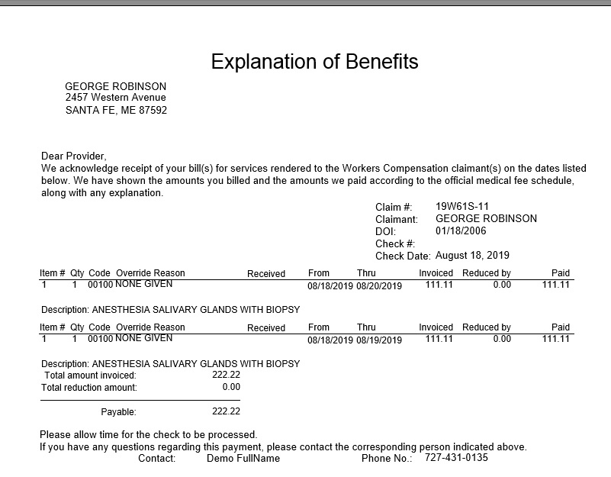

**Figure 6‑3: Sample Explanation of Benefits**

**The process home page**

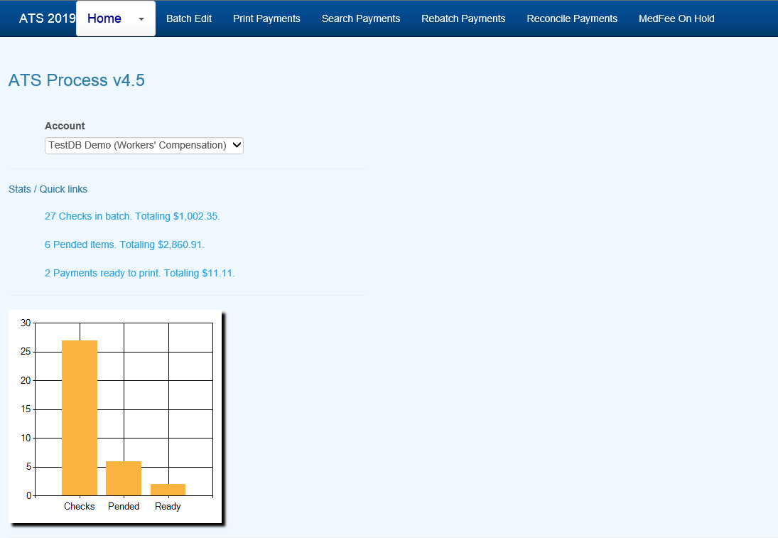

**Figure 6‑4: Process Home Page**

**Batch**

All payments that are entered with a status of “B” are batched for future processing. At any time, these batched payments may be reviewed, approved, posted, deleted and/or released (when pended) by anyone with the proper access level.

Use the Batched Payments menu and click the **Process** button to view all the payments.

Use the **Previous** and **Next** buttons to page through the list. The columns contain the following information.

| **Column** | **Contents** |
| --- | --- |
| Type | The type of payment where C = check and V = voucher |
| Status | “A” if the Approve feature is used, otherwise empty. |
| Entry | The code for the user who entered the payment or AUTO if the system batched the reoccurring payment. |
| Amount | The amount of the payment |
| Payee | The name of the payee |
| From/Thru | The dates in the billing period |
| Due | The date the payment is to be issued |
| Desc | The pay code |
| Transaction | The claim number followed by an asterisk and the number of the payment issued for the claim |
| Voucher | The number assigned when the item has been exported with the Accounting Interface module |
| Entry Date | The date the payment was batched |

**Mode Filters**

The Edit Batch utility has a wide variety of features as evidenced by the number of buttons and check/edit boxes that appear on the form. Each of the features, including those available from the menu, will be covered in the following sections.

There are two buttons that may be used to process batched (the default) or pended payments which were entered for more than the operator’s check writing limit.

The following filters are available to select a specific group of batched payments.

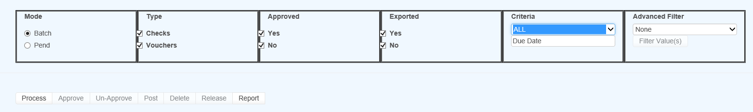

**Figure 6‑5: Batch Mode Filters**

(Not) Approved

The ATS System has a Pre-Approve feature that may be used to require the approval of payments before they can be printed.

If the Pre-Approve flag has been set in Module Parameters, these filters will be enabled so that all payments that are not approved will be listed when the Process button is clicked. Remove the check in the Not box to get a list of approved payments. (Approved payments will have an "A" in the Status column.)

(Not) Exported

By default, all the payments that have not been exported using the Accounting Interface will be listed. Remove the check in the Not box to get a list of exported payments that have a number in the Voucher column.

Criteria

When the Region feature has been implemented, this filter may be used to display a list of payments for claims in a specific region. An operator may only view payments for a particular region if one is specified in the operator's record and the Region View is turned on.

Also available is the due-date filter.

Advanced Filter

By default, the payments for all the claims that meet the other criteria (filters) will be listed. When this is a long list, it may be difficult to find a payment for a specific claim. In that case, click the Claims ellipsis button to display the Select Claim screen. Pick a claim and only those payments will appear on the list.

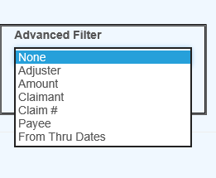

**Figure 6‑6: Advanced Filter**

**Operations**



**Figure 6‑7: Operation Buttons**

A variety of buttons are available so you can perform the following functions.

Approve/Un-Approve

If the Pre-Approve flag has been set to "Y" with Module Parameters, these buttons will be enabled so batched payments can be approved by an operator with the authority to print checks. Otherwise, this button will be disabled (grayed out) since this step is not required. When this feature is used, approved payments will have an "A" in the Status column.

Delete

Any payment may be deleted from batch by an operator with Delete permission. Simply highlight the desired item and click the **Delete** button. The program will ask if you want to perform the operation. To continue, click **Yes**. The program will remove all references to the batched payment from the system and adjust the reserves/paid amounts for the claim.

Post

When a check has been made out by hand or printed with a foreign system, an operator with Print Payments permission should use the **Post** button to post the payment to the check history table. The date and form number may be changed if necessary.

The next voucher number is found in the client’s record, whereas check numbers are stored in the information for the bank account.

Release

Use Pend mode to view any payments that were entered for an amount over the operator’s check writing limit. Select one of the payments. If your check writing limit is higher than the amount of the payment, the **Release** button will be available to place it in Batch mode.

View Button(s) on the grid

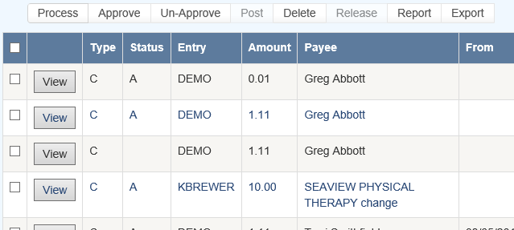

**Figure 6‑8: Grid View Buttons**

Use the **View** button to view all of the information on a specific payment. With proper authority information within the batched payment can be modified.

**Report**

The **Report** button may be used to produce a wide variety of reports with the currently listed payments.

**Export**

The **Export** button will export the grid to a Microsoft Excel type format.

**Rebatch**

This feature is used to search printed items that may need to be reprinted due to a print job error or a mistake on a check or checks.

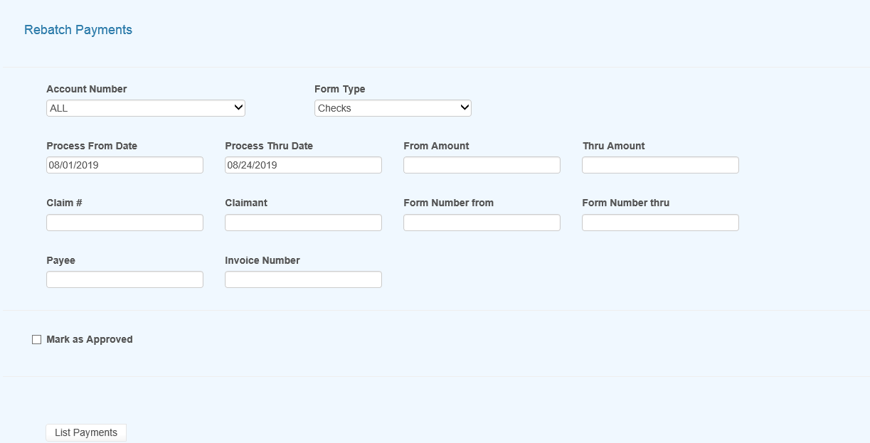

**Figure 6‑9: Rebatch Payments Screen**