# Overview

The purpose of the MedCase Module is to provide a method of capturing and tracking data associated with encounters with the on-site medical.

Includes a combination of pages used to capture information about Work Place Incidents, Medical Provider Encounters, and Medical Cases.

Medical Case Explorer Page

The Medical Case Explorer page provides the ability to view (in list format) and access the Work Place Incidents, Medical Provider Encounters and Medical Cases in the system.

Work Place Incident Page

The Work Place Incident page provides the ability to enter information about an event that resulted in injuries to one or more employees. The information captured includes; Incident Date/Time, Department, Area Code, Facility, Site, Lead Person, Work Stopped, Class/Action, Agent, and Incident Description. In addition, information for one or more injured employees can be associated with the Incident.

Medical Provider Encounter Page

The Medical Encounter page provides the ability to capture information regarding a visit by an employee at the medical facility. The information captured includes; Date, Time In/Out, Purpose, Discharge Action, Follow-up Date, Referred To information, and Soap Notes. The encounter can be related to an existing Medical Case or can result in the creation of a new one.

Medical Case Page

The Medical Case page provides the ability to enter information about the condition of the employee as a result of the Work Place Incident. The information captured includes; Creation and Update Dates, Case Type, Date, Complaint, Condition, Body Part, OSHA Code, Privacy Case, Lost Time Injury, Diagnosis, ICD-9 Code, Date/Time of Death, Receiving Outside Care, Hospitalized, Physician, Hospital, and Activity At Time Of Injury. If applicable, the FROI number can also be entered.

Incident (Work Place Incident)

Any event that results in the injury of one or more employees

Medical Case

Information regarding the nature and scope of the injury to an employee.

Encounter (Medical Provider Encounter)

A visit to the medical facility to be treated by or confer with a medical professional.

Limitation

A work restriction placed upon an employee by a medical professional.

## Medical Case Explorer Page Description

The Medical Case Explorer page provides access to all of the Encounters, Medical Cases, and Work Place Incidents in the system. It provides the ability to search through records using various criteria and to display all data associated with a particular Employee. It also provides the ability to initiate a new Encounter and/or to create new Encounters and Medical Cases.

The following depicts the existing Medical Case Explorer.

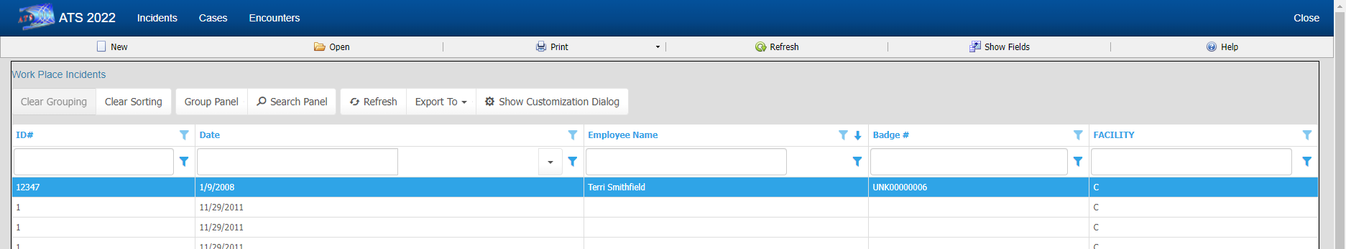

## Encounter Page Description

The Encounter Page allows the user to collect information related to a visit at the Medical Facility by an Employee, such as; Date, Time In/Out, Purpose for the visit, Date for the next Follow-Up appointment, who the Employee may have been referred to, and Notes.

The following depicts the existing Encounter screen.

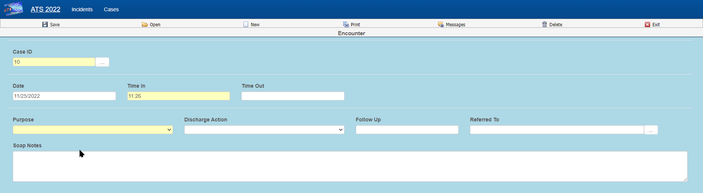

## Medical Case Description

The Medical Case page allows the user to collect and view information about the injury/illness of the Employee and the diagnosis of the Medical Provider. In addition, it displays a log of all Encounters related to the Medical Case and allows entry and viewing of Limits associated with the Medical Case.

The following depicts the existing Medical Case screen

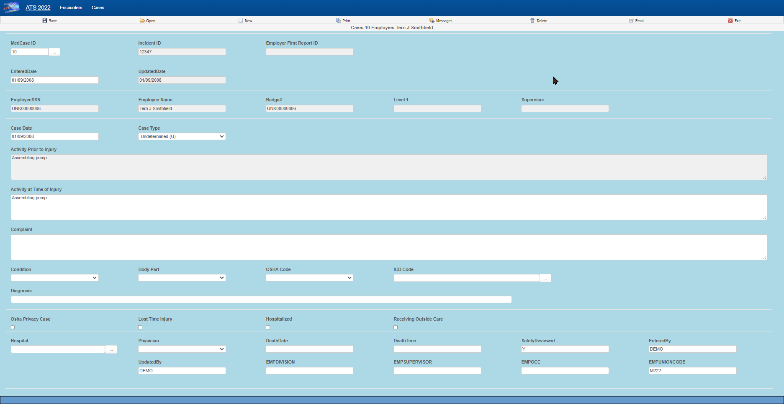

## Work Place Incident Description

The Work Place Incident page allows the user to collect information about when, where and how Employee(s) sustained an injury or became ill.

The following depicts the existing Work Place Incident screen.

