## Medical Fee Module

Each year, medical costs continue to skyrocket. Instead of simply paying the full amount on every invoice, use the Medical Fee module, an optional, add-on product designed to lower your medical costs. Each line item on the invoice is calculated and either accepted or overridden based on the state’s fee schedule, the DOL’s OWCP schedule, and/or the Usual and Customary Reimbursement (UCR) value. A vendor’s custom fee schedule may also be used.

This module has also automated the printing of Explanation of Benefits to the medical providers. The UCR module is an optional feature and not part of the standard ATS/Comp Medical Fee product.

Bundling and unbundling is another optional feature that is available. The data to implement any of these features is available from a third party.

### Setup Considerations

1. By default, the program will check to see if the specified vendor has an HMO/PPO with Valid From/Thru dates that cover the From date in the payment record. If so, it will look in the HMO/ PPO’s record for the rate table to be used.

When a rate table is not specified (or found), the program will use the vendor’s State to see if the Schedule flag for that state has been set with the Maintain-State Codes menu.

If the vendor’s State field is empty or the state has no fee schedule, a message will appear indicating that it will use the Fee State Code set with the Administer-Configuration-Module Parameters menu to calculate the amount for the line items to be paid on the invoice.

2. If UCR percentiles are to be used, they should be stored by state with the Medical Fee- UCR Percentile menu. By default, the program will detect that a percentile exists for the vendor’s state and use the UCR value to calculate the amounts, based on the zip code, for the line items ignoring the $ per Unit value in the fee schedule.

3. If the Override State flag has been set with the Module Parameters menu, the program will calculate the amount of the line item using both of the above methods and display whichever amount is lower.

### Making a Payment

The bill review process is quick and easy. The Bill Review button will display a data entry screen with two pages, the first of which is used to enter general information on the payment as shown below.

| **Field Name** | **Description** |
| --- | --- |
| Payment Type | The type of payment, either check or voucher. |
| Invoice | The number of the invoice that is being paid. |
| Invoice Date | The date of the invoice. |
| Received | The date the department received the invoice may be entered for accounting purposes |
| Status | The status of the payment; either batch to be printed later, print when the record is saved or notation only, which writes the payment record to the check history file with a specified form number and processed date without printing it first. |
| Payment Code | The code for the type of payment. |
| Payment Note | A note to be displayed on the check or voucher. |
| Vendor Code | Enter “C” if the payee is the claimant or press the Ellipsis button to select an active vendor. |
| Payee | Making a selection will display the name and address from the vendor’s record. |

Clicking the Line Items button will display the page shown below.

The fields on this form are described as follows:

| **Field Name** | **Description** |
| --- | --- |
| Amount | The amount on the invoice. The total amount that will be paid for the line item(s) is displayed in the Payable field. The program will display a message and adjust the amount for the line item or the amount payable if either is greater than the invoiced amount. |
| Service Zip | By default, the vendor’s zip will be displayed as the zip code where the service was performed. This zip code will not only determine which fee schedule is used, but also the tax rate if tax is to be applied as in New Mexico. |
| ICD-9 | The ICD-9 code(s) from the invoice. Up to four codes may be entered. |
| Inpatient | A check indicates that the employee has been admitted in a facility and treated as an inpatient. |
| Item | The number of the line item. Use the arrow keys to enter another item or review a previous one listed in the grid below. |
| From/Thru | The starting and ending date of the billing period. (The default ending date is the same as the From Date.) These dates will determine which particular fee schedule to use. (It must be after the open date on the claim.)  For your convenience, the previous From/Thru dates will be displayed as you enter new line items. |
| ICD-9 | A number to specify which ICD-9 code applies to the specified CPT code for the line item. |
| Invoiced CPT Code | The CPT code for the item. Normally, this must be a valid code (in the fee schedule) in order to continue. The exception is “00000”, which may be used to enter a miscellaneous item that is not found in any fee schedule.  Note that the professional component or technical unit value may be used instead of the maximum reimbursable by entering the CPT code followed by either "-26" or “-27” respectively (e.g. 00100-26). |
| CPT Code | If the UCR module is in use, the vendor’s zip code will be used to determine the appropriate region. |
| Description | The description of the procedure. |
| Modifiers | Up to three modifiers may be applied to the CPT code. For example, the following modifiers may be applied to CPT 00100. |
| Specialty | When there is a specialty associated with the CPT code, it may be selected from a list of choices by clicking the Ellipsis button. |
| Qty | The number of units billed for this line item. Unit Amount The amount billed per unit is optional. |
| Amount | The amount billed for the procedure. If the amount per unit has been specified, the program will multiply it by the quantity when the Qty is greater than one and the CPT code begins with 1 or higher (anesthesia units are billed differently).  When the following situation occurs, the invoiced amount will be set to zero.  The values from the preceding Invoiced fields will appear as soon as the Amount is entered. |
| Accepted Amount | The Maximum Reimburseable Amount (MRA) is displayed if it is less than the amount invoiced, otherwise the MRA will appear. As the amount of each line item is accepted, the total value in the Payable field will be incremented.  Note that if the Bundling/Unbundling feature is in use, the program will check for major or comprehensive procedures that consist of a number of individual procedures. For example, the CPT code 31505 (larynoscopy diagnostic) consists of many other procedures, one of which is 36000 (microsurgery add-on). If both are on the same bill, the program will detect that the "code 36000 is part of the comprehensive procedure code 31505" and enter ZERO in the accepted amount for line 36000. The program will also look for mutually exclusive procedures (e.g. 27177 and 11010) that are not allowed on the same bill. |
| Override | An override code to explain why the amount to be paid is different than the amount billed. Press the Ellipsis button for the user-defined choices entered with the Tables-Medical Fee menu. |
| Futures | The amount available in the claim’s (future) medical reserves. See below for details when the amount is insufficient to cover the payment. |
| Payable | As line items are entered and accepted, the program will adjust this value accordingly. When the record is saved, this amount will be used to update the paid to date and future reserves in the claim. |
| Rate Table | The program will display the name of the fee schedule table in use. |

If you are in the Override field and want to enter another line item, press <Page Down> to increment the Line Number by one and move the cursor to the next From field. By default, the previous From/ Thru dates will be displayed for your convenience.

### Saving the Record

After all the line items have been entered, save the record. The program will verify that the future medical reserves will cover the payment. If the futures are not enough, the program will check the Negative Reserves value set with the Module Parameters menu.

If the Negative Reserves value is "Y", the entry is allowed and the future reserves in the claim will become negative. If the value is "N", the program will check the Stair Step Reserves value that was set using the Application Parameters screen.

If the Stair Step Reserves value is “A”, the incurred amount in the claim will automatically be increased to cover the payment. Otherwise, the Edit Reserves dialog may be used to increase the reserves. (All changes depend on the operator's reserve limit.) Clicking Close without making a change will decrease the amount to equal the future reserves.

At this point, the payment will be batched, printed, or manually posted to history depending on how the Status field is set.

Note that the payment will be pended if it is over the operator’s check writing limit. (Pended payments must be released using the File menu in the Batched Payments section of the Process module.)

After the record is saved, you will be asked if you want to input another payment for this claim. If you click Yes, the form will be cleared so you can start again. Otherwise, you will be returned to the main menu.

### The Bundling and Unbundling Feature

When this optional feature is in use, the program will check for mutually exclusive procedures (e.g. 27177 and 11010) that are not allowed on the same bill. It will also look for major or comprehensive procedures that consist of a number of individual components or procedures. For example, the CPT code 31505 (larynoscopy diagnostic) consists of many other procedures, one of which is 36000 (microsurgery add-on). If both are on the same bill, the program will detect that the "code 36000 is part of the comprehensive procedure code 31505" and enter ZERO in the accepted amount for line 36000.

### Using Custom Fee Schedules

The ATS system supports multiple fee schedules; federal (DOL), state, and the usual and customary reimbursement (UCR) schedule. In that case, the program will display the amounts in the different schedules so the user can make a selection.

Discounts and/or custom fee schedules can also be setup for specific vendors. (Without this ability to use custom schedules, invoices for vendors that use their own service codes could not be reviewed.) After custom schedules have been setup, their use is transparent during data entry unless the code on the invoice is found in multiple schedules.

If you would like to use this feature, please contact ATS support as the procedure is beyond the scope of this manual.

### Printing the Explanation of Benefits

The Explanation of Benefits (EOB) is normally printed at the same time as the payment. A special menu option is provided for those clients who export their payments to be printed by a foreign system and/or want to print them again later.

An option on the Financial menu may be used to print the EOBs any time after the check or voucher payments have been printed (not while they are still batched). When the report screen appears, enter the specifications to meet your requirements.

| **Field Name** | **Description** |
| --- | --- |
| Provider Code | A specific provider (vendor) code. Leave this field empty to include every provider that received a payment within the specified range of dates. |
| Display By | The EOBs will be sorted by provider code and then by either the claimant’s name (the default) or the claim number. |
| Starting Date | The first payment date to be selected. By default, this is the date that was used the last time the forms were produced. |
| Ending Date | The date of the last payments to be selected. |

An example of the standard EOB has been included below.

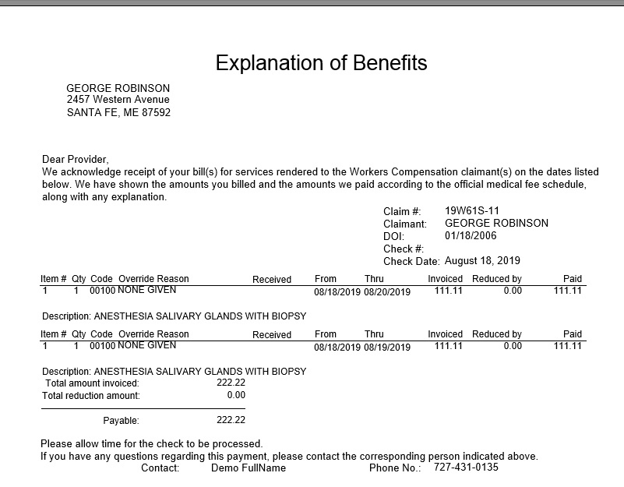

Figure 6‑3: Sample Explanation of Benefits