## Payments

If you are in Explore, you can make payments without actually opening the claim. Simply select the desired claim and click the General Payments button. The button is also available if you are already editing a claim and want to make a payment.

Knowing that some bills arrive after a claim has been closed, the ATS System has a special Stair Step Reserves feature that may be set so you can make a payment without having to reopen the claim.

The future reserves are always displayed for your convenience, but the bank account number and the balance in the trust will not appear if you are creating vouchers. (The number of reserve categories and their names will depend on how your ATS System has been set up.)

On the upper right side of the screen, you’ll see a special field that displays the claim number with an ellipsis button to the right. This field allows you to enter multiple payments rapidly by saving the payment, typing the next claim number in this field, entering the next payment and saving. The ellipsis button provides a claim search function if you don’t have the claim number available.

The example above shows an indemnity payment that was set up by simply clicking the Ellipsis button next to the amount. Refer to the fields below for information on this feature. The fields are described as follows:

| **Field Name** | **Description** |
| --- | --- |
| Pay Type | The payment type is either voucher or check. Note that checks debit the trust fund (bank account) balance, but vouchers do not.  The record shown above will produce a voucher so the number of the trust fund account and the balance in the account are not displayed at the bottom of the screen. This information will appear if you produce checks. |
| Amount | The amount to be paid. A special feature allows you to make an auto indemnity payment by pressing the Ellipsis button. The program will automatically display the amount, the employee’s name and address, the default From/Thru dates and “1” in the reserve category field. A default pay code may also appear. (The defaults are set with the Administer-Configuration-Application Parameters menu.)  If there is a negative account balance, you may get a "Bank Balance Insufficient" message depending on a setting entered with the Administer-Configuration- Module Parameters menu. When this message appears, the amount will be reset to zero.  Another setting may allow you to enter a batched payment with a negative balance. Attempting to print a payment or enter a notation will display the message "You may only batch this payment due to low funds".  If you are using the Stair Step Reserves feature set with the Administer- Configuration-Application Parameters menu, the reserves will automatically be increased to cover the payment. |
| Vendor Code | If the payee is any of the following, enter the code and the program will fill in the information from the claim.  C claimant  D dependent (a choice list will appear)  CA claimant’s attorney  DA defense attorney  P medical provider  Otherwise, enter the vendor code including the asterisk and location or press the Ellipsis button to select a vendor from the table. |
| From/Thru Periods | The dates for up to three billing/payment periods may be entered. Pressing the Ellipsis button next to the amount will display a period based on the Thru date for the last indemnity payment and whether the Benefit type for the claim is “TD” or “PD”. By default, these are two week periods, but the values may be changed with the Administer-Configuration-Application Parameters menu. If the From/Thru period is changed for an auto calculated indemnity payment, the program will display a message explaining how the benefit amount was recalculated and ask if the amount should be adjusted.  When a future date has been entered, the program will display “Warning: Date entered is greater than today’s date” on the title bar. Depending on your check printing schedule, you may need to enter future dates. In that case, ignore the warning message when it appears.  Back and post-dating payments may be allowed depending on the settings entered with the Administer-Configuration-Module Parameters menu. Note that it is very important to be able to back-date a notated payment that was printed on a prior date. The post-dating feature is also useful since it allows payments to be entered for printing sometime in the future when you may or may not be in the office (e.g, on vacation). |
| Reserve Cat | The code for the reserve category that the payment will be drawn against. If the payee is a vendor with a default reserve category and pay code, these values will be displayed on the screen automatically, but they can be modified. |
| Wage Continued | If the Wage Continued flag is set in the claim, the message “Warning - Wage Continued” will appear to remind you that an indemnity payment is being made to an employee who is receiving his or her salary in lieu of worker’s comp benefits.  A message will also be displayed when auto payments have been scheduled for that period.  Unless the Negative Reserves value has been set to “Y” with the Administer- Configuration-Module Parameters menu, the amount to be paid may not be more than the future reserves for the specified category. If the amount is higher, the program will read the Stair Step Reserves value set with the Administer- Configuration-Application Parameters menu. If the value is “N”, you will be given an opportunity to edit the reserves and increase the amount so the payment may be issued. For example, “Futures insufficient by 286.00. (Use the Change Reserves icon on the tool bar.”  If Stair Step Reserves contains an “A”, the incurred amount will be automatically increased by the amount of the payment. A value of “C” will increase the reserves for closed claims only. In both cases, the future reserves will still be zero after making the payment.  Refer to the Editing Reserves section in this chapter for more information on this process. |
| Payment Code | The payment or cost center code for the specified reserve category. Default codes for auto TD or PD indemnity payments may be set with the Administer- Configuration-Application Parameters menu. |
| OSHA Days | When making a payment to the employee from reserve category 1 or 3 (indemnity or rehab), the program will check the contents of the Grouper field in the specified Payment Code. If this value contains “TD”, then the From/Thru days are used to calculate the OSHA Days based on a calendar week. This value will be displayed on the screen and added to the existing values in the claim record.  There will be times when an employee performs another job or the same job with restrictions due to an injury or illness. If the job pays less than the usual, the employee should get a comp payment to make up the difference. In that case, it is very important that the temporary disability payment is made with a pay code that contains I08 (wage loss) in the report category so the days in the From/Thru period will be ignored when reporting to OSHA. If this feature is not used, the days would be counted as lost time when the employee is really at work. |
| Note | An optional note or memo to be displayed on the check/voucher. |
| Status | There are three choices:   1. Batch the payment record so that it can be printed later or exported with the Accounting Interface module. 2. Notate payments that were issued without using the ATS System. For example, suppose a check is lost. After voiding the original payment, enter a notated payment with the same date. 3. Click the Print button if you want to print the payment immediately. |
| Form Number  Process Date | When the Status is Print or Notate, the program will make these fields available and fill in the form number and current date which can be changed if necessary.  This is a handy feature when the original payment was incorrect (e.g. has the wrong reserve category) and has to be voided. You can’t batch another payment because the check has already been cashed. In this case, you will need to enter a notated payment  Note that the next check number is stored in the bank information entered with the Trust Fund menu while the voucher number is in the client’s record. |
| Due Date | The Due Date field is available when the payment is to be batched. If there is no specific date, leave the field empty so the payment will be included the next time a batch is printed.  Back and post-dating payments may be allowed depending on the settings entered with the Administer-Configuration-Module Parameters menu. Since the Print Batch program asks for a due date, the post-dating feature allows you to enter payments to be printed in the future. It is also important to be able to back- date a notated payment that was printed on a prior date. |
| Separate Handling | If the Separate Handling box is checked, the payment will not be combined with other payments to the same vendor. Checking this box also allows you to inform the accounting department (when the Handle Return File option in the Accounting Interface is used) that the check should be sent back to claims for special handling before it is mailed. |
| EDI Late Reason | Each state requires that the initial indemnity payment is issued a specific number of days after the date of injury. If this payment will be transmitted to the state via EDI, then select a code to indicate why the payment is late. Omitting the code may cause the state to reject the transaction. |
| Invoice Number | The invoice or reference number being paid, if any. |

### Saving a Payment

At this point, the program will search for possible duplicate payments for the same payee, reserve category, pay code and from date. If one is found, the program will display all the details on the other payment(s) so you can decide whether you should click Continue and save the payment. Clicking Cancel will leave you in the payment screen without saving the record the payment is over this amount, the program will display “Over check limit. Record will be pended.” The payment will be pended until someone with a higher limit releases it (to batch) with the Process- Edit Batch menu.

In states such as Florida and South Carolina, the MMI Date in the claim determines whether a $10 copayment can be applied to a medical payment. A message will appear if the date has been reached. Click Yes to apply the $10. The No button will return to the payment program. When you Save the record, the program will clear the screen except for the payee. At this point, you can enter another payment to the same or a different payee or exit the program.

### Scheduling Auto Payments

The AutoPay module is included with the standard ATS System so you may schedule payments to be made on a regular, ongoing basis. This feature is available from the menu from within a claim or from the Selected Claims list screen after selecting a claim.

The program displays the following screen. .

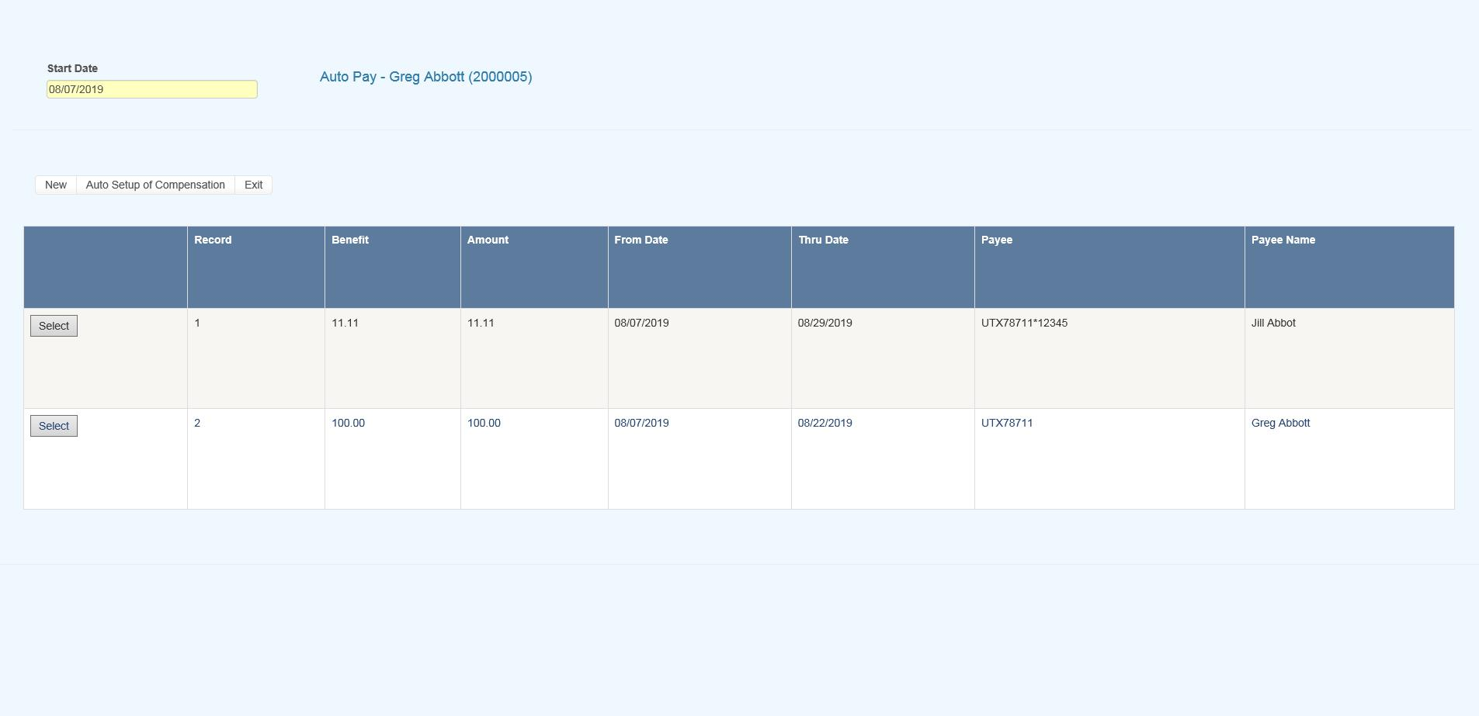   
Figure 6‑1: AutoPay Screen

Depending on how the claim has been set up, the following buttons may be used.

| **Button** | **Function** |
| --- | --- |
| Edit | Displays the selected payment record for viewing and/or editing purposes. If the list is empty, this button will be disabled. |
| New | Displays a blank form so a new record may be entered. |
| Auto Setup | Sets up a new payment schedule automatically. This button will be disabled if there is a Start TD or Start PD Date in the claim. |
| Close | Exits to wherever you started, either the claim or the Selected Claim menu. |

There are two ways of scheduling new payments. Each method will be covered in this section.

#### Using the Auto Setup of Compensation Button

The Auto Setup button is available for setting up the benefit period. It will be enabled for indemnity claims that have a specific Benefit Rate, but no benefit payments (i.e. the Start TD and Start PD Date fields are both empty).

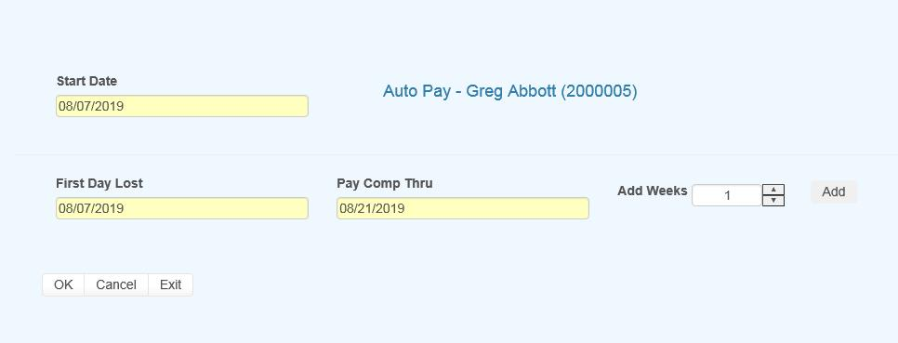   
Figure 6‑2: AutoPay Setup

Selecting the button will prompt for the compensation period. The First Day Lost will be displayed if the date exists in the claim record. Enter the date when the period will end. It can always be changed later. If you don’t know the exact date, add the number of weeks to be paid and click the Pay Comp Thru field to update the ending date.

Click OK and the program will set up the payment schedule as shown in the following example.

In addition to the information found in the claim record, the program will search the various tables to find the default values for the Pay Code, State Days, and Waiting Period when the Auto Setup of Compensation feature is used. (All of the fields will be covered next.)

If the program finds all the required information and the Pay Day value for the employer is set to something besides any day, then the only thing left to do is save the record. Otherwise, the date for the Next Check must be entered before the record can be saved.

#### Using the New Button to Schedule Payments

If you use the New button, normally the information on the form will have to be entered manually. The fields are described as follows:

| **Field Name** | **Description** |
| --- | --- |
| Record # | The default is “1” for the first payment schedule. Enter “2” to indicate a 2nd one.  A total of nine records may exist at any one time. Records no longer appear on the list after the last payment has been made. |
| PMT Type | The payment type is either checks or vouchers. If necessary, a system administrator may change the default value. |
| Payee ID | The payee’s social security or federal ID number. Enter "C" if the payee is the claimant, "D" for a dependent receiving alimony or child support, or press the Ellipsis button for a list of vendors.  If this is a fatality case, we recommend that you enter the individual who will receive the death benefits as a dependent to make it easier to schedule payments. |
| Payee | The name of the payee will be filled in automatically after reading the social security number or vendor code in the previous field. |
| 2nd Payee | The name of a second payee if any. For example, if the employee's check needs to go to a legal firm for disbursement, the c/o name should be entered here. |
| Address, City, State, Zip, Phone | The address and phone information will be filled in automatically after reading the record with the specified social security or federal ID number. |
| RSV Cat | The reserve category to be used. The Auto Setup feature will enter “Indemnity” by default. Press the Ellipsis button for a list of other categories that are available on your system. |
| Pay Code | The payment or cost center code. Press the Ellipsis Button for a list of codes that are available for the specified reserve category.  If the Auto Setup button is used, the program will use the Benefit Type code specified in the claim record to look for the default code set up with the Administer-Configure-Application Parameters menu. |
| Rate | The employee’s benefit rate. If an amount has been entered in the claim record, it will be displayed here automatically. (A benefit rate must have been entered in the claim in order to use the Auto Setup feature.) |
| Work Comp From | When the Auto Setup of Compensation button is used, the program will calculate the starting date based on the First Day Lost and the days in the state's waiting period, otherwise it must be entered manually. In either case, the From Date will be adjusted as payments are made. |
| Work Comp Thru | The day benefits should end. The program that batches the payments will generate "Next to Last Payment" and "Last Payment" diaries to warn the adjuster that the claim should be reviewed. This date may be modified if the payment period needs to be shortened or extended. |
| Wait Period From/Thru | When the Auto Setup of Compensation button is used, the program automatically calculates the From and Thru dates based on the Waiting Period and Before Paid values in the record for the claim's state of jurisdiction.  This feature will not work correctly if the values in the state's record are incorrect. If for some reason, you do not want the program to calculate the waiting period payment, zero out the values for the state. |
| Pay Period | The Auto Setup feature will automatically enter “B” (bi-weekly) as the Pay Period.  Other valid entries are “W” (weekly) and “M” (monthly). |
| Benefit Type | The benefit type from the claim record, either “TD” (temporary disability), “PD” (permanent disability), or “VR” (vocational rehabilitation). |
| PMT Periods | The total number of payments to be made will be calculated after you have entered the pay period and from/thru dates. This value can not be modified. It will be updated automatically as payments are made. |
| Original From | The Comp Period From Date will be updated as payments are made, but the original date is displayed here for your information. |
| Next Check | The date of the next payment. This date will appear as the first Batch On date on the list of future payments. (See below for details.) |
| Prior Check | The date of the last payment that was batched. |

### Saving a Payment Schedule

When the record is saved, the program will check the claim to verify that there are sufficient reserves to make the payments. If there aren’t, you will be prompted to increase the reserves accordingly.

AutoPay creates the payment schedule and displays it on the screen as it saves the record. This particular example was created to batch the payments after the pay period (AutoPay Mode set to A) and the employer’s Pay Day set to any day. (Refer to the Setup Procedure in a later section.) The Next Check date is used as the first Batch On date. This is the most typical configuration.

Note the first payment on the list is for the waiting period. In the state of jurisdiction for the claim, there is a 14 day period before those days can be paid.

### Calculating the Last Payment

Typically, the Comp Thru Date does not fall at the end of a pay period so the last payment is only for a few days. When that happens, the program will check the Scheduled Hours in the claim record.

If there are no Scheduled Hours, AutoPay assumes that the individual works a regular week and calculates the payment accordingly. But, suppose the employee works Monday and Wednesday through Saturday. (Work days are those which contain a value in the Total field on the Scheduled Hours dialog.) If the Thru Date falls on a Wednesday, the program will know that the employee does not work on Tuesday and only pay for two lost days.

The program that batches the auto payments will generate a diary to the adjuster when the next to the last and the last payments are batched.

### Batching Auto Payments

The Autobat program must be run to batch payments according to their Batch On date. AUTO will be stored as the user who processed the transaction. Although the reserves must be sufficient to schedule the payments, the reserves may have been used up since then.

Auto payments will always be batched because of a possible late penalty. When the reserves are insufficient, the program checks the Stair Step Reserves value entered with the Application Parameters. If it is either "Closed" or "All", the reserves will be automatically increased to cover the payment. Unless Negative Reserves has been set to “N”, the futures will become negative. In any case, a diary will be sent to the adjuster.

Auto Batch logs may be viewed with the Image Files menu. When appropriate, "Next to Last Payment" and "Last Payment" entries will appear along with a diary telling the adjuster to review the claim.

The number of OSHA Days in the claim is updated as payments are batched against reserve categories 1 and 3 (indemnity and rehab) for pay codes with “TD” in the Grouper field. This number is based on a calendar week.

### Setup Procedure

The system administrator must set up AutoPay so payment schedules are created to meet your particular needs. When the record is saved, the program will check the Pay Day and AutoPay Mode values as defined below.

| **Item** | **Set In** | **Value** |
| --- | --- | --- |
| Pay Day | Employer’s record | Sunday thru Saturday or Any Day |
| AutoPay Mode | Application Parameters | Standard (sets the first Print Date to the first Pay Day at the end of the pay period)  After (sets the first Print Date to the first pay day after the pay period ends) |

When the Auto Setup of Compensation feature is used and Pay Day is set to a specific day of the week, the program will ignore the Next Check date, if one exists, and use the AutoPay Mode to calculate it and the subsequent Print Dates (displayed with the List option). Changing the Next Check date will have no effect.