### Rebatch

This feature is used to search printed items that may need to be reprinted due to a print job error or a mistake on a check or checks.

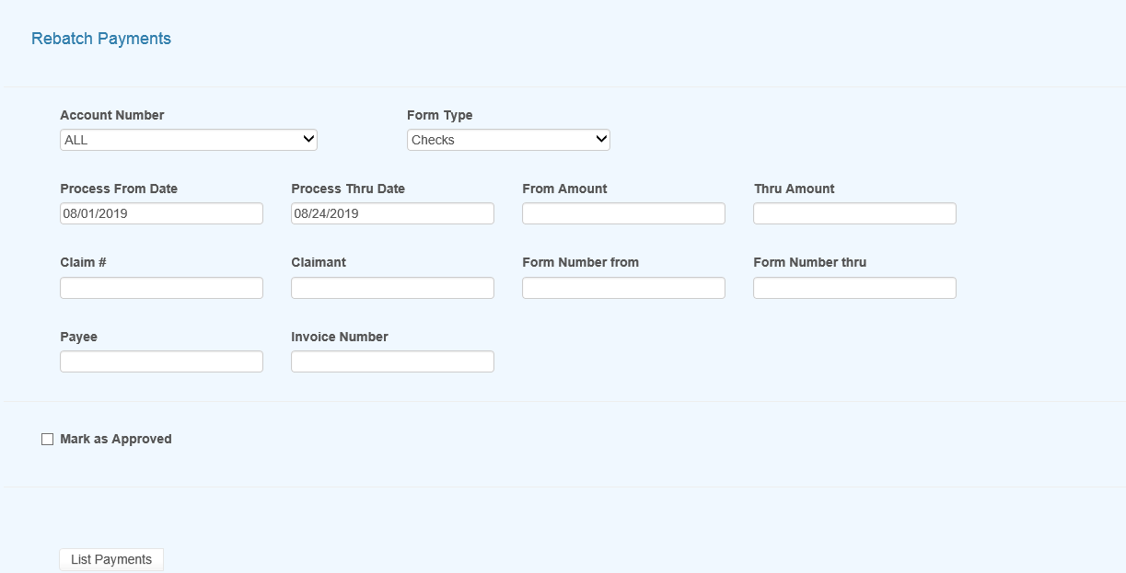

Figure 6‑9: Rebatch Payments Screen

Once you enter the search criteria and have records in the grid you will then be presented with the View option button as in edit batch as well as a button to Rebatch the selected items. Use the check box to the left of the item you wish to rebatch or use the checkbox in the header section to select all of the records in the grid.

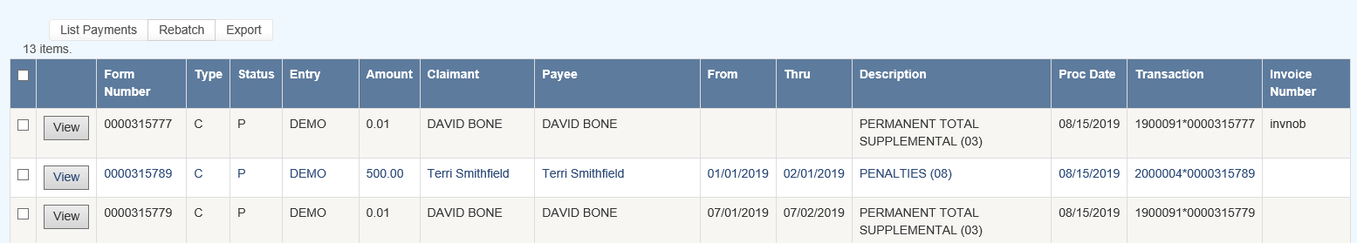

Figure 6‑10: Payments Grid