# Reports

ATS Reports comes with a wide variety of standard reports that are generally divided into the following categories:

* Claims
* Financial
* Statistical
* Government
* User

However, additional categories may be available, depending on the reports available, and new categories can be created, as required.

In addition to standard reports, ATS provides the option for a web-based Ad Hoc report tool as well as an Analytics reporting tool (Tableau).

Users with the appropriate permission may access the report menus. Those who are restricted to viewing claims for specific regions and/or levels will also be restricted when producing reports.

This chapter will explain how to use the reporting features. Details on specific reports and samples of the output are included in the Appendix.

To access the Report module, select Reports from the Menu Bar of the Console.

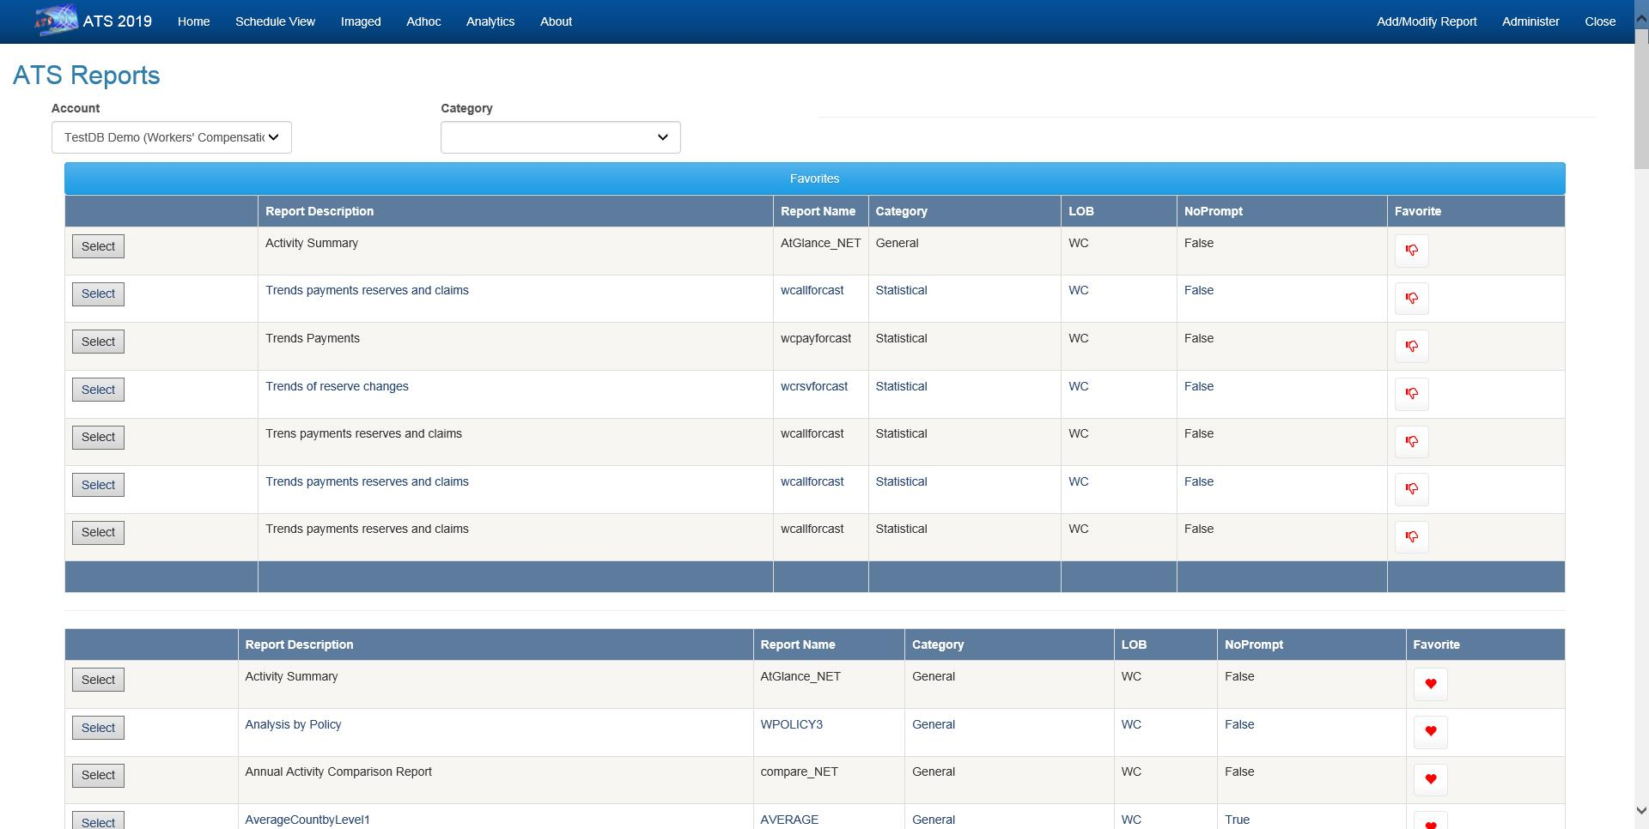 Figure 10‑1: Reports – Home

On the Home page you can select the Account (database) that the report will use when it runs.

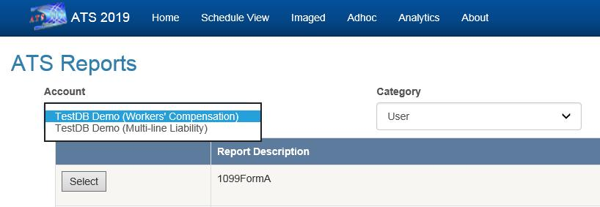   
Figure 10‑2: Reports – Account Selection

## Producing a Report

The following is an example of the output from the “Activity Summary” report.

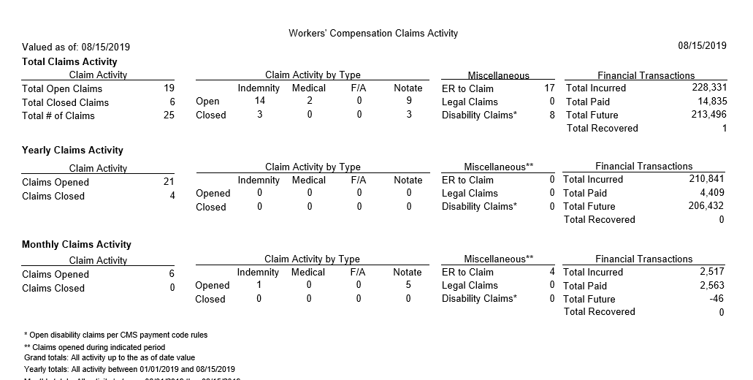   
Figure 10‑3: Reports – Activity Summary Report Sample

### Entering the Selection Criteria

All of the report screens operate the same way. They are designed to help you enter the specifications you need to generate a report. Selecting an item such as “Activity Summary” will display a screen with the report parameters.

The following information is requested on the sample form shown below.

#### Region Code

ATS allows you to group the departments or divisions in your company into regions. If this feature is used, you may select a specific region for reporting purposes.

When the default value of “ALL” is used, the program will skip this initial selection process and start with the next item.

Note that if a user only has permission to view the claims for a specific region, this field will be set to that value and can’t be edited.

#### Level 1 Code

Each claim record contains the codes for the employee’s levels. If you enter a specific code for level 1, the program will read each claim record and select only those for that level.

If a user has permission to view the claims for a specific region, only the levels in that region will be listed.

#### As Of

By default, financial information is based upon the current date. A special valued as-of date may be used to generate some information as it had been on a prior date. The program will provide a snapshot of the Claim data based on the date entered.

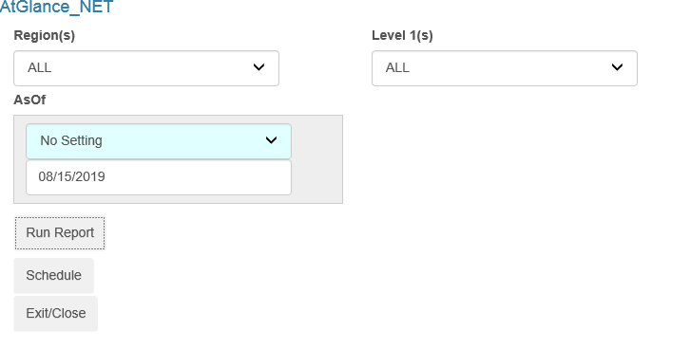   
Figure 10‑4: Reports –Activity Summary Parameter Entry Example

### Entering the Output Specifications

After completing the selection process, the program will check for any specifications that indicate how to display the records such as:

* Display Totals Only
* Print Level 2
* Subtotals

#### Display Totals Only

Check the Display Totals Only box to produce a summary report. Remove the check to display the details on the selected claims.

Note that if this box is checked, the details on the closed claims will not appear even if you have used the option to include them.

#### Print Level 2

Some reports will group the selected claims by level 1 and then sort each of those groups by the level 2 code. In that case, the default is to display the subtotals for level 2, but you may have the option of removing the check in order to suppress them.

After selecting options and filling in the parameters, the report can be generated immediately by clicking the Run Report button or scheduled to run at a later time by clicking the Schedule button.

### Valued As-of Reporting

At any time, you can pull up the record for a particular claim and get the current reserves and paid to date figures broken down by reserve category. The totals displayed on the Financial page are stored in the claim record. The details on the specific transactions are stored separately in history. (Reserve transactions are stored in a reserve history table while payment, credit, and void details are in check history.) As each transaction is saved, a routine is run to keep the claim and history in balance.

Since reports that include a Valued As-of Date field must be able to create a snapshot of the claim on a specific date in the past, the financial transactions are taken from history.

Suppose you want a report showing the reserves and payments the way they were on December 31, 2010. The following criteria will select all the transactions processed during 2003 for all claims opened since 1985. The reserve and payment transaction amounts (normally marked with an asterisk) for the various categories will appear as though the report was run on 12/31/2010 instead of the way they are today.

Open Dates

From 01/01/1985

Thru 12/31/2010

Transaction Dates

From 01/01/2010

Thru 12/31/2010

Valued As-of

12/31/2010

The Incurred, Total PTD, and Futures are always the same as those that appear in the claim record. The payment transaction value includes only the payments with Processed Dates within the specified range. Any credit or void applied to a payment after the as-of date will not be reflected on the report. The reserve transaction value includes all changes made up until the Valued As-of Date.

### The Sort Order

Typically, the information in the reports is sorted by the region and division (level 1) in which the claim occurred. When ”Include all Items” is specified in both of the fields, the program will sort and group the selected records by the region (if used) and then by the level 1 code found in the claim. The records will then be displayed in order by the claimant’s name or claim number.

The description of the report may indicate another sort order. For example, the phrase “By Levels 1 and 2” indicates that the selected records for each level 1 will also be sorted by the code for level 2. In that case, the following order would be used if you have EASTERN, WESTERN, NORTHERN, and SOUTHERN as regions, state codes as level 1, and ST0001, ST0002… as level 2.

EASTERN / MA / ST0001

EASTERN / MA / ST0002

EASTERN / MA / ST0003… EASTERN / ME / ST0111

EASTERN / ME / ST0112…

### Previewing a Report

When the report specifications have been entered, select the Print Preview button on the toolbar to load the report into the report viewer where it can be viewed and/or printed.

If you are printing from the Crystal Report Writer, it is important to note that only the first page of the report is displayed initially. If you click Print at that point, only that page will be printed.

You must go to the end of the report if you intend to print all or selected pages. (Maximize the report so the Go to Last Page button is available.)

### Printing a Report

ATS reports may be printed by selecting the Print button on the toolbar. A Print dialog will appear so you can specify which printer to use, the number of copies, and the pages to be printed.

### Exporting to Another Format

Click the Export button to select the specific format you wish to use. Those that Crystal supports are listed below.

### Using the Report Image Option

Reports produced by the ATS system may be stored in an image file on the disk. The Image Reports list allows you to view, print, delete, and/or email these files to someone else. There are a variety of ways to find the report you want.

# Dashboards

The ATS System provides a dynamic dashboard system that provides the ability to view information in graphical format with drill-down capabilities. Dashboards can be configured to display directly on the Console and then expand to the full screen when desired. Dashboards can also be accessed via the Dashboard option on the Console menu bar.

## Viewer

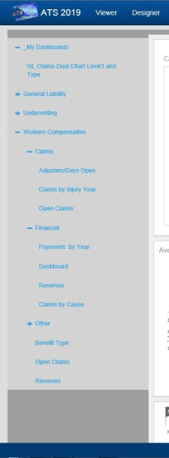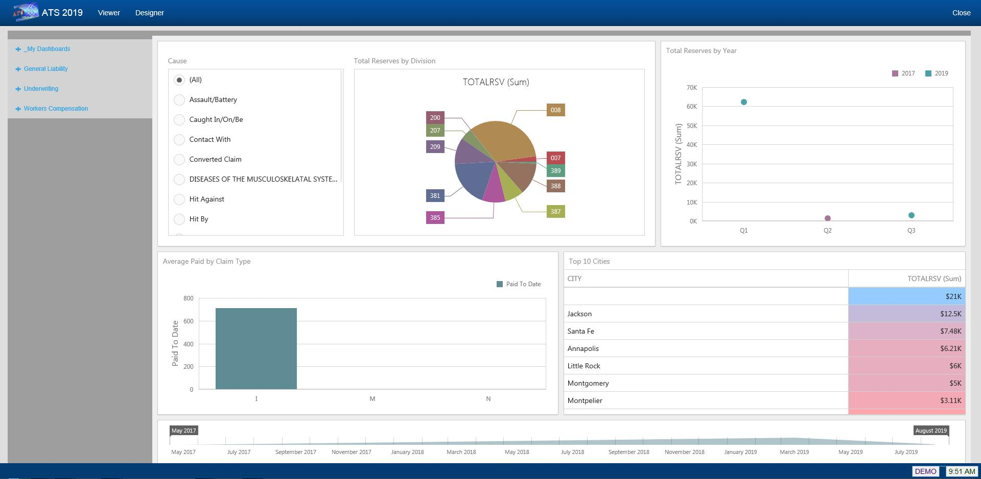   
Figure 11‑1: Dashboard Viewer

The Dashboard Viewer allows you to display interactive dashboards that operate on data in real time. Subsets of data can be selected and clicking on specific identifiers within the display will automatically cause the other portions of the screen to display data based on the specified identifier.

The left side of the viewer contains the menu of available dashboards. The menu is broken down by Line of Business and then by category, such as Claims, Financial, etc.

The My Dashboards section of the menu contains any dashboards created by you with the Designer.

## Designer

The Dashboard designer allows authorized users to create new dashboards that report on information that is meaningful to them.

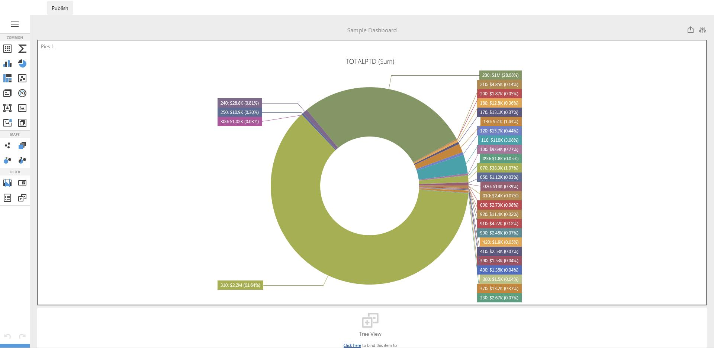   
Figure 11‑2: Dashboard Designer

In addition to the web-based designer, a more robust Windows version is available.