**Security**

The ATS architecture includes an advanced security system that allows administrators to setup the specific tasks that users can perform so that they can get their jobs done quickly and efficiently.

The ATS Security module gives administrators the ability to restrict user access down to the task level. For example, a user can be set to view-only for claims but still enter notes or diaries. Or a user can be allowed to view claims and notes, but not the financial information. Users can also be restricted to viewing data from their own level within the hierarchy. This is all accomplished through a simple interface with a list of rights.

The security module uses a group model, where several group profiles are setup with specific permissions based on their job. Users can be assigned to one or more groups and take on the rights of that group. In this way, the administrator does not have to recreate the same profile repeatedly. If one user requires special rights to do one task, then they can be given rights through the user profile, which overrides the group profile.

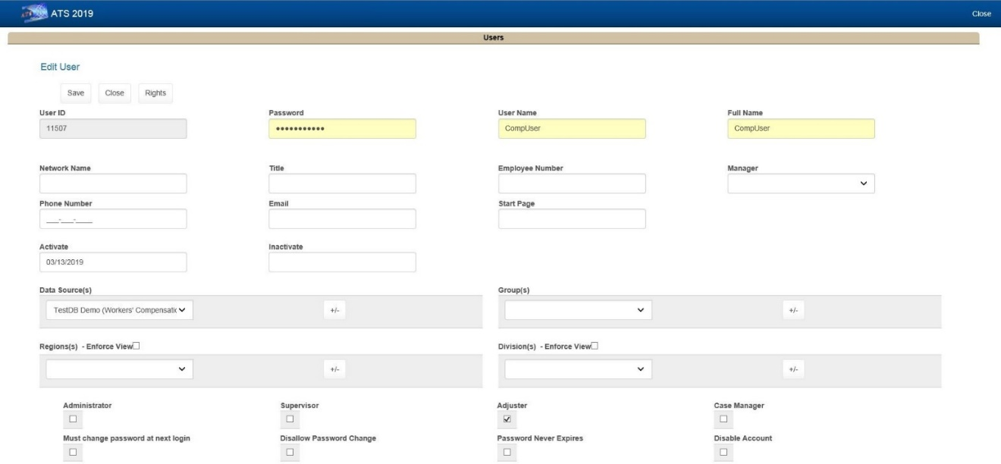

**User Profile Screen**

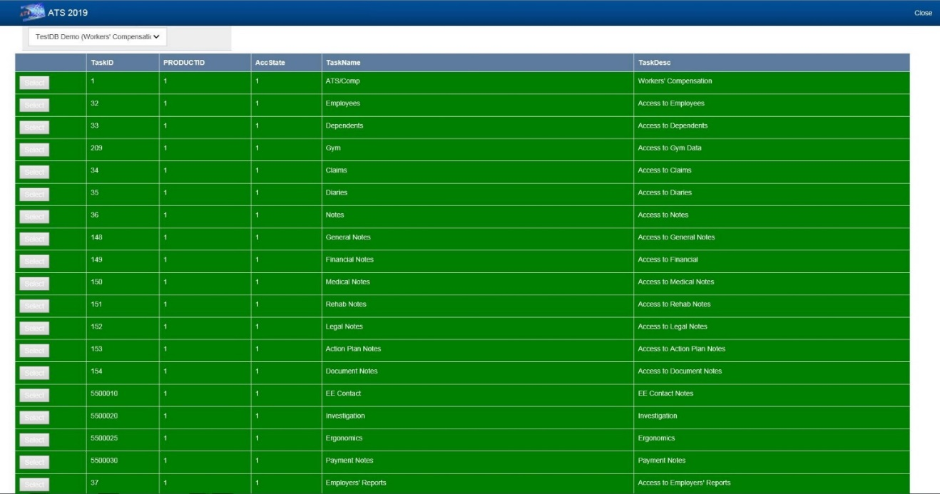 **Rights Administration Screen**

