***Show Fields***

In all Search grids you can change your preferences of columns to show as well as order.

Use the Show fields button to view your options.

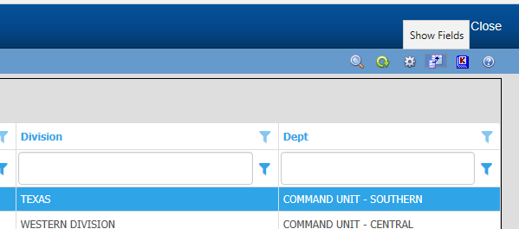

You then will be presented with your available column selections.

